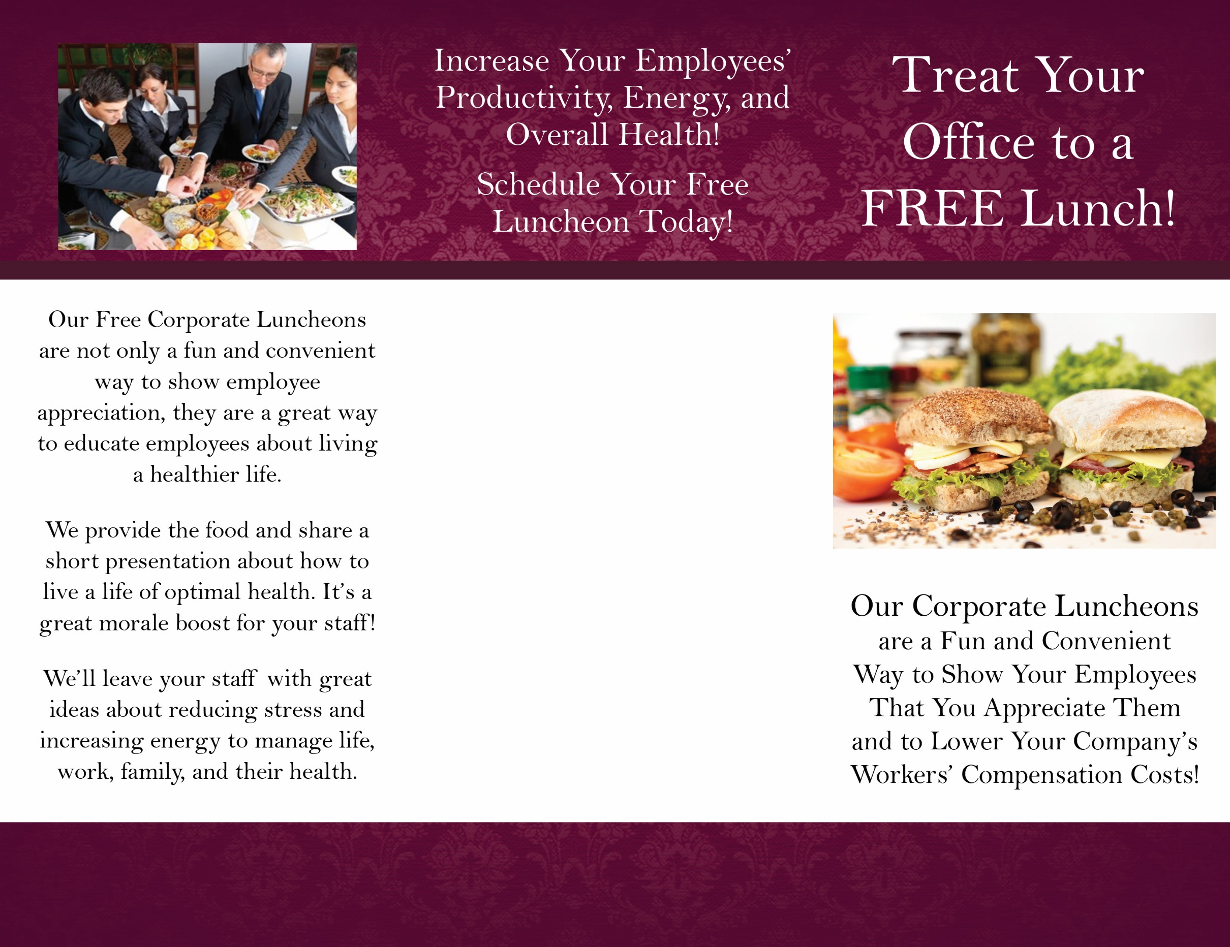
[(555) 555-5555]
[Your address]
[Your city, state, and zip]
[Monday-Thursday 9:00am – 8:00pm]

Your Logo Here
Keeping employees educated on wellness issues has proven to lower absenteeism and reduce health care costs!

At [Your Clinic Name], we know that weight loss is a tough journey,
but trying to go at it alone is an
even rougher climb! Let us help!

For more information about our
Free Corporate Lunches
Give us a call!

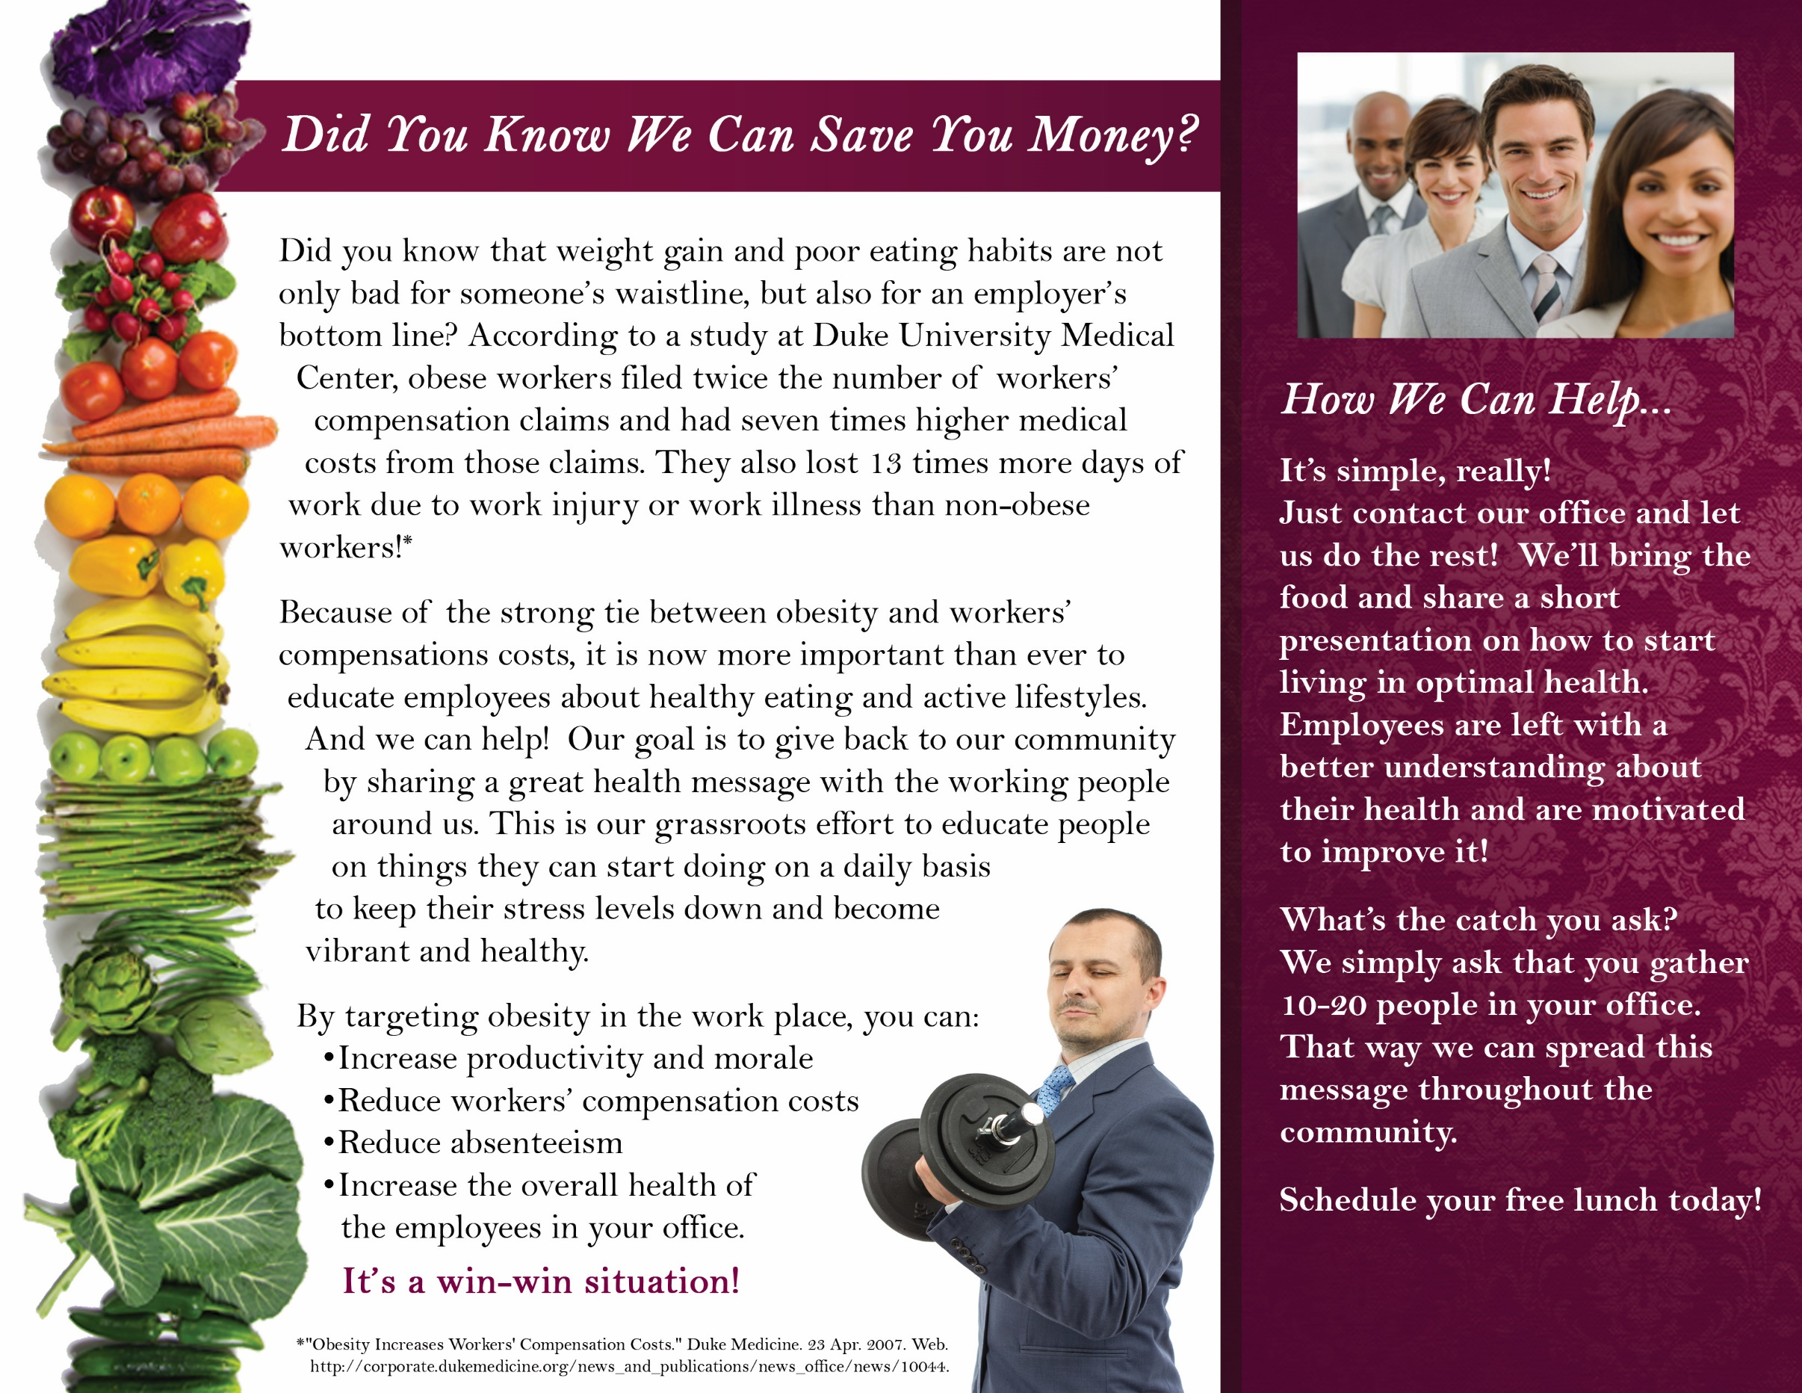
Call
[(555) 555-5555]

