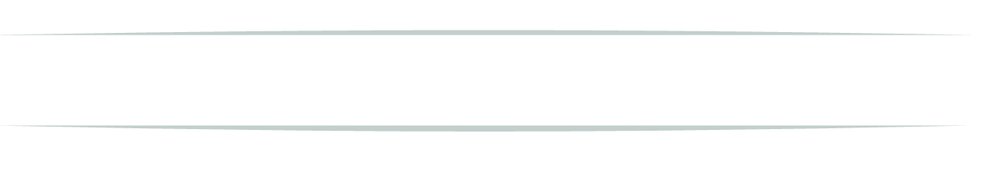
DAILY CHECKLISTS Date: __ /__ /__

What you do every day matters more than what you do once in a while.
Log Any Emotions or Situations that Affected Your Eating Today:
__________________________________________________________________________________________________________________________________________________________________________________________________________________________________________________________________________________________________________________________________________________________________________________________________________________________________________________________________________________________________________________________________________________________________________________________________________________
Breakfast | Calories

Mid-Morning Snack | Calories

Lunch | Calories

Mid-Afternoon Snack | Calories

Dinner | Calories

Calories Allotted for the Day
Total Calories You Ate
AM:

NOON:

PM:

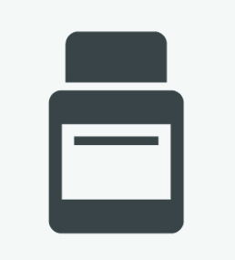

Lifestyle Guidelines: (√ = Yes X = No)

- Did you follow nutritional guidelines?
- Did you take all of your supplements?
- Did you track your calories?
- Did you stay within your calorie budget?
- Did you drink ½ your weight in oz. of water?
- Did you exercise? ____ min.

- Did you sleep at least 8 hours? ___ hrs.
- Did you apply exercise gel before exercise?
- Did you apply anti-cellulite lotion after showering?
- Write down questions for next appointment:
___________________________________
___________________________________

