How does the LipoLaser Shrink fat cells?
The Laser was designed to stimulate the adipocytes causing them release the excess fat.
This in turn reduces their size resulting in inch loss as well as the reduction of the appearance of cellulite.
This is how it works:
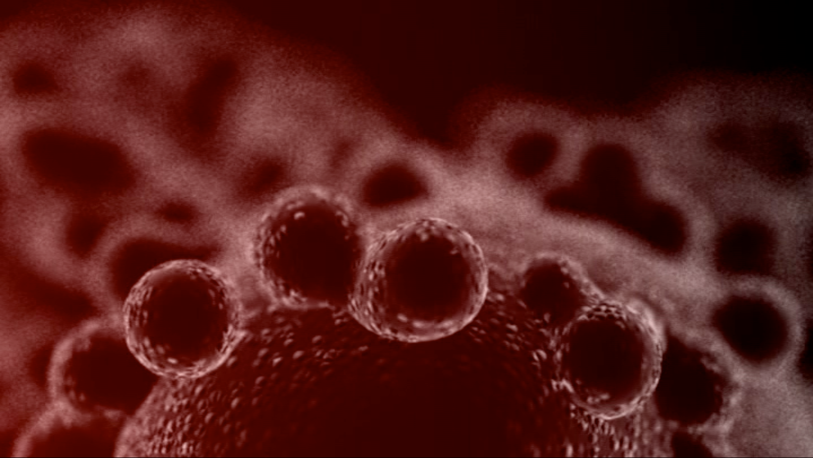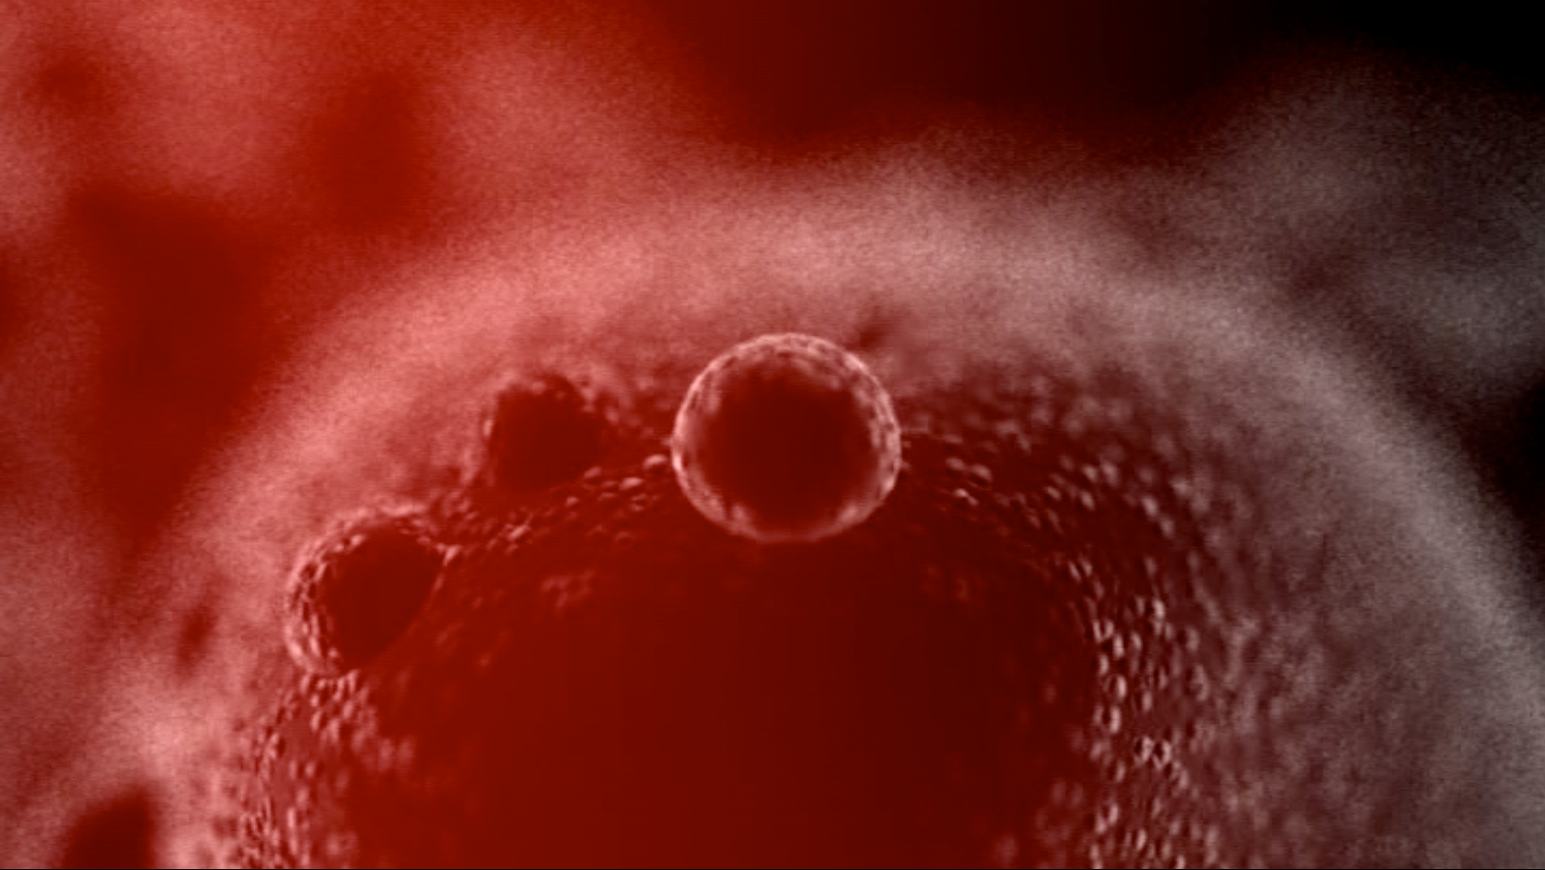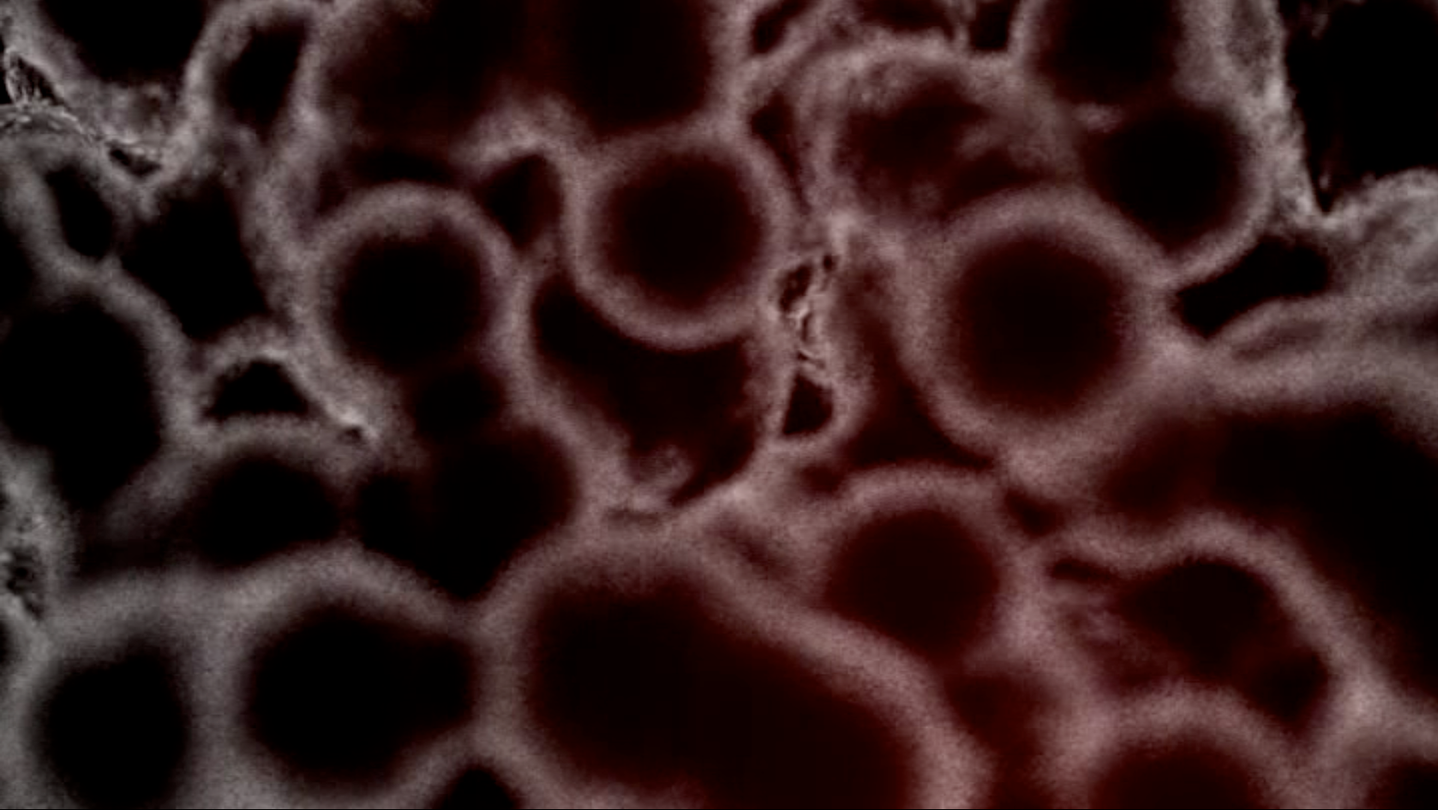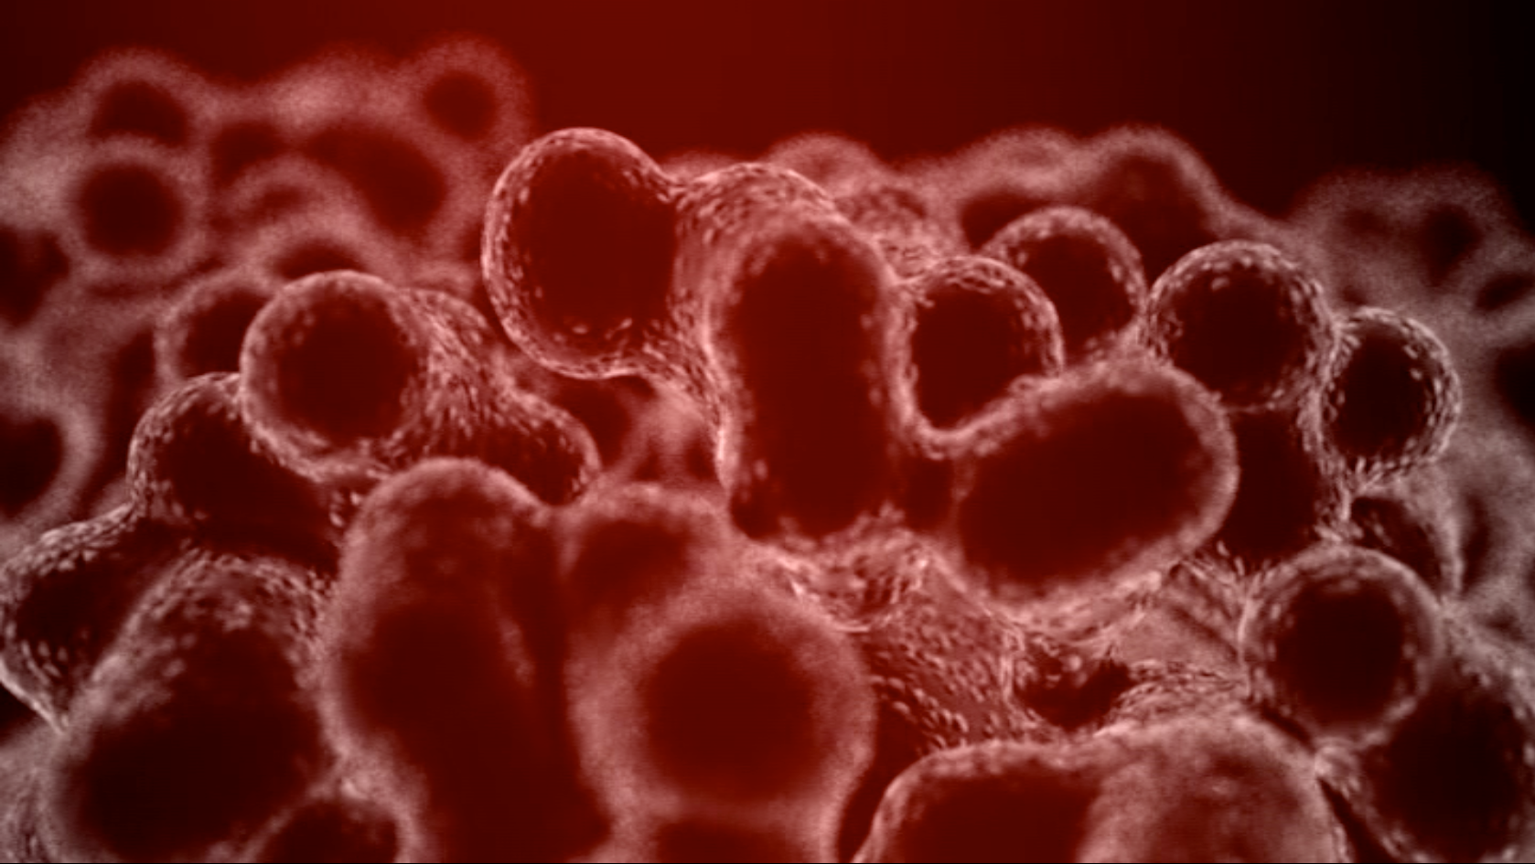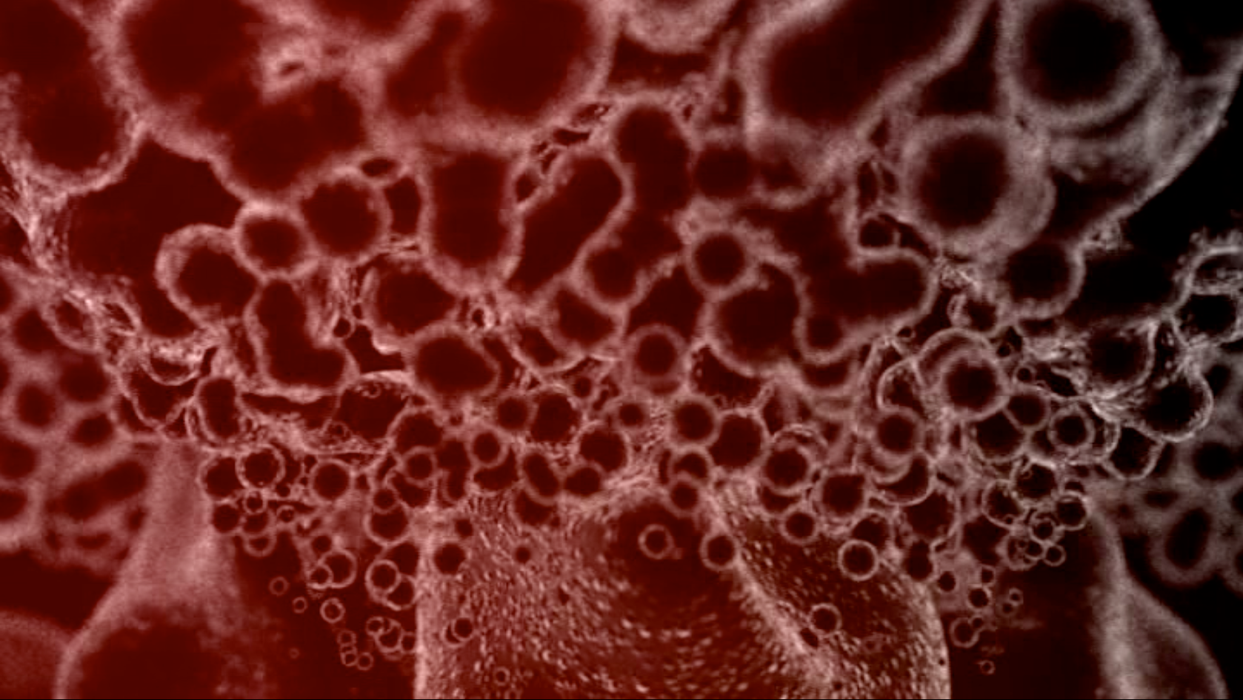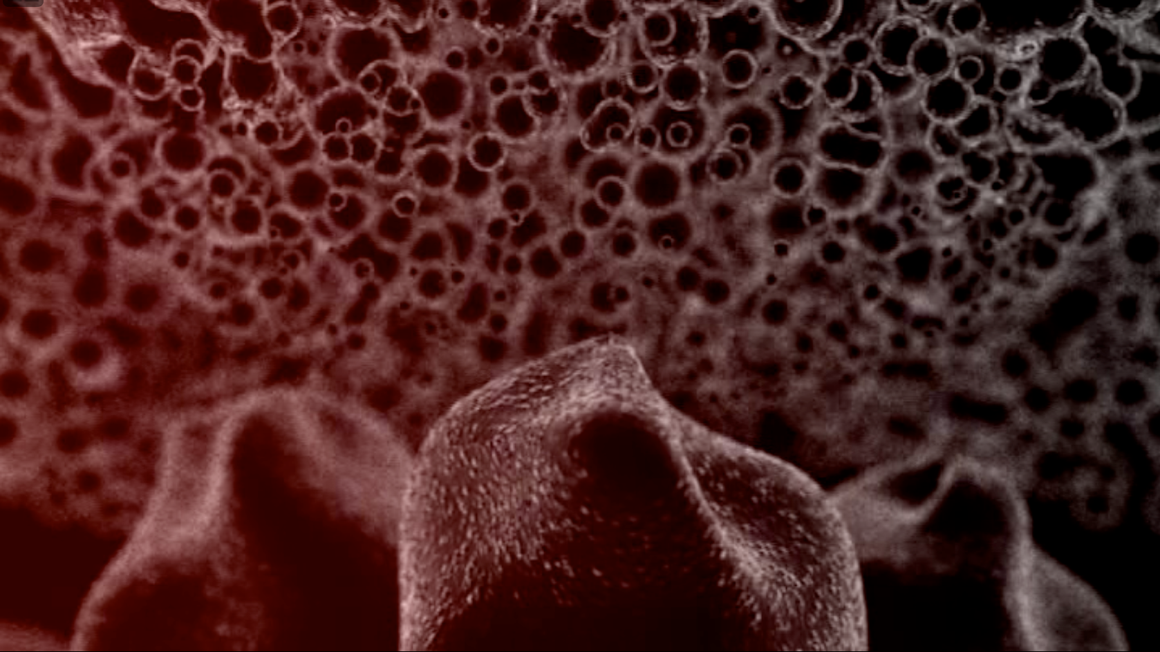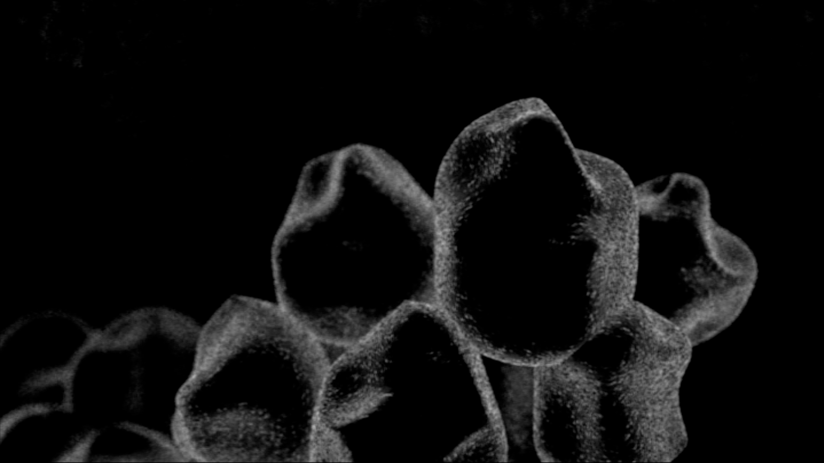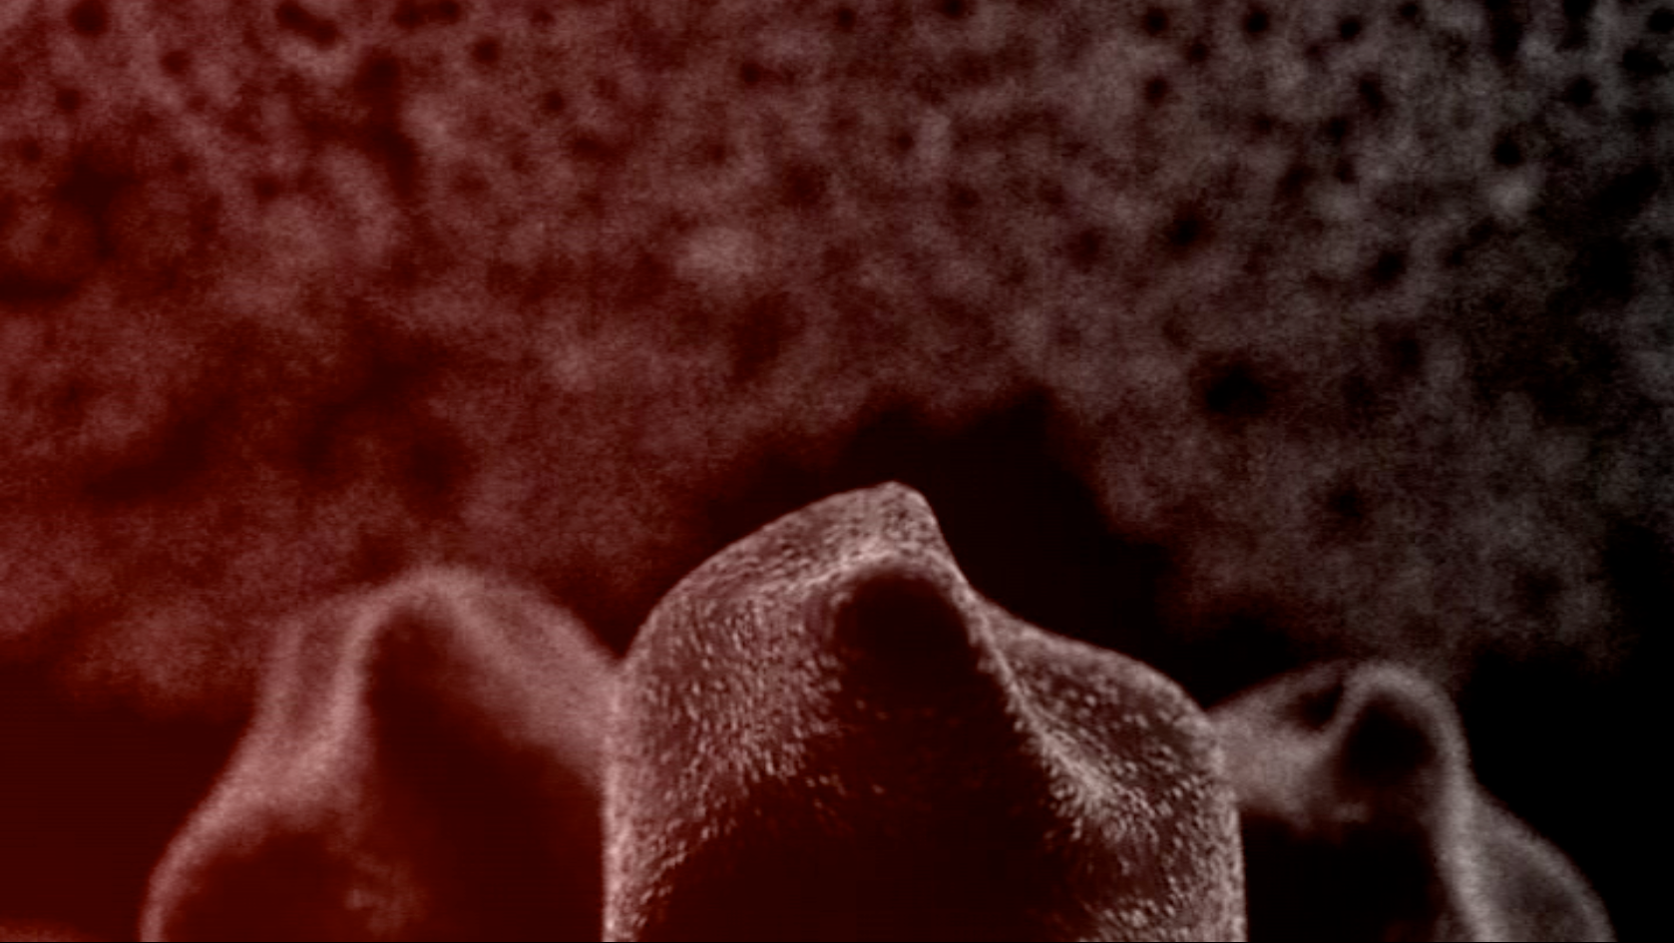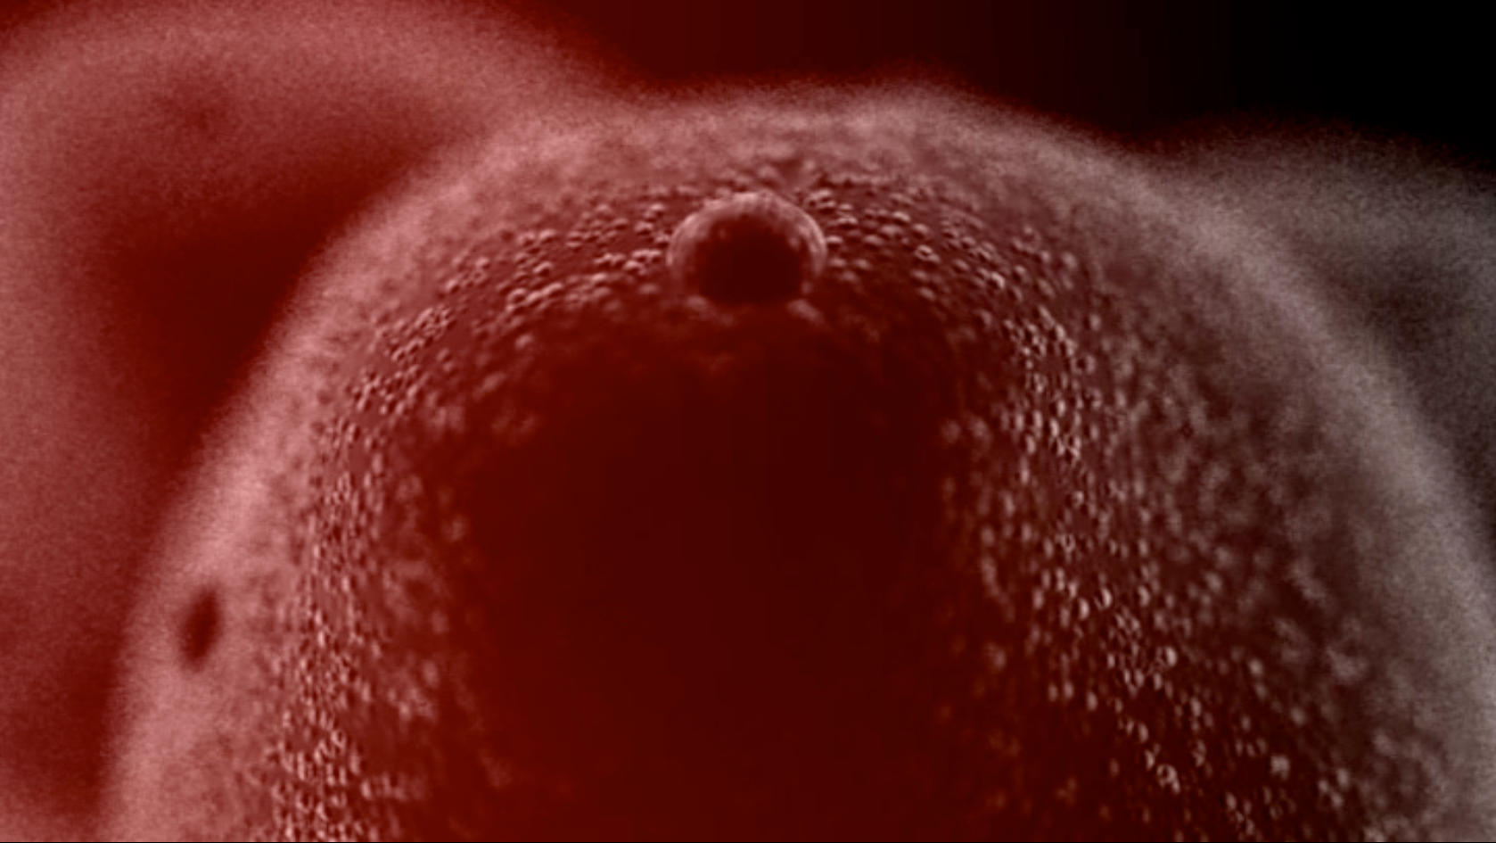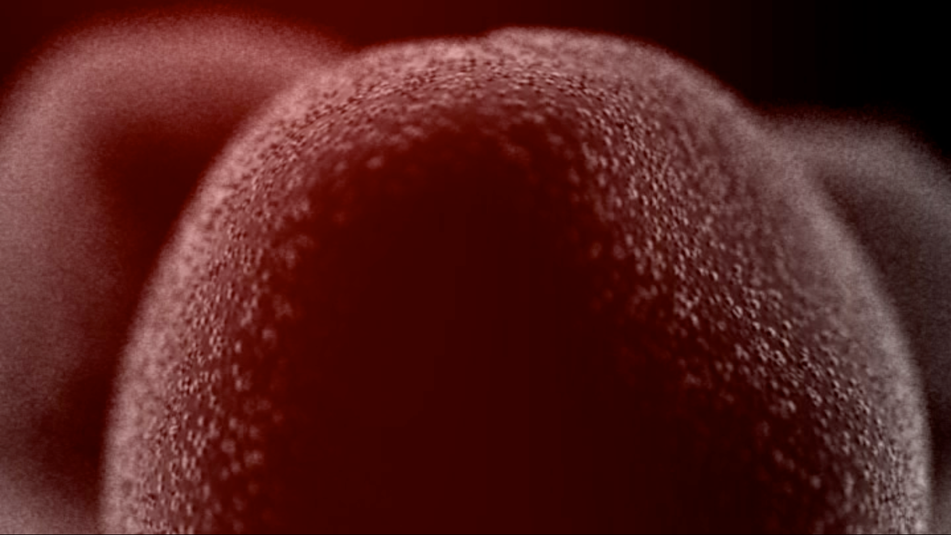Laser Energy safely penetrates the skin at a specific wavelength range of 630 to 680 nanometers targeting the adipos tissue or fat cells.

The Adipocytes receive the electromagnetic energy.

After a few minutes, transitory pores begin to form on the outside surface.

When enough energy is absorbed by the adipocytes, water, glycerol and free fatty acids begin to leak out through the pores and into the interstitial space.

As the adiposities release these substances into circulation, their size diminishes and the adiposities are left with a more uniform shape, resulting in inch loss and the appearance of cellulite.

