The Difference Between LipoLaser and the rest…
 | LipoLaser | Laser Liposuction | Liposuction | Lap-Band
 | (No Surgery) | (Like SonoBello or Smart Lipo) | (Traditional Surgery) | (Traditional Surgery)
 |  | 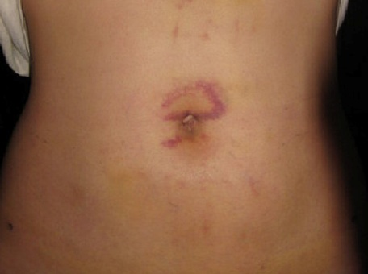 | 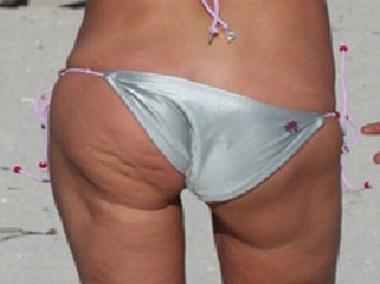 | 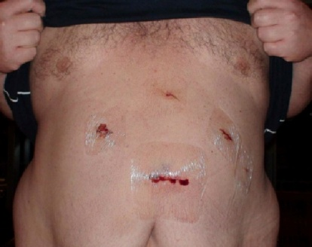
Use of Anesthesia | No Anesthesia | General or Local Anesthesia | General or Local Anesthesia | General Anesthesia
Risk | No Risk | Same as traditional liposuction, but can also include friction burns, damage to the skin and nerves, damage to vital organs | Bleeding, swelling, rapid heart rate from anesthesia, infection, fat or blood clots… clots can migrate to the lungs and lead to death | Same risks as any major surgery, such as death, also tears in the stomach wall, risks from the medications, nausea, vomiting, constipation, diarrhea
Recovery Time | No Recovery Time | Outpatient with recovery days | Outpatient with recovery days | Inpatient hospital stay 3 to 5 days
Fine Print | You have to do your part by utilizing the easy to follow diet, taking the supplements, drinking the water and doing WBV. | The fat cells in the area are permanently removed, so when you gain weight back, you gain it in strange new places. | Again, the fat cells in the area are permanently removed, so when you gain weight back, you gain it in strange new places. | The band can spontaneously deflate because of leakage. You can also suffer with an irritated stomach, heartburn, bloating and gas.
Prices | Ask about our special introductory offer! | $4,000 to $6,000 for the first area, $2,000 to $3,000 for each additional area. | $10,000 to $20,000 for the first area and $2,000 to $7,500 for each additional area. | $11,000 to $16,000 plus the costs of follow-up visits.
In short – There’s no health risk, no recovery time and it’s cheaper!!!!

