“Lose One to Two Pant Sizes in Just 3 Weeks!”
Come in for YOUR “FREE” VISIT to See How Much You Shrink!*
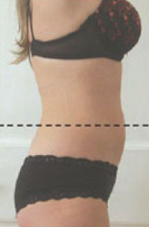
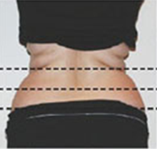
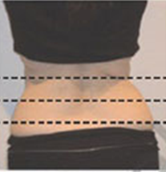
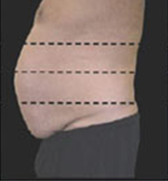
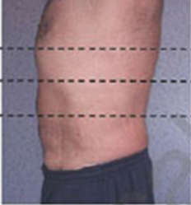
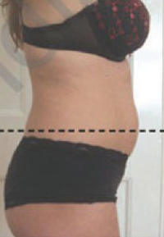


Brand New Technology As Seen on…
How Does This Work?
The laser energy safely penetrates the skin targeting the fat cells. Once the cells are permeated, they release fatty acids, water and glycerol (also known as triglycerides.) The triglycerides are released from the fat cells and the body uses them as an
energy source. The fat cells then “shrink” significantly resulting in inch loss.
Who is a Good Candidate?
If you have considered liposuction, but you don’t want the risks, side effects and downtime, this is a great option for you. Or if you are looking for a way to jumpstart and lose inches quickly, if you have love handles or a belly bulge that diet and exercise alone haven’t been able to get rid of, today is your lucky day! Call us now and schedule to come in to see if you qualify for this amazing new Laser Treatment!

What Are the Benefits of the Body Contouring Laser?
It’s non-surgical, non-invasive, safe, natural and pain-free. It has no side effects and effortlessly melts your fat. It is designed for FAT SPOT REDUCTION. You’ll have no downtime and you can target specific spots that exercise and diet alone can’t.
Is It Effective?
This new technology has produced amazing results. In double blind studies, patients lost an average of 3 to 7 inches of abdominal girth. In our office we are getting even better results with patients losing 3 to 9 inches!
Is It Affordable?
This amazing laser technology is a FRACTION of the cost of traditional Liposuction! It is also much less expensive than Laser Liposuction.
Is This Laser Treatment Safe?
Yes, it is safe, non-invasive and painless. This breakthrough laser mimics the effects of exercise by stimulating the adipose cells to release their fatty contents. This technology specifically targets those fatty areas wherever they occur in the body.
What Areas Can Be Treated?
Your waistline, abdomen, upper mid and lower back, buttocks, thighs, and arms.
Go CALL Now For Your
“FREE LipoLaser Treatment” Certificate

Call (222) 222-2222 and Mention this Ad
*Not Everyone Is A Candidate for LipoLaser .You Must First Have a Qualifying Evaluation.
(Limited FREE Appointments Available so Act Fast!)
Before & After Treatments:
Female, Age 33
Before & After Treatments:
Male, Age 37
Before & After Treatments:
Female, Age 48

