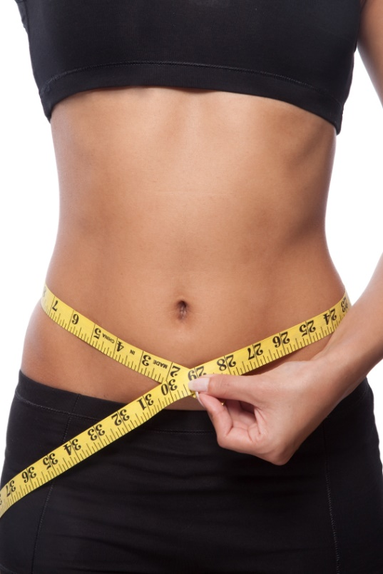
Tired of the “Bulges” that Exercise Alone Can’t Touch?
LipoLight
Treatments

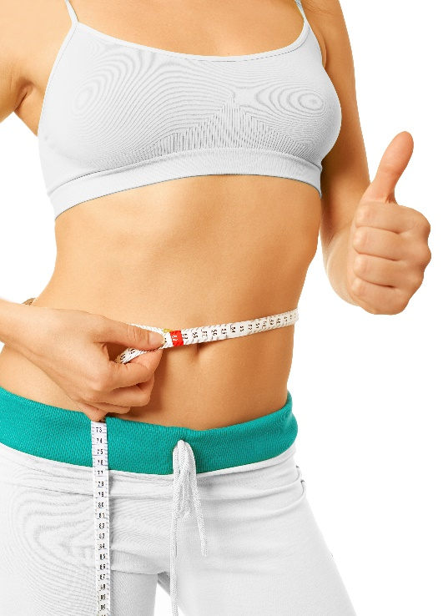

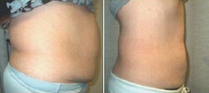


with
[Your Logo or
Clinic Name Here]
[Your Logo or
Clinic Name Here]
Before & After
This amazing Laser-Like Lipo Technology can deliver effective results in just one treatment! Unlike traditional liposuction, there is no pain, no bruising, no swelling, no drugs, and no downtime. In other words,
NO side effects whatsoever!
It’s safe, simple, and
affordable, and just
as relaxing as any
spa treatment!
You CAN Have the Body You’ve Always Wanted!
[Your Address]
[City, State, Zip]
[(555) 555-5555]
[YourWebsite.com]

Experience the Results for Yourself!
As Seen On:
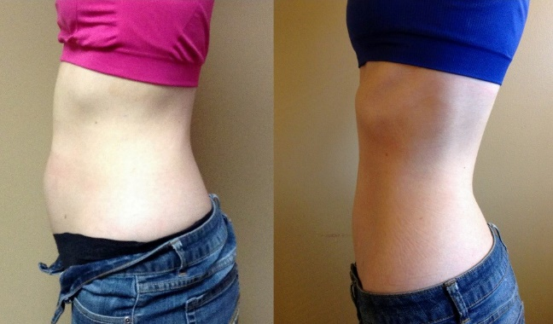
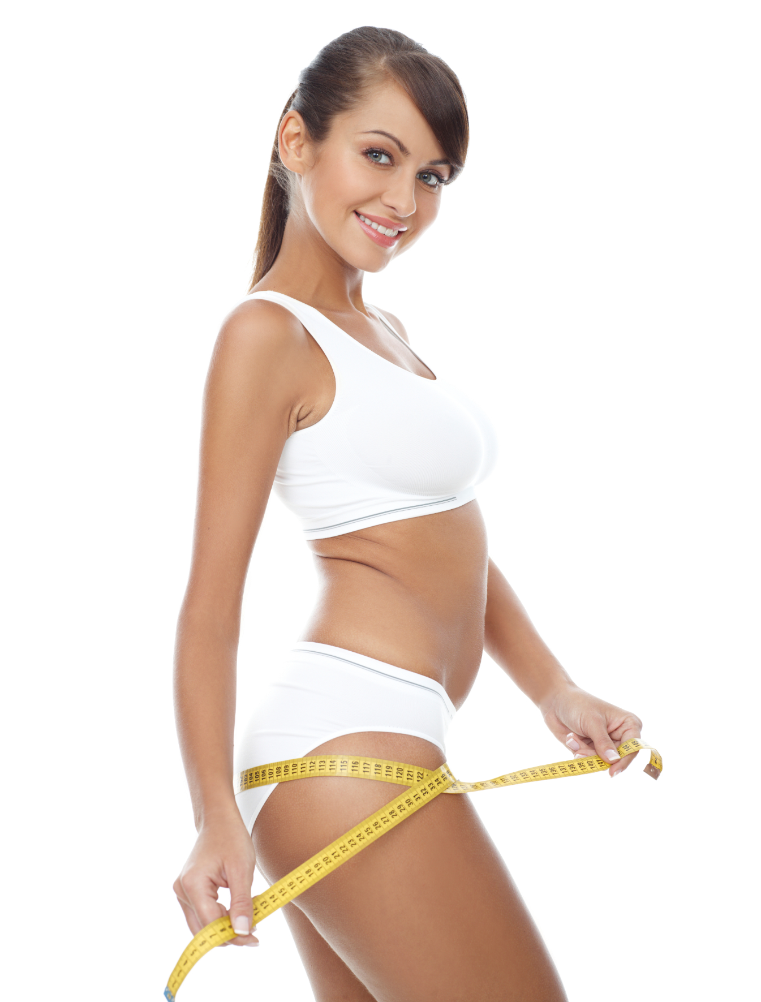

What Areas Can Be Treated?
Your waistline, abdomen, upper-, mid-, and lower-back, buttocks, thighs, and arms.

Who is a Good Candidate?
If you have considered liposuction, but you don’t want the risks, side effects and downtime, this is a great option for you. Or if you have love handles or a belly bulge that diet and exercise alone haven’t been able to get rid of, you’ve come to the right place!

How Does This Work?
The laser energy safely penetrates the skin targeting the fat cells. Once the cells are permeated, they release fatty acids, water and glycerol (also known as triglycerides.) The triglycerides are released from the fat cells and the body uses them as an energy source. The fat cells then “shrink” significantly resulting in inch loss.

What Are the Benefits of the Body
Contouring Laser?
It’s non-surgical, non-invasive, safe, natural and pain-free. It has no side effects and effortlessly melts your fat. It is designed for FAT SPOT REDUCTION. You’ll have
no downtime and you can target specific spots that exercise and diet alone can’t.

Is It Effective?
This new technology has produced amazing results. Practitioners and patients report an average loss of 3 to 7 inches of abdominal girth. In our office we are getting even better results with patients losing 3 to 9 inches!

Is This Laser Treatment Safe?
Yes, it is safe, non-invasive and painless.
This breakthrough laser mimics the
effects of exercise by stimulating the
adipose cells to release their fatty
contents. This technology
specifically targets those fatty areas
wherever they occur in the body.

Before & After

