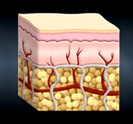
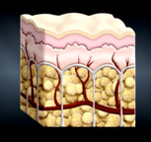
Reduction of Cellulite
after LipoLaser Treatment
Cellulite before LipoLaser Treatment

The laser energy safely penetrates the skin targeting the fat cells (Subcutaneous layer). Once the cells are permeated, they release fatty acids, water and glycerol, or triglycerides. The triglycerides are released from the fat cells and the body uses them as an energy source. The fat cells then “shrink” significantly resulting in inch loss and the removal of cellulite.
Where does the fat go?

