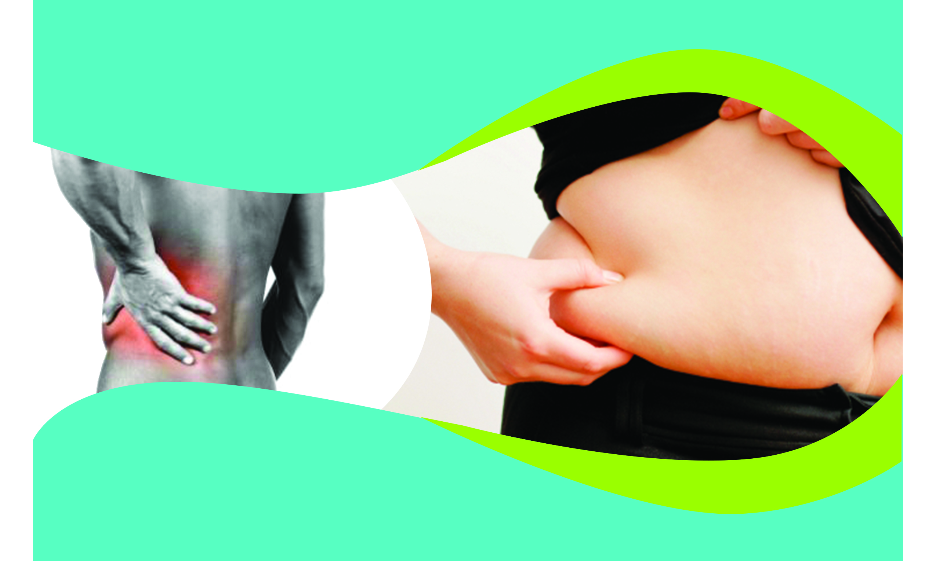
Dr. Smith has spent years practicing, researching,
studying, and helping patients get out of pain.

Now his research and studies have uncovered a
Breakthrough Weight Loss System…
Which is Finally Available to YOU!

Who Else Wants to Lose Belly Fat and Pain?
Attend a FREE SEMINAR to learn about new Breakthrough Technology that shows YOU specifically how to “finally lose your weight and keep it off!”

Seating is extremely limited for this popular seminar, so act fast!
Sign Up Today at the Front Desk!
or go to
www.DrSmith.WeightSeminar.com
Dr. Smith Can Now Help
You With Both!

