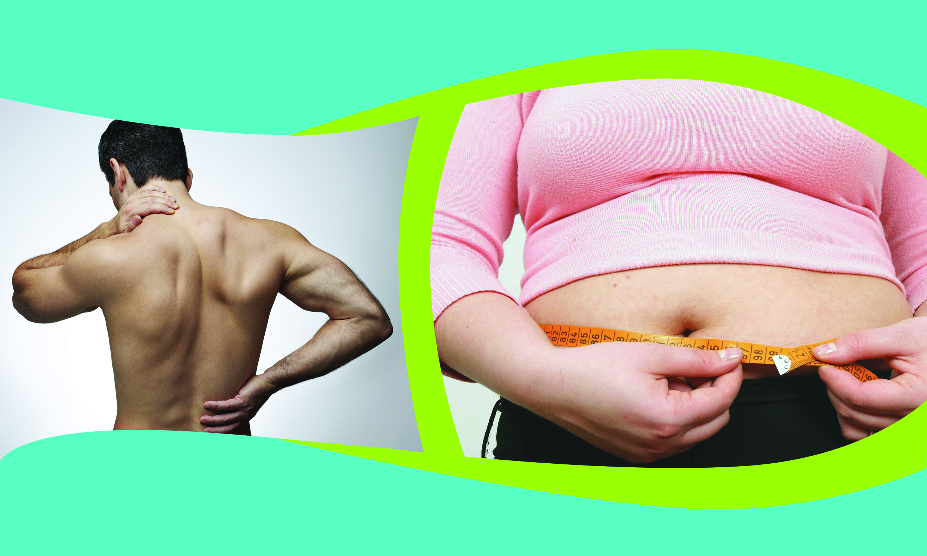
We Helped Your Spine…
Now We Can Help You Lose Weight Too!
Could Your Back Pain Be
Tied To Your Weight?
Dr. Smith has helped rid your body of pain… Now he can help rid your body of excess weight too!

Now his research and studies have uncovered a
Breakthrough Weight Loss System…
Which is Finally Available to YOU!

Attend a FREE SEMINAR to learn about this new Breakthrough Technology that shows YOU specifically how to “finally lose your weight and keep it off!”

Seating is extremely limited for this popular seminar, so act fast!
Sign Up Today at the Front Desk!
or go to
www.DrSmith.WeightSeminar.com

