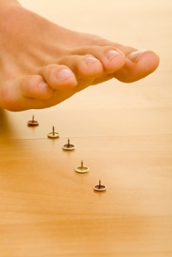

Do you suffer from any of the following…
- Numbness of your feet
- Painful tingling feet
- Night-time discomfort
- Pin-like sensation with each step
Have you ever been told…
- You have Neuropathy
- Live with the pain, nothing can be done
If you answered YES to any of these questions, you’re in LUCK!
Hi, I’m Dr. (your name) and every day I see patients in my office who have suffered for years from neuropathy and are finally getting relief!
I will explain to you why you are having this problem in the first place and what you can do to reverse this degenerative nerve disease and eliminate your numbness, tingling, and pain.
Join me HERE
at my FREE seminar:
Living with Neuropathy Pain?

