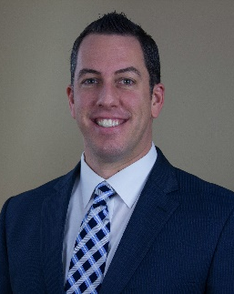
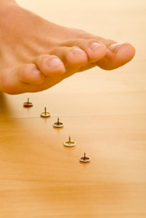

If you answered YES to any of these questions, you’re in LUCK!
Hi, I’m Dr. Chad Goodman and every day I see patients in my office who have suffered for years from neuropathy and are finally getting relief!
I will explain to you why you are having this problem in the first place and what you can do to reverse this degenerative nerve disease and eliminate your numbness, tingling, and pain.
For more information, or to schedule an appointment, call my office at:
(801) 265-3400
Lighthouse Health & Body Makeover • 715 E. 3900 S. #107 • Salt Lake City, UT 84107
Do you suffer from any of the following…
- Numbness of your feet
- Painful tingling feet
- Night-time discomfort
- Pin-like sensation with each step
Have you ever been told…
- You have Neuropathy
- Live with the pain, nothing can be done
Living with Neuropathy Pain?

