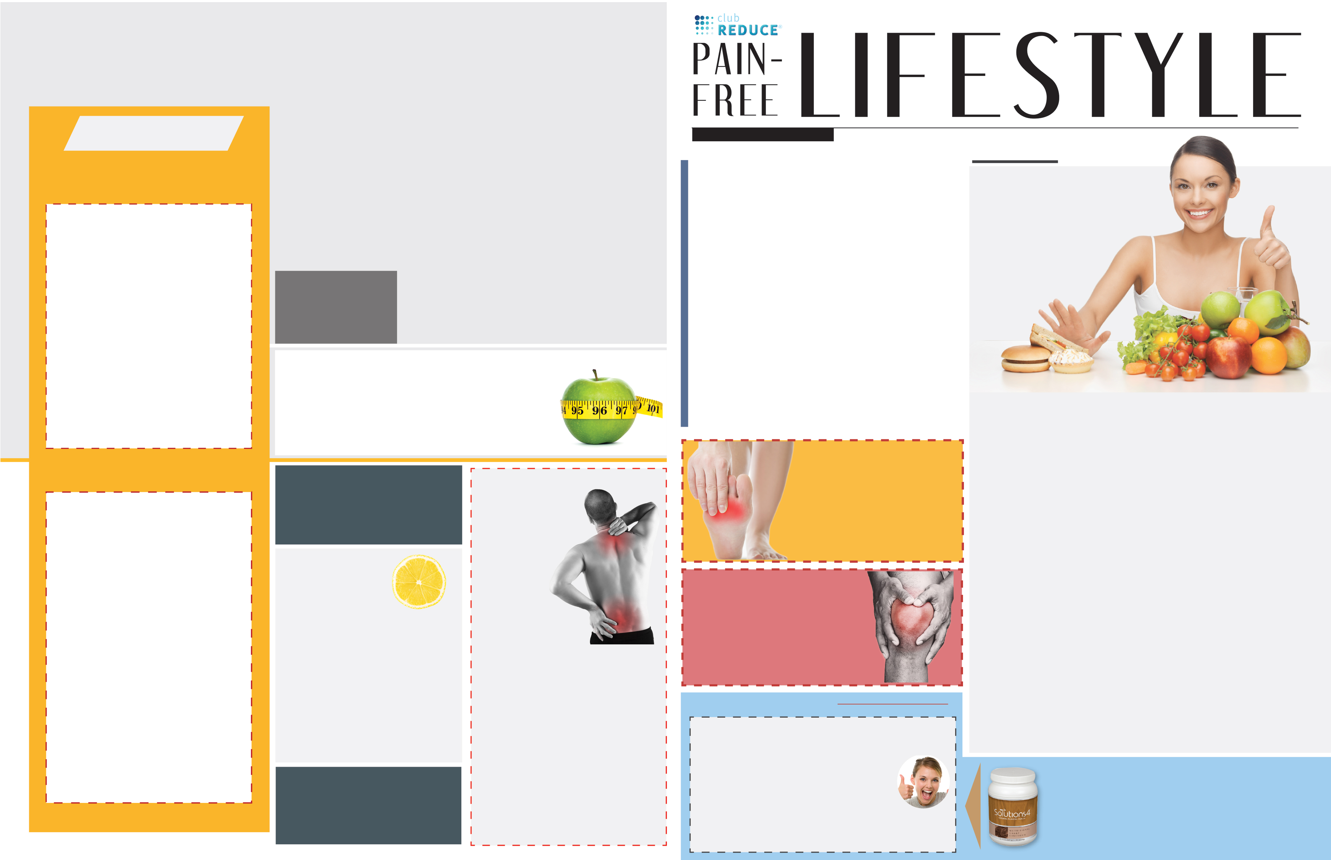
Tt
All you have to do is give them this Free Evaluation coupon! When they bring it in, we will contact you and you’ll get a FREE Solutions 4 Nutritional Shake!
Refer a Friend Today for a
FREE Nutritional Shake
THE INSIDE STORY

The world we live in provides us with junk food at almost every corner. Grocery stores are filled with packaged, boxed, canned, and processed foods that are loaded with harmful additives and preservatives. Though most of these foods have little nutritional value, we continue to eat them, day in and day out. Americans eat an alarming average of 3,800 calories each day and consume only 7% of their calories from fruits and vegetables. On top of all this, the average American drinks 600 cans of soda each year. With a diet like this, it’s no wonder that Americans are so overweight! If you need even more motivation to change your diet, keep reading…

Sugar Makes You Sick
If you seem to come down with every cold that goes around, it’s time to reflect on what you eat. If you’re eating refined sugar, you’ve found your culprit! Refined sugar wreaks havoc on the immune system and makes your body more susceptible to illness and disease. The ingestion of only 100 grams of refined sugar reduces the immune system’s function by 50% within two hours of eating!

Refined Grains Make You Fat
The saying that “the whiter the bread, the sooner you’re dead” isn’t far off. When it comes to weight gain, refined carbohydrates are the real culprit. These empty calories end up directly on your body as fat. And refined grains are everywhere! Refined grains are used to make bread, pasta, cookies, breakfast cereals, crackers, and other snack foods.
I had an amazing experience
with [Dr. So-and-so] at
[Your Clinic Name Here], and I know you
will too! They have some incredible solutions
for neuropathy and back pain.

Present this coupon and receive a [FREE
One-On-One 7-Point Evaluation] with the doctor.

To Schedule an Appointment for the FREE Evaluation,
Call [555-555-1234] Today!

The Inside Story: “Top 6 Reasons to Give Up Processed Food This Summer!”

Product Spotlight + Coupon: Solutions4
Children’s Shake!

This Month’s Pain Free Patient:
Congratulations Ron

Ask a Doctor: “How do processed foods
Interfere with the healing process

Break Time: Sudoku and a Tropical Green
Smoothie Recipe!

Sidebar: “5 Ways to Avoid Gaining Weight
on Vacation!”

Event Listings & Information

What’s Inside?
PAIN-FREE LIFESTYLE
Find the
Lemon!

Find the hidden lemon somewhere in this newsletter! Be the first one to find it and we’ll give you a FREE SMT Treatment (valued at $50)! Call [Your Clinic Name Here (555) 555-1234] to redeem your prize!

*This prize is non-transferable and cannot be exchanged for product.

Winner will be drawn on August 31st
Call Our Office to Find Out How You Can Win!
August Monthly Promotion
Win an SMT MindFit
REJUVENATION CLASS
[Offered Twice Weekly, Every Tues. & Wed.]

This Breakthrough Rejuvenation Class will teach you how to get better sleep, have more energy, lose weight, reduce your stress levels, and maintain a positive outlook in life! You’ll be able to make big changes in your life based on the information you receive in this class alone. Come alone or bring a friend. Register online at [subdomain.weightseminar.com!]

Dates

[Tuesday, Aug. 4, 12:30 PM Wednesday, Aug. 5, 6:30 PM
Tuesday, Aug. 11, 6:30 PM Wednesday, Aug. 12, 6:30 PM
Tuesday, Aug. 18, 6:30 PM Wednesday, Aug. 19, 12:30 PM
Tuesday, Aug.25, 6:30 PM Wednesday, Aug. 26, 6:30 PM]

Call us at [555-555-1234] to learn
more! For a limited time only,
we’re offering this Breakthrough
Rejuvenation Class for FREE!

Bring a friend with you to [Your Clinic Name Here] Breakthrough Rejuvenation Class, and you will both receive FREE Body Wraps!

If you haven’t attended our Breakthrough Rejuvenation Class, now is a great time to come! If you have already been in, come for a refresher class!

Bring in this newsletter with a first-time guest, and you’ll both receive a FREE Body Wrap in our clinic!

We look forward to seeing you soon!

Register Online at SubdomainWeightSeminar.com or
Call [555-555-1234] Now!

*Offer expires 8/31/2016
*Coupon has no cash value.
*Guest body wrap for new patients only.
HEALTH AND WELLNESS EVENTS
August Events
“He who takes medicine and neglects his diet wastes the skill of his physicians.” – Chinese Proverb

Top 6 reasons to give up
Processed Food
This summer

[Your Clinic’s Name Here]
[Address]
[Hours]
[Phone Number]

RETURN SERVICE REQUESTED



Finally get help with the pain, tingling, and numbness
In your feet!

If you’re suffering from neuropathy,
we can help!
Pick up the phone and
call [555-555-5555] now!

Bring in this coupon and receive
a FREE One-on-One Evaluation!

vv
FREE BODY WRAP COUPON

[Your Clinic’s Name Here]
[Address]
[Hours]
[Phone Number]

RETURN SERVICE REQUESTED

FREE Back
& Neck Pain
Evaluation!
[Expires 8/30/2017]

Help Has Arrived for
Excruciating
Back and Neck Pain!

We’re so sure we can help you resolve your pain with affordable solutions that we have a special offer for those who suffer from serious back and neck pain and pain related to a herniated or bulging disc.

To take advantage of this offer: call our office at [555-555-1234] and
mention this ad!

Learn more at [Website Here]

Get rid of your KNEE PAIN without drugs
Or surgery!

Don’t live with your pain for another day! Call [555-555-5555] now to set up you’re FREE
Evaluation!

Rewards for Referrals

Make Sure to Bring a Friend
and Join Us for These
Free In-Office
Club Reduce Events!


This Month’s Pain Free Patient:
Top 6 reasons to give up
Processed Food
This summer
Healthy Tip:

To help your body heal more quickly, get more sleep. When you’re asleep, your body does its most important healing work. Don’t neglect it!
Meet Ron: Halfway through his program, the shooting pains and cramps in his legs have completely disappeared!

5 Ways to Avoid
Gaining Weight on
Vacation!
Now that summer is in full-swing, vacation season is here. When you’re traveling, it can be challenging to find healthy options along the way. Use these tips to keep unwanted pounds
at bay!

WHAT WAS LIFE LIKE BEFORE YOUR PROGRAM?
“Before I started my program, I was suffering from neuropathy caused by diabetes. I had shooting pains down my leg and would get cramps at night while I was asleep.”

HAS YOUR LIFE CHANGED AT ALL SINCE YOUR PROGRAM?
“So far, I’m halfway through my program, and I’ve seen some good improvements. The shooting pains and cramps have completely disappeared, and the numbness is about 50% gone. Since I’ve been on this program, I’ve been able to come off of my insulin and my blood sugar is exactly what it should be. It’s a great program, and it’s worked for me! I would recommend it to anyone who suffers from similar problems.”

Use the Nutritional Shake
Using the Nutritional Shake will leave you free to enjoy your trip without constantly worrying about what you’ll eat next! It’s now available in single-serve packs that you can take with you wherever you go.

Plan Ahead
Locate restaurants with healthy options or find ways to prepare your own food. If you’re going to eat out, call ahead to find out what’s on the menu. Many restaurants even have their menus
available online!

Avoid Dining-Out Disasters
It isn’t easy to find healthy options in restaurants, and it’s even harder to find “healthy” options that are really as good as they claim. Consider talking to the chef to find out what’s really in the food.

Pack Meals To-Go
If you’re driving to your destination, bring healthy food with you in a cooler. You can have plenty of food ready to eat at a moment’s notice!

When in Doubt, Eat a Salad
Salads are generally quite healthy, and they’re also widely available. Many grocery stores have salad bars or ready-to-eat lettuce mixes that only require dressing and toppings. Most restaurants have a salad on the menu too!

PROCESSED MEATS CONTRIBUTE TO CANCER
Your choice to eat double-bacon cheeseburgers for lunch may eventually prove deadly. Much of the meat you find in a fast food establishment is laced with antibiotic and hormone residues, preserved with carcinogenic nitrates, and “flavored” with a variety of questionable chemicals. These substances increase your risk of dying from cancer by as much as 43%! Choosing to eat these types of meat – even in moderation – is a risky business. .

DAIRY MAKES YOU SLUGGISH
Create a rewards system! Do something (non-food related) when you reach each weight loss milestone. Get a massage or buy a new dress for an upcoming party! Consider trying something you couldn’t do before you lost weight.
Celebrate your success!

TRANS FATS HURT YOUR HEART
Studies show that cutting trans fats out of the American diet would prevent as many as 20,000 heart attacks and 7,000 coronary heart disease deaths each year. These numbers are startling, especially considering that trans fats are found in almost all processed foods, baby formulas, non-dairy creamers, and salad dressings. Trans fats are dangerous because they oxidize rapidly in the digestive system, releasing a deadly bombardment of free radicals that destroy cells and cause widespread damage.

MSG IS BAD FOR YOUR BRAIN
MSG is used to enhance the flavor of foods, making cheap ingredients taste delicious. Though many people report that they experience adverse reactions to MSG immediately upon eating, most people experience a slower onset of more insidious symptoms. In the long-term, MSG can damage your neurons and increase your risk of developing conditions like Alzheimer’s and Parkinson’s disease. This happens because MSG is an exitotoxin – a substance that overstimulates brain
cells to the point of death.

Did You
Know…?

You can save 10% on all your favorite Solutions4 supplements when you order online?

Ask a staff member for details on how you can take advantage of this amazing offer!

We can’t wait to feature YOU as next month’s Pain-Free Patient! Keep setting your goals and working hard and you could be featured here!

August’s Featured Solutions4 Product: Quick Start Kits!

The 7-Day Quick Start Cleanse and Quick Start Weight Loss Kits make it quick and easy to
achieve optimal health! With these two kits – and the Solutions4 Nutritional Shake – you’ll have everything you need to deep clean your body and heal from chronic pain! As an added benefit, you’ll lose weight while you’re at it.

With the 7-Day Quick Start Cleanse, you’ll get a 7-day supply of powerful detoxifying supplements and Essential Greens (a convenient powdered beverage). The supplements help to flush all of the toxins out of your system while the greens provide your body with energizing nutrients. With the Quick Start Weight Loss Kit, you’ll get a 14-day supply of supplements designed to reduce cravings, speed up your metabolism, and facilitate healthy weight loss.

For best results, we recommend that you use these kits together to create a 21-day program. Using this system, you would complete a 7-day cleanse followed by a 14-day weight loss program (all while using the Nutritional Shake). Use the coupon below for a special discount! the Nutritional Shake). Use the coupon below for a special discount!

You can always find more detailed information about Solutions4 products on your Club Reduce membership site.

Ask a
Doctor

“How do processed
foods interfere with
the healing process?”

Processed foods interfere with the
healing process in several different
ways. Let’s discuss the top three:

1. Toxins Do Further Damage.
When you devour a bowl of sugary breakfast cereal, you probably don’t think about all of
the additives and preservatives used to create the uniquely addictive flavor you expect.
Unfortunately, many of these additives are harmful to human health. For example, most breakfast cereals contain Trisodium Phosphate
– an industrial solvent used in dishwasher detergents and toilet bowl cleaners!

2. Your Body Becomes Unable to Eliminate Toxins. When you consume too many toxins from processed foods, your body decides to put them into long-term storage, rather than eliminating them right away. This build-up of toxins makes it increasingly difficult for your body to heal quickly and efficiently.

3. Processing Toxins Takes Energy Away From Healing. Your body needs a certain amount of downtime to be able to heal effectively. When your body is busy processing incoming toxins, it doesn’t have time to make repairs. The work of healing takes time
and energy.

“Life is not merely to be alive, but to be well.”
Break time

Tropical Green Smoothie

Green smoothies are a great way to maximize your nutritional intake in the most delicious way possible. This smoothie provides your full daily value of vitamin A, vitamin C, vitamin K, and manganese! For all of its nutritional value, it tastes a lot like a piña colada. It’s also super quick and easy to make for breakfast!

Ingredients:
2 cups fresh spinach
2 cups coconut water
1 cup chopped pineapple
1 cup chopped mango
2 bananas
Ice (for desired thickness)

Directions:
1. Put all ingredients in a blender and puree
until smooth.
2. Add ice until you reach your desired
consistency.
3. Pour into glasses, serve, and enjoy!

$2 Off Quick Start Cleanse!

Bring this Coupon in to Receive $2 OFF
the 7-Day Quick Start Cleanse!
Cannot be combined with any other offer.

Coupon expires 08/31/2016

