
PAIN-FREE
LIFESTYLE
[Your Clinic Name Here]
[Address]
[Hours]
[Phone Number]
Make sure to Bring a Friend and Join Us for These Free In-Office Events!
------------- The Inside Story

[Patient Name]
[Address]

August 2018
What’s Inside:
The Monthly Dish: “Top 6 Reasons to Give Up Processed Food This Summer!”
Product Spotlight + Coupon: Solutions4 Quick Start Kits!
This Month’s Pain Free Patient: Congrats Ron!
Ask A Doctor: “How do processed foods interfere with the healing process?”
Break Time: Sudoku and a Tropical Green Smoothie Recipe
Sidebar: “5 Ways to Avoid Exacerbating Your Pain on Vacation!”
Event Listings & Information

Top 6 Reasons to Give Up Processed Food This Summer!


The world we live in provides us with junk food at almost every corner. Grocery stores are filled with packaged, boxed, canned, and processed foods that are loaded with harmful additives and preservatives. Though most of these foods have little nutritional value, we continue to eat the, day in and day out. Americans eat an alarming average of 3,800 calories each day and consume only 7% of their calories from fruits and vegetables. On top of that, the average


Get rid of your KNEE PAIN without drugs or surgery!
Don’t live with your pain for another day! We can help. Call our office to schedule a FREE Evaluation.
American drinks 600 cans of soda each year. With a diet like this, it’s no wonder that Americans are so overweight! If you need even more motivation to change your diet, keep reading…
1. Sugar makes you sick.
If you seem to come down with every cold that goes around, it’s time to reflect on what you eat. If you’re eating refined sugar, you’ve found your culprit! Refined sugar wreaks havoc on the immune system and makes your body more susceptible to illness and disease. The ingestion of only 100 grams of refined sugar reduces the immune system’s function by 50% within two hours of eating!
2. Refined grains make you fat.
The saying that “the whiter the bread, the sooner you’re dead” isn’t far off. When it comes to weight gain, refined carbohydrates are the real culprit. These empty calories end up directly on your body as fat. And refined grains
Find the Lemon!

Find the hidden lemon somewhere in this newsletter! Be the first one to find it and we’ll give you a FREE SMT Treatment! Normally valued at $50! Call our office to redeem your prize!
*This prize is non-transferable and cannot be exchanged for product.
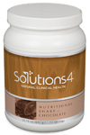

Rewards for Referrals
We have a mission to help our entire community live happier and healthier lives. Refer a friend today and we’ll reward you with a FREE Nutritional Shake!

To: _______________________________________
From: _____________________________________
I had an amazing experience at my doctor’s office and I know you will too! They have some incredible solutions for neuropathy and back pain.
Present this coupon and receive a FREE EVALUATION with the doctor.
August Events
FREE BACK & NECK PAIN EVALUATION
WEIGHT LOSS EVENT

Help Has Arrived for Excruciating Back and Neck Pain!

REJUVENATION CLASS
Offered weekly

This Breakthrough Rejuvenation Class will teach you how to get better sleep, have more energy, lose weight, reduce your stress levels, and maintain a positive outlook in life! You’ll be able to make big changes based on the information you receive in this class alone. Come alone or bring a friend!
Call our office for dates and times, and to register for a spot!


Neuropathy Sufferers!
are everywhere! Refined grains are used to make bread, pasta, cookies, breakfast cereals, crackers, and other snack foods.

See page 2 for more….


If you suffer from serious back and neck pain or pain related to a herniated or bulging disc, we can help you resolve it! Call our office to take advantage of this offer.

Finally get help with the pain, tingling, and numbness in your feet!
If you’re suffering from neuropathy, we can help! Call our office to schedule a FREE EVALUATION.
“He who takes medicine and neglects his diet wastes the skill of his physicians.” – Chinese Proverb
This month’s winner will receive
FREE LIPOLIGHT SESSIONS!
5 Ways to Avoid Exacerbating Your Pain on Vacation!

Meet Ron – Halfway through his program, the shooting pains and cramps in his legs have completely disappeared!
are dangerous because they oxidize rapidly in the digestive system, releasing a deadly bombardment of free radicals that destroy cells and cause widespread damage.
6. MSG is bad for your brain.
MSG is used to enhance the flavor of foods, making cheap ingredients taste delicious. Though many people report that they experience adverse reactions to MSG immediately upon eating, most people experience a slower onset of more insidious symptoms. In the long0term, MSG can damage your neurons and increase you risk of developing conditions like Alzheimer’s and Parkinson’s disease. This happens because MSG is an excitotoxin – a substance that overstimulates brain cells to the point of death.
for humans. It may make you feel sluggish, upset your stomach, or cause you to produce excess mucus. You may be in such poor health that you don’t even notice when dairy affects you in this way! Even if you don’t react poorly to dairy, most of the dairy products you find at the store are loaded with fillers, chemicals, and preservatives.
5. Trans fats hurt your heart.
Studies show that cutting trans fats out of the American diet would prevent as many as 20,000 heart attacks and 7,000 coronary heart disease deaths each year. These numbers are startling, considering that trans fats are found in almost all processed foods, baby formulas, non0dairy creamers, and salad dressings. Trans fats
3. Processed meats contribute to cancer.
Your choice to eat double-bacon cheeseburgers for lunch may eventually prove deadly. Much of the meat you find in a fast food establishment is laced with antibiotic and hormone residues, preserved with carcinogenic nitrates, and “flavored” with a variety of questionable chemicals. These substances increase your risk of dying from cancer by as much as 43%! Choosing to eat these types of meat – even in moderation – is a risky business.
4. Dairy makes you sluggish.
Because cow’s milk is designed for baby cows, it isn’t an ideal source of food
This Month’s Skinny Star
“Top 6 Reasons to Give Up Processed Food…” – From Page 1
Healthy Tip:

WHAT WAS LIFE LIKE BEFORE YOUR PROGRAM?
“Before I started my program, I was suffering from neuropathy caused by my diabetes. I had shooting pains down my leg and would get cramps at night while I was asleep.”
HOW HAS THIS PROGRAM CHANGED YOUR LIFE?
“So far, I’m halfway through my program, and I’ve seen some good improvements. The shooting pains and cramps have completely disappeared, and the numbness is about 50% gone. Since I’ve been on this program, I’ve been able to come off me insulin and my blood sugar is exactly what it should be. It’s a great program, and it’s worked for me! I would recommend it to anyone who suffers from similar problems.”
To help your body heal more quickly, get more sleep. That’s when your body does most of its healing work!
Now that summer is in full swing, vacation season is here. When you’re traveling, it can be challenging to find healthy options along the way. Use these tips to avoid exacerbating your pain while you’re on the road!
1. Use the Nutritional Shake.
Using the Nutritional Shake will leave you free to enjoy your trip without constantly worrying about what you’ll eat next! It’s available in single-serve packets that you can take with you wherever you go.
2. Plan Ahead.
Locate restaurants with healthy options or find ways to prepare your own food. If you’re going to eat out, call ahead to find out what’s on the menu. Many restaurants even have their menus available online!
3. Avoid Dining-Out Disasters.
It isn’t easy to find healthy options in restaurants, and it’s even harder to find “healthy” options that are really as good as they claim. Consider talking to the chef to find out what’s really in the food.
4. Pack Meals To-Go.
If you’re driving to your destination, bring healthy food with you in a cooler. You can have plenty of food ready to eat at a moment’s notice!
5. When in Doubt, Eat a Salad.
Salads are generally quite healthy, and they’re also widely available. Many grocery stores have salad bars or ready-to-eat lettuce mixes that only require dressing and toppings. Most restaurants have a salad on the menu too!

Did You Know…?

You can save up to 10% on all your favorite Solutions4 supplements when you order online!
Ask a staff member for details on how you can take


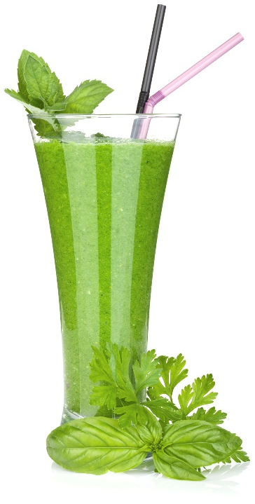
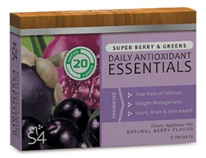

“Life is not merely to be alive, but to be well.”
Break Time
August’s Featured Solutions4 Product: Quick Start Kits!
1. Toxins Do Further Damage. When you devour a bowl of sugary breakfast cereal, you probably don’t think about the additives and preservatives used to create the uniquely addictive flavor you expect. Unfortunately, many of these additives are harmful to human health. For example, most breakfast cereals contain Trisodium Phosphate – an industrial solvent used in dishwasher detergents and toilet bowl cleaners!
2. Your Body Becomes Unable to Eliminate Toxins. When you consume too many toxins from processed foods, your body decides to put them into long-term storage, rather than eliminating them right away. This buildup of toxins makes it increasingly difficult for your body to heal quickly and efficiently.
3. Processing Toxins Takes Energy Away from Healing. Your body needs a certain amount of downtime to be able to heal effectively. When your body is too busy processing incoming toxins, it doesn’t have time to make repairs. The work of healing takes time and energy.
Ask a Doctor
We can’t wait to feature YOU as next month’s Skinny Star! Keep setting your goals and working hard and you could be featured here!
advantage of this amazing offer!


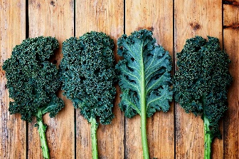
Tropical Green Smoothie!


“How do processed foods interfere with the healing process?”
Processed foods interfere with the healing process in several different ways. Let’s discuss the top three:

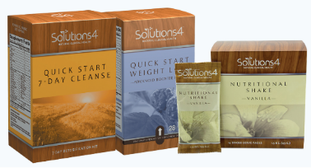

The 7-Day Quick Start Cleanse and Quick Start Weight Loss Kits make it quick and easy to achieve optimal health! With these two kits – and the Solutions4 Nutritional Shake – you’ll have everything you need to deep clean your body and heal from chronic pain. As an added benefit, you’ll lose weight while you’re at it. With the 7-Day Quick Start Cleanse, you’ll get a week’s supply of powerful detoxifying supplements and Essential Greens. The supplements help flush the toxins from your system while the greens provide you with energizing nutrients. With the Quick Start Weight Loss Kit, you’ll get a 14-day supply of supplements designed to reduce cravings, boost your metabolism, and facilitate healthy weight loss. For best results, we recommend that you use these kits together to create a 21-day program. Using this system, you would complete the cleanse first followed by the 14-day weight loss (all while using the Nutritional Shake).
Green smoothies are a great way to maximize your nutritional intake in the most delicious way possible. This smoothie provides your full daily value of vitamin A, vitamin C, vitamin K, and manganese! For all its nutritional value, it tastes a lot like a piña colada!
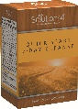
$2 off Quick Start Cleanse!
Bring this Coupon in and Receive $2 OFF this product!

Coupon expires 8/31/2018
Ingredients:
--2 cups fresh spinach
--2 cups coconut water
--1 cup chopped pineapple
--1 cup chopped mango
--2 bananas
--Ice (for desired thickness)

Directions:
1. Put all ingredients in a blender and puree until smooth.
2. Add ice until you reach your desired consistency.
3. Pour into glasses, serve, and enjoy!

