
LIFESTYLE
[Your Clinic Name Here]
[Address]
[Hours]
[Phone Number]
Pain-Free
Make sure to Bring a Friend and Join Us for These Free In-Office Club Reduce Events!

[Patient Name]
[Address]

November 2018
What’s Inside Pain-Free Lifestyle:
------------- The Inside Story
6 Reasons Why You Should Avoid Overeating This Thanksgiving!
The Inside Story: “6 Reasons Why You Should Avoid Overeating This Thanksgiving!”
Product Spotlight + Coupon: S4 Digestive Enzyme Blend!
This Month’s Pain-Free Patient: Congrats Eugene!
Break Time: Sudoku and a Pumpkin Spice Smoothie Recipe!
Ask Dr. Goodman: “I always overeat on Thanksgiving. What can I do to curb my cravings?”
Sidebar: “5 Sneaky Ways to Eat More Vegetables This Thanksgiving!”
Event Listings & Info


If you’re like millions of other Americans, Thanksgiving means eating until you’re so uncomfortable that you can’t stand the thought of food. But does it have to be this way? Overeating may seem fun, but it often comes at the cost of other fun holiday activities. There’s no reason why Thanksgiving dinner needs to be so unpleasant! Keep reading to discover 6 reasons why you should avoid overfilling your plate this year…



activities. There’s no reason why Thanksgiving dinner needs to be so unpleasant! Keep reading to discover 6 reasons why you should avoid overfilling your plate this year…
1. Fewer Nutrients
Your body is only capable of digesting so much food at once. If you overload your system, you won’t get the full nutritional benefit out of each food on your menu. You could prepare the healthiest Thanksgiving meal possible – and still end up with too few nutrients if you overeat. To get the maximum nutritional value out of your healthy meal, listen to your body when it lets you know you’re full. You can also take the Digestive Enzyme Blend to ensure that you’re getting 100% nutrition from your Thanksgiving dinner. This will help expedite your body’s natural healing process and help you feel better ASAP!
2. Lack of Control
Giving in to the desire to overeat reinforces the mindset that healthy eating is “just too hard.” Each poor choice that you make adds up and contributes to the feeling that you can’t control what you eat or how you behave. When you consciously make good choices instead, you’ll build confidence in yourself until you know you can succeed! Wouldn’t you rather go forward with optimism, confidence, and peace of mind? If you can navigate Thanksgiving dinner without giving in to temptation, you’ll find that the rest of the holiday season is just that much easier! You’ll find that your pain begins to subside and that you can get back to doing what you love.

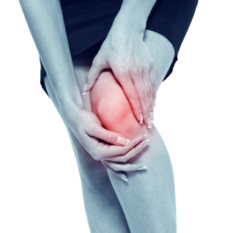
Get rid of your KNEE PAIN without drugs or surgery!
Don’t live with your pain for another day! We can help. Call our office to schedule a FREE Evaluation.
Find the Lemon!

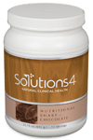
Rewards for Referrals
Find the hidden lemon somewhere in this newsletter! Be the first one to find it and we’ll give you a FREE SMT Treatment! Normally valued at $50! Call our office to redeem your prize!
*This prize is non-transferable and cannot be exchanged for product.

We have a mission to help our entire community live happier and healthier lives. Refer a friend today and we’ll reward you with a FREE Nutritional Shake!

To: _______________________________________
From: _____________________________________
I had an amazing experience at my doctor’s office and I know you will too! They have some incredible solutions for neuropathy and back pain.
Present this coupon and receive a FREE EVALUATION with the doctor.
November Events
FREE BACK & NECK PAIN EVALUATION
WELLNESS EVENT

REJUVENATION CLASS
Offered weekly

This Breakthrough Rejuvenation Class will teach you how to get better sleep, have more energy, lose weight, reduce your stress levels, and maintain a positive outlook in life! You’ll be able to make big changes based on the information you receive in this class alone. Come alone or bring a friend!
Call our office for dates and times, and to register for a spot!
Help Has Arrived for Excruciating Back and Neck Pain!



Neuropathy Sufferers!
If you suffer from serious back and neck pain or pain related to a herniated or bulging disc, we can help you resolve it! Call our office to take advantage of this offer.

Finally get help with the pain, tingling, and numbness in your feet!
If you’re suffering from neuropathy, we can help! Call our office to schedule a FREE EVALUATION.
“6 Reasons Why You Should Avoid Overeating…” – From Page 1
Meet Eugene: He’s suffered from neuropathy for 13 years, but he’s finally getting well!
This month’s winner will receive
FREE LIPOLIGHT SESSIONS!
5 Sneaky Ways to Eat More Vegetables This Thanksgiving!

Healthy Tip:
digestion over everything else. There’s no reason to put your body through this uncomfortable ordeal! When you eat a more moderate amount, your body will have more energy to help your body heal.
6. Exacerbated Pain
When you eat too much, your body must prioritize digestion over everything else. This means that other functions (like your body’s natural healing process) are put on hold. If you want to start feeling better in time for Christmas, you must start making healthier choices today. This means forgoing an overly large Thanksgiving meal so that your body has the energy it needs to heal and repair anything that needs attention. If you don’t, you might find that your symptoms get even worse!

3. Non-Stop Cravings
Overeating is rarely a one-time thing. Usually when you overeat, you choose foods that are fatty, sugary, buttery, or salty to satiate a craving. These foods are addictive and giving into cravings will only make them worse. To nip cravings in the bud, you must learn to say “no” and make healthier choices. Begin by preparing healthier foods this Thanksgiving. You’ll feel satisfied sooner and you’ll have an easier time saying no to seconds.
4. Digestive Discomfort
Overeating wreaks havoc on the digestive system. When you eat more food than your body can handle, you’ll experience the uncomfortable symptoms of indigestion, gas, bloating, constipation, or even diarrhea. These symptoms are the last thing you want to worry about when you’re spending the holiday with friends or family! To have a more enjoyable experience, put your plate down once you’re full. You can always have more food later!
system. When you eat more food than your body can handle, you’ll experience the uncomfortable symptoms of indigestion, gas, bloating, constipation, or even diarrhea. These symptoms are the last thing you want to worry about when you’re spending the holiday with friends or family! To have a more enjoyable experience, put your plate down once you’re full. You can always have more food later!
5. The Food Coma
We all know what it’s like to feel lethargic after an overly large meal (hence, the “food coma” that follows Thanksgiving dinner). What you don’t realize is that a food coma is far from harmless – it’s your body shutting down non-essential functions, prioritizing the arduous act of digestion
This Month’s Pain-Free Patient
Think of vegetables as the main dish at every meal. Eat your veggies first, then move on to other foods if you’re still hungry.
WHAT WAS LIFE LIKE BEFORE YOUR PROGRAM?
“I’ve been suffering from neuropathy for 13 years. It got to the point that I couldn’t feel the floor with my feet or go up and down the stairs. I had trouble with balance, and I wasn’t able to sleep through the night because the pain was so severe.”

HAS YOUR LIFE CHANGED AT ALL SINCE YOUR PROGRAM?
“I’ve been coming here for three weeks. After just the first treatment, my pain went down from a level 10 to a level 5, and I was able to sleep through the night for the first time in months. Over the course of the past three weeks, my pain has dropped down to about a 1. I’m able to sleep for 9-10 hours each night without being woken up by pain. It’s just wonderful!”

1. Make pumpkin-based smoothies. Pumpkin pie smoothies are one of the most delicious treats you can make during the holiday season! Check out our recipe on page 3.
2. Add vegetable puree to your favorite desserts. You can sneak pureed spinach into brownies, pureed beets into berry pie, pureed carrots into pumpkin pie, and so much more! Let your creativity run wild with this fun way to make Thanksgiving even healthier.
3. Replace mashed potatoes with a cauliflower or sweet potato mash. Potatoes may be a vegetable, but they’re not the healthiest choice. For something equally delicious, try mashing sweet potatoes or cauliflower instead. Your friends and family may not even notice the difference!
4. Make a vegetable-based pasta and sauce. Have you ever heard of zucchini noodles? There are tools you can buy that let you turn your favorite vegetables into long, stringy noodles! Try pairing zucchini noodles with a squash-based sauce for something light, refreshing, and satisfying.
5. Replace heavy casseroles with vegetable side dishes. With so many healthy Thanksgiving choices, there’s really no excuse to fall off the wagon. Try pairing your traditional turkey with roasted Brussels sprouts, roasted squash, or any number of other seasonal vegetables!

Did You Know…?

You can save up to 10% on all your favorite Solutions4 supplements when you order online!
Ask a staff member for details on how you can take

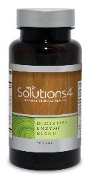

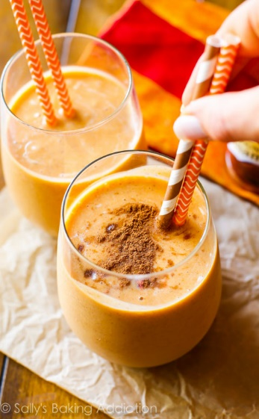

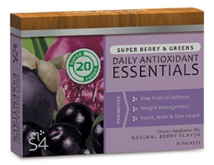


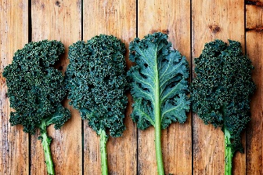
November’s Featured Solutions4 Product: Digestive Enzyme Blend!
You eat food, but your body doesn’t absorb food. It absorbs nutrients. Food must be broken down into individual nutrients (amino acids, fatty acids, simple sugars, etc.) before your body can use it. When you’re optimally healthy, your body should produce its own digestive enzymes to facilitate this process.
However, many people don’t produce enough digestive enzymes to effectively absorb nutrients from food. Though this happens for a variety of reasons (inflammation, aging, low stomach acid, stress, etc.), the result is the same – your body becomes unable to absorb all nutrients from food. This means that you may suffer from malnutrition, even if you’re eating the healthiest diet possible!
The Digestive Enzyme Blend can be especially useful when you overeat or eat foods that are hard to digest. It can even help you beat the Thanksgiving food coma! The extra enzymes help your body to avoid many of the uncomfortable symptoms that accompany poor food choices. Though it’s better to make healthy choices in the first place, this supplement can be very helpful if you slip up once in a while.
You can always find more detailed information about Solutions4 products on your Club Reduce membership site.
holiday without overeating. Thanksgiving is all about gratitude, family, and good food – but it doesn’t have to be about binge eating. There
are plenty of delicious, healthy foods that you can eat in moderation and really enjoy. If you’re worried that you’ll be tempted to overeat despite all of this, there are a few steps you can take to curb your cravings:
1. Take the Appetite Appeaser before you sit down for Thanksgiving dinner. This can help you ward off intense cravings and eat a more appropriate amount of food.
2. Allow yourself a healthy treat, but don’t overdo it. Consider making a healthier pie with an almond-based crust, a homemade coconut-based ice cream, or some other lightly (and naturally) sweetened dessert.
3. Focus on other aspects of the experience. Enjoy some quality time with friends and family members, rather than obsessing over food. You’ll be surprised when you realize how much fun you can have without eating foods you’ll regret! It is 100% possible to have a happy holiday without falling off the wagon.

“I always overeat on Thanksgiving. What can I do to curb my cravings?”
First of all, it’s important to realize that you can enjoy the Thanksgiving
Ingredients:
2 frozen bananas, sliced
½ cup pumpkin puree
½ cup coconut milk
¼ tsp. vanilla extract
¼ tsp. cinnamon
Pinch of ginger
Pinch of cloves
Pinch of nutmeg

Directions:
1. Place everything in a blender.
2. Blend until smooth.
3. Serve immediately and enjoy!
With Thanksgiving just around the corner, you’re probably craving your favorite holiday treats. Fortunately, there are several healthy alternatives that you can eat instead! This Pumpkin Spice Smoothie tastes like your grandma’s pumpkin pie, but doesn’t contain anything you (or your body) will regret! You can whip up this delicious, healthy recipe for a luxurious breakfast, a mid-afternoon snack, or a guilt-free dessert. With recipes this good, navigating the holiday season will be a cinch!

Ingredients:
-- 1 teaspoon vanilla extract
-- 6-8 small organic apples
-- Unsweetened coconut flakes
-- 6-8 sticks poked into apple cores
We can’t wait to feature YOU as next month’s Pain-Free Patient! Keep setting your goals and working hard and you could be featured here!
“Your happiness is a reflection of your health.”
Pumpkin Spice Smoothie!
Break Time
$2 off Solutions4 Digestive Enzyme!
Bring this Coupon in and Receive
$2 off this product!
*Cannot be combined with any other offer. Coupon expires 11/30/2018
Ask a Doctor
advantage of this amazing offer!

