
LIFESTYLE
[Your Clinic Name Here]
[Address]
[Hours]
[Phone Number]
Pain-Free
Make sure to Bring a Friend and Join Us for These Free In-Office Club Reduce Events!

[Patient Name]
[Address]


What’s Inside Pain-Free Lifestyle:
February 2019
------------- The Monthly Dish
How Your Self Image Can Make or Break Your Health Goals!
The Inside Story: “How Your Self-Image Can Make or Break Your Health Goals!”
Product Spotlight + Coupon: Solutions4 Vitamin B12!
This Month’s Pain-Free Patient: Congrats Cowen!
Break Time: Sudoku and an Organic Berry Cobbler Recipe!
Ask a Doctor: “With Valentine’s Day just around the corner, I know that I’ll be tempted to eat a box of chocolate. Is there something healthy that I could eat instead?”
Sidebar: “5 Healthy Ways to Treat Yourself This Valentine’s Day!”
Event Listings & Info


Oscar Wilde once said, “To love oneself is the beginning of a lifelong romance.” If you’re struggling to meet your health goals, it’s time to think about your relationship with yourself. If you’re not in love with you¸ no amount of self-improvement will change that. Self-loathing cannot be cured with a better, healthier body. You won’t come to love and accept yourself more as your problems go away. That’s not how it works. It’s time to get yourself out of the “I’ll be happy when…” mindset and start loving who you are here and now.
Begin by addressing yourself mentally. Tell yourself that you will love yourself, no matter what. Once you’ve taken this first mental step, you’ll find that the physical part of living a healthier lifestyle is that much easier! When you really value yourself, you’ll want to make the choices that make you feel your very best. You’ll want to treat yourself with greater respect, choose foods that nourish your body, stay physically active because it feels good, and make other healthy lifestyle choices because they feel right. With Valentine’s Day just around the corner, you don’t want to wait for someone else to show you that they care. Instead, show yourself a little love by making healthier choices and really investing in your future! Once you’ve taken care of yourself, you’ll be in a better position to show some love to those around you.
If you embark on this journey with the wrong mindset, you’ll fall victim to the same cycles and patterns as before. If you’re subconsciously telling yourself that you’ll only really be happy when you’re healthier, you may find yourself making poor choices (for example, eating too little during the day, and then binging later when you have less control over what to eat). You may try “quick fixes” that promise quick results but only enable you to continue making unhealthy choices. This can make it even harder to cultivate a positive self-image! You’ll be right back where you started, and the cycle will continue on and on..

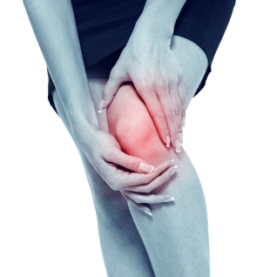

Rewards for Referrals
Get rid of your KNEE PAIN without drugs or surgery!
Don’t live with your pain for another day! We can help. Call our office to schedule a FREE Evaluation.

Find the Lemon!

We have a mission to help our entire community live happier and healthier lives. Refer a friend today and we’ll reward you with a FREE Nutritional Shake!
Find the hidden lemon somewhere in this newsletter! Be the first one to find it and we’ll give you a FREE Body Wrap! Normally valued at $125! Call our office to redeem your prize!
*This prize is non-transferable and cannot be exchanged for product.


To: _______________________________________
From: _____________________________________
I had an amazing experience at my doctor’s office and I know you will too! They have amazing services like inch-loss body wraps and all-natural, organic skincare. When you attend the Free Breakthrough Weight Loss Seminar, present this coupon and receive a FREE One-On-One Evaluation with the doctor. (Normally it’s $125!)
February Events
HEALTH & WELLNESS EVENT
MAINTENANCE PROGRAM



Help Has Arrived for Excruciating Back and Neck Pain!

Neuropathy Sufferers!

REJUVENATION CLASS
Offered weekly

This Breakthrough Rejuvenation Class will teach you how to get better sleep, have more energy, lose weight, reduce your stress levels, and maintain a positive outlook in life! You’ll be able to make big changes based on the information you receive in this class alone. Come alone or bring a friend!
Call our office for dates and times, and to register for a spot!


If you suffer from serious back and neck pain or pain related to a herniated or bulging disc, we can help you resolve it! Call our office to take advantage of this offer.

Finally get help with the pain, tingling, and numbness in your feet!
If you’re suffering from neuropathy, we can help! Call our office to schedule a FREE EVALUATION.

Meet Cowen: He stopped using a cane and ended his back pain without surgery!
“How Your Self Image Can Make or Break…” – From Page 1
5 Ways to Treat Yourself This Valentine’s Day!

To break free from this vicious cycle, you must address the root cause of your problem – your headspace! When you’re unhappy with yourself, you’ll make choices that reinforce your negative self-image. When you learn to practice greater love and acceptance, you’ll feel more optimistic about your decision to live a healthier lifestyle. Just keep in mind that “loving yourself” doesn’t mean that you have to stay as you are. If you truly love yourself, you’ll make the choices that make you feel your very best – not because others expect it of you, but because it’s what you want for yourself.

To take charge of your health and reverse a chronic pain condition for good, start by improving your relationship with yourself this Valentine’s Day. Take some personal time to think about where you’re at in life, where you’re going, and what goals you want to reach. Practice radical self-acceptance and learn to love yourself no matter what. This Valentine’s Day, don’t focus on receiving love from others. Focus on your relationship with yourself, because you are PERFECTLY IMPERFECT, inside and out!

If you need any help as you embark
upon this journey, don’t be afraid
to give us a call! That’s what we’re
here for. We’d love to sit down with
you and talk about the progress you’ve
been making so far! If you’re facing
obstacles that seem insurmountable
in your personal life, we’re happy to
talk about that too. Everything that
happens in your life is interrelated –
your personal problems, your food
choices, and even your sleep habits!
To overcome obstacles in any one of these categories,
you may need help overcoming obstacles in other areas. We’re always here to help!

This Month’s Pain-Free Patient
WHAT WAS LIFE LIKE BEFORE YOUR PROGRAM?
“Before I came here, I had to use a cane to get around. I had undergone back and hip surgery. The surgery on my back didn’t stop my pain, and my doctors said I needed to have my back operated on again. I didn’t want to go through that, but I was still in a lot of pain. I had heard about this clinic, so I came to check it out. The doctor started me on a program that included spinal decompression on my back and neuropathy treatments for my legs and feet. Because of my diabetes, my left foot was numb.”
HOW HAS YOUR LIFE CHANGED?
“I have been coming in twice a week, and the pain in my legs and feet is almost entirely gone. I no longer need to use a cane to walk! My back feels much better. The treatments have really done wonders for me! To anyone who would like to get rid of pain, I recommend you come and see what programs they have here and get the help you need.”
Healthy Tip:
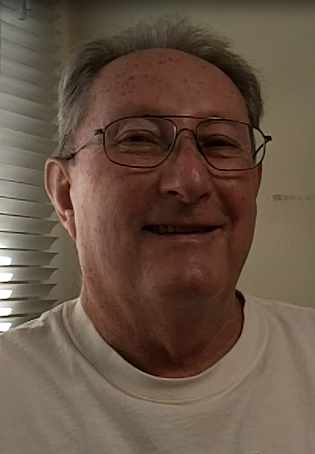
This February, don’t depend on food to make you feel good. There are plenty of other ways to treat yourself that won’t make you feel guilty after. Use these five tips to treat yourself to a guilt-free holiday!
1. Do something you love!
Take the time to do something you’re passionate about, whether that means playing your favorite sport, reading a good book, or sitting down to a good movie.
2. Take a night to yourself to de-stress! Life can be hectic, and sometimes the best of us need a breather. Schedule some time just for you to unwind and recharge your batteries.
3. Get together with loved ones! Spending quality time with those you love can be enormously restorative. Don’t miss out on the stress-reducing benefits of this quality time.
4. Buy yourself something nice! Maybe it’s time to splurge on that sweater you’ve had your eyes on for months. It’s time to start looking as good as you feel!
5. If you must treat yourself with food, choose a healthier alternative! Try the Organic Berry Cobbler listed on page 3. This recipe will satisfy your sweet tooth and deliver a healthy dose of antioxidants!

Plan ahead. If you know you’re going to be in a situation where tempting food is available, plan to bring a healthy alternative.

Did You Know…?


You can save up to 10% on all your favorite Solutions4 supplements when you order online!
Ask a staff member for details on how you can take


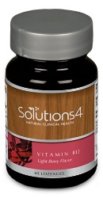

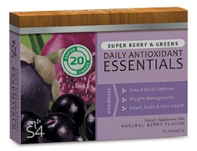


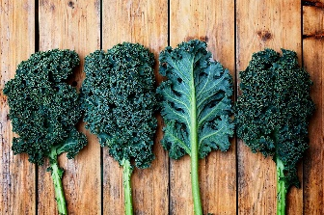

Directions:
1. To make the crust, pulse pumpkin seeds, almonds, salt and olive oil in a food processor until it’s dough-like. 2. Slowly add dates and mix into a “dough.” 3. Use it to cover the bottom of a small pie dish. 4. To make the syrup, blend blueberries and dates, adding water as needed, into a thick syrup. 5. Pour the syrup mixture over the crust, covering the dish. 6. Top with the 1 ½ cups of berries.
Your body needs antioxidants to ward off the free-radicals that contribute to premature aging and poor health. This recipe packs in high levels of health-boosting antioxidants without adding any sugar! It’s just as delicious as it is nutritious.
Ingredients: Syrup
Crust 1 cup organic blueberries
1 cup dry pumpkin seeds ½ cup pitted organic dates
1 cup dry almonds ¼ cup water
¾ tsp. sea salt
4 Tbsp. extra virgin olive oil Topping
½ cup pitted dates 1 ½ cups blueberries
“With Valentine’s Day just around the corner, I know that I’ll be tempted to eat a box of chocolate. Is there something healthy (but equally satisfying) that I could eat instead?”
Vitamin B12 is a fast-acting lozenge that provides you with an all-natural energy boost. This useful vitamin plays a key role in keeping your brain functioning at peak performance. When your vitamin B12 levels dip too low, you’ll notice that you’re often fatigued, constipated, and experience “brain fog” throughout the day. If your levels dip too far, you can even develop more serious disorders of the nervous system!
In addition to increasing your energy, vitamin B12 can boost your mood, improve your digestive health, improve your memory, bolster your immune system, reduce your risk of cancer, and make you look like a million bucks!
If you want to make this Valentine’s Day your best yet, Vitamin B12 is your secret weapon. You could even use it as a nice Valentine’s Day gift!
This Valentine’s Day, we’re featuring our favorite energy-boosting supplement. Whether you’re single or in a relationship, Solutions4 Vitamin B12 is exactly what you need to get you through Valentine’s Day.

Vitamin B12 is a fast-acting lozenge that provides you with an all-natural energy boost. This useful vitamin plays a key role in keeping your brain functioning at peak performance. When your vitamin B12 levels dip too low, you’ll notice that you’re often fatigued, constipated, and experience “brain fog” throughout the day. If your levels dip too far, you can even develop more serious disorders of the nervous system!

In addition to increasing your energy, vitamin B12 can boost your mood, improve your digestive health, improve your memory, bolster your immune system, reduce your risk of cancer, and make you look like a million bucks!

If you want to make this Valentine’s Day your best yet, vitamin B12 is your secret weapon. You could even use it as a nice Valentine’s Day gift for a friend or family member! With just one lozenge daily, you can see big results in your health.
Taking your Daily Essentials will help to ensure that your body is receiving the nutrients it needs to maintain optimal health and achieve your weight loss goals. If you want this year to finally be the year that you reach your goal weight, supplementation is essential. Your body needs to receive 100% nutrition on a daily basis to keep your “fat burning” hormones at work!

Each day that you take your Daily Essentials, you’ll find yourself a step closer to finally checking off your New Year’s resolutions. One box will last approximately 30 days: the perfect amount to last you through the month!
We can’t wait to feature YOU as next month’s Pain-Free Patient! Keep setting your goals and working hard and you could be featured here!
February’s Featured Solutions4 Product: Vitamin B12!
Though the standard box of chocolates you’d find at a chocolatier or grocery store will almost always contain unhealthy additives and unwanted ingredients, it’s possible to find dark chocolate that’s additive-free and very lightly sweetened. If this sounds appealing for you, go ahead and buy yourself a bar from your local health food store!

If you’re not into dark chocolate, look for another way to satisfy your sweet tooth. There are hundreds of sugar-free recipes out there that are just as healthy as they are delicious (like the Organic Berry Cobbler recipe on pg. 3).

If you don’t know where to start with healthy desserts, try looking for recipes online. If you want to know whether something is suitable for your program, just give us a call! We’re always here to answer any questions you may have.

Organic Berry Cobbler
$2 off Solutions4 Vitamin B12!
Bring this Coupon in and Receive
$2 off this product!
*Cannot be combined with any other offer. Coupon expires 2/28/2019

Break Time
“To love yourself is the beginning of a lifelong romance.”
Ask a Doctor
advantage of this amazing offer!

