
LIFESTYLE
Pain-Free
Make sure to Bring a Friend and Join Us for These Free In-Office Club Reduce Events!

[Patient Name]
[Address]
[Your Clinic Name Here]
[Address]
[Hours]
[Phone Number]
------------- The Inside Story

What’s Inside Pain-Free Lifestyle:
March 2019

The Inside Story: “7 Healthy Habits that Will Boost Your Energy and Reduce Your Pain!”
Product Spotlight + Coupon: Solutions4 Super Berry Greens!
This Month’s Pain-Free Patient: Congrats Lorraine!
Ask Dr. Goodman: “Why can’t I just use an energy drink for a boost?”
Break Time: Sudoku, Grilled Cabbage with Spicy Lime Dressing
Sidebar: The 5 Best Green Foods for All-Day Energy!
Event Listings & Information
7 Healthy Habits That Will Boost Your Energy and Reduce Your Pain!


One of the most common complaints that we hear from our patients who suffer from neuropathy and/or back pain is how exhausted they are. (The experience of chronic pain and emotional stress will do that to a person.) On top of that, life itself is just plain exhausting. February has already come and gone, and there’s still so much to do! Admit it, you’re tired. How could you not be tired?


Don’t worry! We are here to educate you on how to keep your energy up and reduce your bodily inflammation and pain along the way. A few simple lifestyle changes will help you put a spring in your step this March, and once you have more energy, you will have better circulation and less inflammation, which will cause your pain to fade away!
First, let’s talk about consumption. Food boosts our energy by supplying calories. However, some foods provide better, longer-lasting energy than others. So, what are some everyday all-natural, energy-boosting foods?
Leafy green vegetables pack an energy punch! Just ask Popeye. Spinach, kale, arugula, chard, virtually every variety, are chockfull of vitamins and minerals that provide a sustained energy boost.
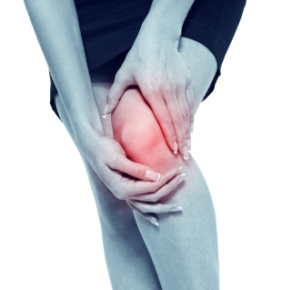
Get rid of your KNEE PAIN without drugs or surgery!
Don’t live with your pain for another day! We can help. Call our office to schedule a FREE Evaluation.

Find the Lemon!

Find the hidden lemon somewhere in this newsletter! Be the first one to find it and we’ll give you a FREE Body Wrap! Normally valued at $125! Call our office to redeem your prize!
*This prize is non-transferable and cannot be exchanged for product.


Rewards for Referrals
We have a mission to help our entire community live happier and healthier lives. Refer a friend today and we’ll reward you with a FREE Nutritional Shake!

To: _______________________________________
From: _____________________________________
I had an amazing experience at my doctor’s office and I know you will too! They have amazing services like inch-loss body wraps and all-natural, organic skincare. When you attend our Free Breakthrough Weight Loss Seminar, present this coupon and receive a FREE One-On-One Evaluation with the doctor. (Normally it’s $125!)
March Events
FREE BACK & NECK PAIN EVALUATION
minerals that provide a sustained energy boost. Outside of the leafy green family, there is a huge variety of fruits and vegetables that’ll keep you energized too. Snack on your favorites throughout the day. Grapes, peaches, and citrus fruits are particularly energizing. The same goes for broccoli, parsley, and of course, cabbage—a St. Patrick’s Day classic (see recipe on pg. 3). Another idea would be to switch your morning coffee for a nutrient-packed green smoothie! Make sure to include a base of dark greens and then add some fruit. These creamy green blends are very effective at boosting energy and they taste like indulgent desserts! Also, lean meats prevent blood sugar spikes and give you more steady energy. They help you feel more alert, focused, and fuller longer. Plus they’re an excellent source of protein. Good choices include fish and other seafood, eggs, chicken, and turkey.
WELLNESS EVENT

Help Has Arrived for Excruciating Back and Neck Pain!

REJUVENATION CLASS
Offered weekly

This Breakthrough Rejuvenation Class will teach you how to get better sleep, have more energy, lose weight, reduce your stress levels, and maintain a positive outlook in life! You’ll be able to make big changes based on the information you receive in this class alone. Come alone or bring a friend!
Call our office for dates and times, and to register for a spot!



Neuropathy Sufferers!

If you suffer from serious back and neck pain or pain related to a herniated or bulging disc, we can help you resolve it! Call our office to take advantage of this offer.

Finally get help with the pain, tingling, and numbness in your feet!
If you’re suffering from neuropathy, we can help! Call our office to schedule a FREE EVALUATION.

“May your blessings outnumber the shamrocks that grow and may trouble avoid you wherever you go!” – Irish Blessing
Meet Lorraine: She had severe back pain and now she is feeling 100% better than when she first walked in!
5. Socialize with High-Energy Friends! If you surround yourself with positive people whenever possible, you’ll increase your energy long-term. Negative people can bring down your mood and cause a stress reaction in your body. Negativity drains your body of energy and may increase pain. So, choose carefully—emotions are catching!
6. Reduce Stress! Stress burns out the adrenals, and when those are gone, you are left physically and mentally exhausted. Combat stress by taking regular breaks and doing relaxation activities. One short break will make a difference!
7. Breathe! Taking a few deep, controlled breaths is one of the best energizers. Breathe in for five seconds, hold for four, and release for four seconds. You’ll relax your body, reduce stress, and increase the level of oxygen in the blood!
This Month’s Pain-Free Patient
The 6 Best Green Foods for All-Day Energy!

2. Don’t Skip Meals! We eat for energy. So it goes without saying that missing any meal during the day leads to greater fatigue by the day’s end. Eat three meals a day to keep your blood sugar steady and your energy up long-term!
3. Drink Water! Did you know that thirst causes fatigue? There’s a simple solution – drink more water! An ice-cold glass of water can help you wake up and feel alive. Drink half your body weight in oz. of water every day!
4. Get Enough Sleep! This may seem obvious, but we’re going to say it anyway: Make sure you get enough sleep! Have a regular sleep schedule and sleep at least 8 hours each night for full-energy. Why resist? Sleep is wonderful!
1. Eat Breakfast! Breakfast is a gold mine if you want more energy. The best breakfasts deliver plenty of fiber and nutrients through whole fruits and vegetables, good fats, and some type of lean protein. And the food tastes great!
“7 Healthy Habits that Will Boost Your Energy” – From Page 1
Healthy Tip:
“I have had back pain for ten years plus. And during our last move, with all the gardening and moving, the pain got progressively worse. I thought about going to a doctor to have surgery, but I heard about this clinic and I decided I would try the laser and decompression treatments before I resorted to surgery. My experience has been remarkable. I have not had any back pain since! I’ve been able to do housework without my back going out on me. In the past, I would be out for three or four days, flat on my back. It’s incredible that I am feeling 100% better than I did walking in here. I am very satisfied with the treatments. I have five treatments left and I am looking forward to having a more active life! And maybe doing some of the things that I haven’t done for years – water skiing, camping, and more! I look forward to having a nice summer!”
Sneak outside to soak up some sunshine for 15-20 minutes each day. Sunlight energizes and elevates mood!

- Kale

- Spinach

- Celery

- Cucumber

- Avocado

- Kiwi

Did You Know…?
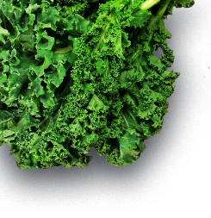


You can save up to 10% on all your favorite Solutions4 supplements when you order online!
Ask a staff member for details on how you can take


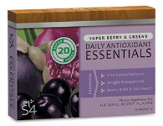

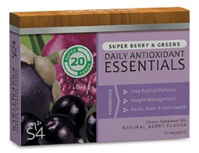
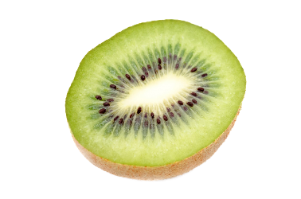
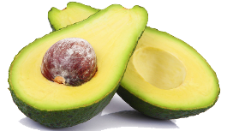

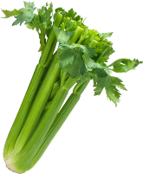
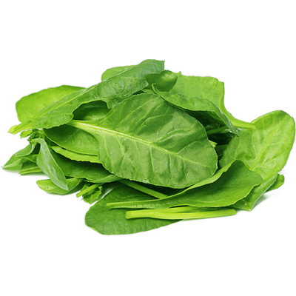


This March, the pot of gold at the end of the rainbow is Solutions4 Super Berry Greens! This exciting product has been created just for you – to help you stick to a healthy lifestyle throughout March and beyond!
Getting your daily dose of nutritious super foods has never been so easy. Each serving of Solutions4 Super Berry Greens Mix is jam-packed with the essential vitamins, enzymes, antioxidants, and phyto-nutrients that your body needs. Super Berry Greens helps to improve digestion and balance the pH of the body, while also delivering high-ORAC value of antioxidants and assisting in cleaning the blood.
This product has been shown to boost energy, cleanse the blood, aid in the removal of free radicals, manage weight, improve skin tone, repair cells, fight disease, improve digestion and help detoxify the body. Drop one stick pack into 8 oz. of water to mix instantly. One box contains 15 convenient stick packs. You can have one every morning, or just before you exercise. Good luck!

We can’t wait to feature YOU as next month’s Pain-Free Patient! Keep setting your goals and working hard and you could be featured here!
Directions:
1. Heat a gas or charcoal grill. Whiz the limes, olive oil, garlic, cilantro, salt, cayenne and Fiber Sweetener in a small chopper or blender until the sauce is pale orange and the garlic is pulverized. Set aside.
2. Remove the loosest, toughest outer leaves from the cabbage, and cut into 8 evenly-sized wedges. Do not remove the stalk or inner core. Lightly brush the wedges with grapeseed oil.
3. Place the wedges on the grill and cover. Cook for 5 to 7 minutes, or until the edges of each layer are blackened and the cabbage is beginning to soften. Flip each wedge over, cover the grill, and cook for an additional 5-7 minutes on the other side. Remove the cabbage when it is beginning to wilt but is still firm in the middle. Don’t be afraid of those blackened edges; you want a lot of grill and char marks to give it a smoky flavor.
4. Pour the dressing over top of cabbage on plate and serve immediately. Enjoy!

Ingredients:
--Juice of 3 limes (¼ cup)
--¼ cup olive oil
--2 garlic cloves
--¼ cup cilantro leaves
--½ teaspoon salt
--½ teaspoon cayenne
--¼ teaspoon Solutions4 Fiber Sweetener
--1 head green cabbage
--Drizzle of grapeseed oil

St. Patrick’s Day Grilled Cabbage with Spicy Lime Dressing!
Break Time
$2 off Solutions4 Super Berry Greens!
Bring this Coupon in and Receive
$2 off this product!
*Cannot be combined with any other offer. Coupon expires 3/31/2019
March’s Featured Solutions4 Product: Super Berry Greens!
may provide quick energy, ultimately they will lower your energy levels. The more you drink them, the more you rely on them to get you through the day. That’s why you should be wary of using caffeine for energy boosts. With high-calorie, low-nutrient energy drinks, or just your everyday cup of joe, you will certainly get a rush of energy, but in the end it will cause fatigue (and a whole host of other problems). In addition, it’s important for you to know that sugar – in whatever form – is not a solution to low energy. You might think “candy bar!” when your energy dips, but a sugar boost will just leave you lagging again in an hour. High-sugar foods spike your blood sugar for a brief burst of energy, followed by a rapid drop in blood sugar, leaving you feeling burnt out and moody.
If you can’t use “quick fixes” like coffee, candy bars, and 5-hour energy shots, what can you do? Strive to live an energy-producing lifestyle! It seems counterintuitive, but if you cut caffeine and sugar out of your diet, you will live with much more energy! Read the main article for more information on how to boost your energy naturally through healthy habits!
“Why can’t I just use an energy drink for a boost?”
Energy drinks contain large doses of caffeine, sugar, or other stimulants. While certain drinks
Ask a Doctor
“Why should you never iron a four-leaf clover? You don’t want to press your luck!”
-Daryl Stout
advantage of this amazing offer!

