
LIFESTYLE
[Your Clinic Name Here]
[Address]
[Hours]
[Phone Number]
Pain-Free
Make sure to Bring a Friend and Join Us for These Free In-Office Club Reduce Events!

[Patient Name]
[Address]


October 2019
------------- The Monthly Dish
What’s Inside the Skinny:
6 Scary Reasons Your Thyroid Could Be Interfering With Your Healing Process
The Monthly Dish: “6 Scary Reasons Your Thyroid Could Be Interfering With Your Healing Process!”
Product Spotlight + Coupon: Solutions4 Thyroid/Adrenal Support!
This Month’s Pain-Free Patient: Congrats Diann!
Ask A Doctor: “How can I say ‘no’ to Halloween candy? Is there something I can have instead?”
Break Time: Sudoku and the World’s Best Caramel Apple Recipe!
Sidebar: “5 Weird Ways That Stress Makes You Sick!”
Event Listings & Information



Thyroid disorders are becoming so common that they affect more than 20 million Americans – or more than 12% of the population. If you don’t suffer from a thyroid disorder yourself, you probably know someone who does! Unfortunately, most people find that thyroid medications fail to alleviate all the symptoms of their disorder. To make things even worse, an underlying thyroid condition can make it difficult to heal from other health conditions like chronic pain or neuropathy! To help your body heal, you’ll need to improve your thyroid’s


health through natural supplements, dietary strategies, and treatments. Keep reading to find out how poor thyroid function can interfere with your body’s natural healing process…
Cardiovascular Problems
Hypothyroidism is associated with a wide variety of scary cardiovascular diseases. Low thyroid function can contribute to high blood pressure, high cholesterol levels, and even heart failure! With your cardiovascular system in this state of chaos, what can you do to improve your health and help your body heal? To start with, we recommend the Solutions4 Cardio Health Essentials! This incredible healing product packs in heart-healthy supplements like l-arginine, l-citrine, and CoQ10! Each time you use it, you’ll improve your cardiovascular health and set your body up for successful healing.
Low Energy & Fatigue
If you suffer from hypothyroidism, you probably know what it’s like to suffer from chronic fatigue. When you don’t have enough energy, it’s hard to make healthy choices throughout the day! If you’re tired, you’re more likely to reach for a sugary treat to boost your energy levels and help you make it through the day. You’re also less likely to make it to the gym! To successfully change your eating habits and your level of physical activity, you’ll need to improve your thyroid’s function. You can do this by taking the Solutions4 Thyroid/Adrenal Support supplement and following your doctor’s other recommendations.
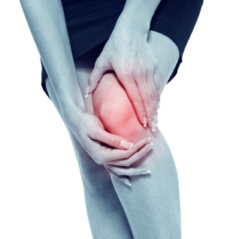
Get rid of your KNEE PAIN without drugs or surgery!
Don’t live with your pain for another day! We can help. Call our office to schedule a FREE Evaluation.
Find the Lemon!


Rewards for Referrals
Find the hidden lemon somewhere in this newsletter! Be the first one to find it and we’ll give you a FREE SMT Treatment! Normally valued at $50! Call our office to redeem your prize!
*This prize is non-transferable and cannot be exchanged for product.

We have a mission to help our entire community live happier and healthier lives. Refer a friend today and we’ll reward you with a FREE Nutritional Shake!

To: _______________________________________
From: _____________________________________
I had an amazing experience at my doctor’s office and I know you will too! They have some incredible solutions for neuropathy and back pain.
Present this coupon and receive a FREE EVALUATION with the doctor.
October Events
FREE BACK & NECK PAIN EVALUATION
WELLNESS EVENT

Help Has Arrived for Excruciating Back and Neck Pain!
REJUVENATION CLASS
Offered weekly

This Breakthrough Rejuvenation Class will teach you how to get better sleep, have more energy, lose weight, reduce your stress levels, and maintain a positive outlook in life! You’ll be able to make big changes based on the information you receive in this class alone. Come alone or bring a friend!
Call our office for dates and times, and to register for a spot!

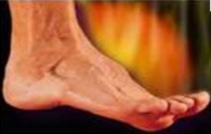

Neuropathy Sufferers!
If you suffer from serious back and neck pain or pain related to a herniated or bulging disc, we can help you resolve it! Call our office to take advantage of this offer.

Finally get help with the pain, tingling, and numbness in your feet!
If you’re suffering from neuropathy, we can help! Call our office to schedule a FREE EVALUATION.
Meet Diann – After 10 treatments, her feet feel much better and she’s able to walk again!

“6 Scary Reasons Your Thyroid Is Stopping You From Losing Weight” – From Page 1
This month’s winner will receive
FREE LIPOLIGHT SESSIONS!
5 Weird Ways That Stress Makes You Fat!

enough sleep, finding time for the gym, etc.) require a great deal of preparation and planning! Improving your thyroid’s health can make a world of difference in these areas.
Muscle Weakness
Your muscles can become weak when your thyroid produces too many or too few hormones. If this happens, you may experience weakness around the hips and shoulders, painful muscle cramps, and/or slow reflexes. When you’re dealing with these uncomfortable symptoms, it’s very difficult to find the strength to exercise. To get your body back on track, you’ll need to address your underlying thyroid condition. This will improve your muscle strength and alleviate many other symptoms, setting you up for success!
Constant Cravings
When your thyroid doesn’t produce enough hormones, you might start to feel tired and hungry before it’s even lunchtime! To keep your energy levels artificially high, you may reach for a soda or a bag of chips to stay alert. When you get home in the evening, you probably won’t have the energy to cook a healthy meal, so you’ll pop something in the microwave or order a pizza. The next day, you’ll repeat this vicious cycle all over again!
Chronic Discomfort
Your body relies upon thyroid hormones to perform a variety of essential functions.
essential functions. Without these hormones, a variety of uncomfortable symptoms can crop up. You may experience constipation, dry skin, numbness in your toes, or an increased sensitivity to cold. These uncomfortable symptoms make you far less likely to make it to the gym, take the stairs at work, or consider going for a midafternoon walk.
Brain Fog
Many people with thyroid disorders experience “brain fog” – a state of feeling mentally frazzled, confused, or forgetful. It is sometimes described as feeling like a “thick fog” is invading the brain, making it difficult to focus on anything. This lack of mental clarity can make it difficult to live a healthy lifestyle. Many healthy choices (planning meals, scheduling enough sleep, finding time for the gym, etc.) require a great deal of preparation and planning! Improving your thyroid’s health can make a world of difference in these areas.
This Month’s Skinny Star
WHAT WAS LIFE LIKE BEFORE YOUR PROGRAM?

“I’ve had neuropathy for the past three years, and medical doctors told me there was no cure. I had to constantly ice my feet and take painkillers, even throughout the night.”

HAS YOUR LIFE CHANGED AT ALL SINCE YOUR PROGRAM?

“In just 10 sessions here, my feet feel much better. This clinic has changed my life. I’m able to walk again, and I’m able to go to bed without an ice pack. With continued treatment, I’m confident that the last of my symptoms will go away completely. If you’re considering treatments here, take the chance and believe in the staff! It will change your life.”
Healthy Tip:
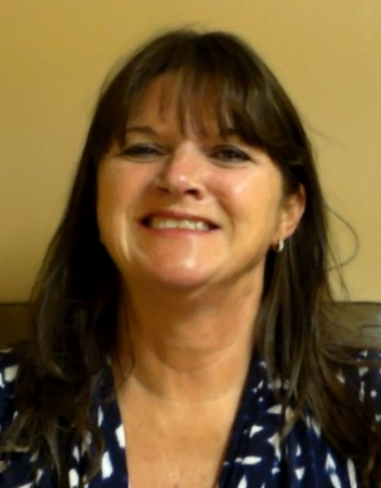
High stress levels can negatively affect your health for a number of reasons:
1. Stress raises your blood sugar levels. Cortisol triggers your body to release glucose into your bloodstream for a quick burst of energy. High blood sugar levels cause inflammation, which can exacerbate chronic pain and neuropathy.
2. Stress makes you crave unhealthy snacks.
When you’re stressed, you’re much more likely to eat something you’ll later regret.
3. Stress causes fat storage around the stomach and liver.
This abdominal fat significantly increases your risk of developing cardiovascular disease or type II diabetes.
4. Stress can make you neglect your health.
When you’re stressed, you probably don’t take time to prepare healthy meals, exercise regularly, or schedule enough sleep. These habits increase your risk for developing painful degenerative diseases.
5. Stress robs you of sleep.
Sleep is essential for health and healing! Your body requires 7-8 hours each night.
Under chronic stress, optimal health may be out of reach. So relax! Take time for yourself to pursue an activity that you love. Find ways to lower your stress levels – whether that involves a spiritual practice or some other calming activity. Be optimistic about your future! You’ve embarked on a journey that will change your life.

Drink half your body weight in ounces daily. It encourages detoxification and facilitates healthy weight loss!

Did You Know…?

You can save up to 10% on all your favorite Solutions4 supplements when you order online!
Ask a staff member for details on how you can take









We can’t wait to feature YOU as next month’s Pain-Free Patient! Keep setting your goals and working hard and you could be featured here!
Your friends are preparing delicious desserts, your kids are looking forward to trick-or-treating, and your partner is helping themselves to portions of caramel-covered popcorn. With all of this going on around you, how do you say no? To stay away from artificially colored and flavored sweets, you can try making healthy alternatives instead! You may be surprised to know that these alternatives are often tastier than their grocery store counterparts. With a little creativity, you can make a variety of delicious treats with all-natural ingredients! Look for recipes sweetened with raw honey or pure maple syrup. For low-calorie treats, try sweetening recipes with the Solutions4 Fiber Sweetener. For a nutritional boost, try sneaking pureed veggies into your treats. Let your creativity run wild and enjoy a happy Halloween!

Though homemade Halloween treats are much healthier, it’s still important to eat them in moderation. On most days, you’ll find that nothing is more satisfying than a piece of fruit or a Solutions4 Nutritional Shake!
“How can I say ‘no’ to Halloween candy? Is there something I can have instead?”
With Halloween right around the corner, you know that the sugar craze is about to begin.
Do you find yourself unexplainably tired during the day, but aren’t sure why? Need an extra boost in the morning or afternoon? Then Vitamin B12 could be the key nutrient missing from your diet.
Vitamin B12 is essential to the functioning of the brain, nerves, and circulatory system. This essential vitamin is known to insulate nerve cells and help the body build new, healthy cells!
Vitamin B12 also helps to stabilize the red blood cells responsible for carrying oxygen to the entire body. Lozenges are provided in a sublingual form for quick-and-easy absorption. For best results, chew the sublingual twice, then let it dissolve under your tongue.
You can always find more detailed information about Solutions4 products on your Club Reduce membership site.
October’s Featured Solutions4 Product: Vitamin B12!
Directions:
1. To begin, add soaked dates to blender along with raw almond butter, lemon juice, salt, and vanilla. 2. Blend until smooth. 3. Pour this mixture onto a nonstick baking mat and spread thinly. 4. Dehydrate in the oven at 140° for 2-3 hours, leaving the oven door ajar to let out excess moisture. 5. When the surface of the caramel is dry, remove from the oven and cut into rectangles. 6. Carefully lift each square of caramel off the baking sheet and mold around the surface of an apple. 7. Roll in coconut flakes and enjoy!

This healthy caramel apple recipe is even better than the original, but without the junk!

Ingredients:
-- 2 cups pitted dates, soaked in water for 4 hours
-- ¼ cup raw almond butter
-- 4 teaspoons fresh lemon juice
-- Pinch of sea salt
-- 1 teaspoon vanilla extract
-- 6-8 small organic apples
-- Unsweetened coconut flakes
-- 6-8 sticks poked into apple cores
“If it doesn’t challenge you, it doesn’t change you.”
World’s Best Caramel Apples!
Break Time
$2 off Solutions4 Vitamin B12!
Bring this Coupon in and Receive
$2 off this product!
*Cannot be combined with any other offer. Coupon expires 10/31/2019
Ask a Doctor
advantage of this amazing offer!

