
LIFESTYLE
[Your Clinic Name Here]
[Address]
[Hours]
[Phone Number]
Pain-Free
Make sure to Bring a Friend and Join Us for These Free In-Office Club Reduce Events!

[Patient Name]
[Address]


January 2019
What’s Inside Pain-Free Lifestyle:
------------- The Inside Story
The Inside Story: “11 Tips to Help You Live Pain-Free in 2019!”
Product Spotlight: Solutions4 Daily Essentials!
This Month’s Pain-Free Patient: Congratulations Melissa!
Break Time: Sudoku and Chicken Fajita Lettuce Wraps!
Ask a Doctor: “How can I reduce my stress this year?
Sidebar: “5 Solutions4 Products That Will Help You Keep Your New Year’s Resolutions!”
Event Listings & Info

11 Tips to Help You Live Pain-Free in 2019!



If you want to significantly reduce your level of pain (back pain, diabetic pain, neuropathy pain, etc.) this year, you should START NOW and START SIMPLE. Kick off the New Year with a resolution to be pain-free! The best way to accomplish this is to take the year one day at a time, making healthy choices along the way. Remember that every little choice will add up – if you make good choices, big things will happen! Try the following 11 tips for a pain-free 2019!
1. DRINK WATER! You should drink half your body weight in ounces of water every day to stay hydrated. When you drink enough water, your blood will deliver nutrients to your nerve cells more efficiently, helping them to heal faster.
2. JUST SAY “NO” TO SODA. Sugar wreaks havoc on the delicate cells of the nervous system, worsening your condition and exacerbating your pain. Even “diet” versions of popular sodas contain chemicals that damage your nerves! Plain old water is ALWAYS the best choice.
3. LIMIT SUGAR INTAKE! When it comes to chronic pain, sugar is often the number one dietary culprit. Foods that are full of refined sugar will trigger an inflammatory response that damages your nerves and produces painful symptoms.
4. LEARN TO LOVE EXERCISING! Regular physical activity increases your circulation, helping your body deliver nutrient-rich blood to the nerves in your legs and feet. No one expects you to run a marathon, but small efforts here and there will go a long way.
5. KEEP A RECORD! Don’t underestimate the power of tracking your habits. Studies show that those who keep a food diary are twice as successful as those who don’t! Recording the foods you consume keeps you accountable for your choices and gives you the perspective you need to keep going.

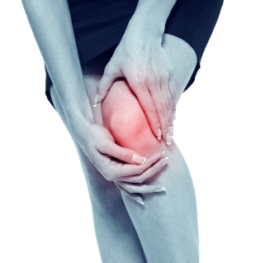

Get rid of your KNEE PAIN without drugs or surgery!
Don’t live with your pain for another day! We can help. Call our office to schedule a FREE Evaluation.

Rewards for Referrals
Find the Lemon!

We have a mission to help our entire community live happier and healthier lives. Refer a friend today and we’ll reward you with a FREE Nutritional Shake!
Find the hidden lemon somewhere in this newsletter! Be the first one to find it and we’ll give you a FREE Body Wrap! Normally valued at $125! Call our office to redeem your prize!
*This prize is non-transferable and cannot be exchanged for product.


To: _______________________________________
From: _____________________________________
I had an amazing experience at my doctor’s office and I know you will too! They have amazing services like inch-loss body wraps and all-natural, organic skincare. When you attend the Free Breakthrough Weight Loss Seminar, present this coupon and receive a FREE One-On-One Evaluation with the doctor. (Normally it’s $125!)
January Events
FREE BACK & NECK PAIN EVALUATION
WELLNESS EVENT


Help Has Arrived for Excruciating Back and Neck Pain!

Neuropathy Sufferers!

REJUVENATION CLASS
Offered weekly

This Breakthrough Rejuvenation Class will teach you how to get better sleep, have more energy, lose weight, reduce your stress levels, and maintain a positive outlook in life! You’ll be able to make big changes based on the information you receive in this class alone. Come alone or bring a friend!
Call our office for dates and times, and to register for a spot!


If you suffer from serious back and neck pain or pain related to a herniated or bulging disc, we can help you resolve it! Call our office to take advantage of this offer.

Finally get help with the pain, tingling, and numbness in your feet!
If you’re suffering from neuropathy, we can help! Call our office to schedule a FREE EVALUATION.

Meet Melissa: She changed her diet and no longer has migraines or pain in her legs and feet!
“11 Tips to Help You Live Pain-Free in 2019” – from page 1
5 Solutions4 Products That Will Help You Keep Your New Year’s Resolutions!

8. REWARD YOURSELF! Create a rewards system! Do something special (non-food related) each time you achieve one of your goals. Get a massage or buy an outfit for an upcoming party! Consider trying something you couldn’t do before you reduced your pain. Celebrate your success!
9. EAT FOR FUEL, NOT PLEASURE! Remember that food is meant to fuel the body and keep it going. When you eat for pleasure, all of your health goals go out the window. Pay attention to what foods you are eating and how they make you feel.
10. DON’T BEAT YOURSELF UP! If you slip up every once in a while, it’s okay! The worst thing you can do it beat yourself up for it and fall off the wagon forever.
6. EAT A SALAD EVERY DAY! The evidence is clear: VEGETABLES ARE PAIN-REDUCING DYNAMITE. They’re nutrient-rich, anti-inflammatory, and satisfying. Salads are one of the easiest ways to get a full serving of dark leafy greens.
7. DO WHAT YOU LIKE! Eating healthfully doesn’t mean you have to eat foods you dislike. Do some research and try to find some new healthy foods that you might enjoy. The same goes for exercise! Change up your routine when you start to get bored.

11. CLEANSE OFTEN! Detoxification is the key to pain-free living. It’s important to cleanse your body often! You can detox at any time, whether you’ve eaten too much over the holidays or want a little extra boost. Call us to learn more about our Solutions4 Detox Kits!

As you begin to set your goals, keep these 11 tips in mind. Make 2017 the year that you finally check off your pain-free resolution!
This Month’s Pain-Free Patient
Healthy Tip:

WHAT WAS LIFE LIKE BEFORE YOUR PROGRAM?
“About a month ago, I started to get pins and needles in my feet. My ankles and legs were numb. I also had severe headaches.”

WHAT DID THE PROGRAM DO FOR YOU?
“After the FIRST treatment, I had no more pins and needles in my feet! And after a couple weeks of supplements and my new diet, my migraines completely went away! The pain in my legs is almost completely gone!”
Eat organic fruits and vegetables to reduce the toxins you’re exposed to on a daily basis.
If you’ve been struggling to live up to your New Year’s resolutions, it might be time for you to seek out some additional help! Our Solutions4 product line can help you achieve your goals.

Did You Know…?

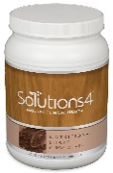
1. The Nutritional Shake will save you time, money, and calories. Replacing one

You can save up to 10% on all your favorite Solutions4 supplements when you order online!
Ask a staff member for details on how you can take
We can’t wait to feature YOU as next month’s Pain-Free Patient! Keep setting your goals and working hard and you could be featured here!

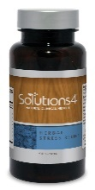

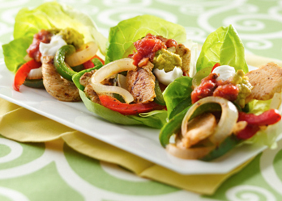
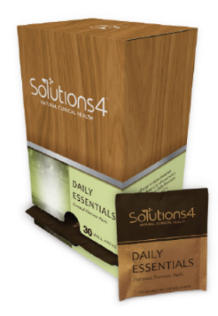
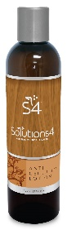





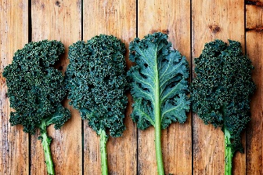
meal each day with the Nutritional Shake is one of the very best tools to reduce your pain!

4. Digestive Enzymes help your body to digest and assimilate all nutrients necessary for proper, healthy, and permanent pain relief.
5. Herbal Stress Relief helps the body to achieve deep relaxation while maintaining peak performance!

Taking your Daily Essentials will help to ensure that your body is receiving the nutrients it needs to maintain optimal health and promote maximum healing. If you want this year to finally be the year that you reach your goal of living pain-free, supplementation is essential. Your body needs to receive 100% nutrition daily to keep your body’s natural healing abilities working!
Each day that you take your Daily Essentials, you’ll find yourself a step closer to finally checking off your New Year’s resolutions. One box will last approximately 30 days: the perfect amount to last you through the month!
stress, which introduces you to
the vicious cycle of stress and pain. To turn
things around, you need to change your headspace. Your headspace is often what’s stopping you from feeling relaxed, motivated, and confident every day! However, changing the way you think isn’t as easy as it might first seem. You may need a little help! You can use Self-Mastery Technology to change your
headspace and protect your body from the consequences of stress.

If you can change your thoughts, you can change your life! Self-Mastery Technology is a form of light and sound therapy that utilizes mind messaging (also known as creative visualization) to “reprogram” your headspace. You can use Self-Mastery Technology to crave healthier foods, make better choices, and reduce stress. Each time you use Self-Mastery Technology, you tap into your own mental power to make meaningful and long-lasting changes in your life. You have every reason to be optimistic about your future!

Directions:
1. Mix the olive oil, Bragg’s, chili powder, garlic powder, and sea salt together. 2. Add chicken tenderloins to pan and cook until browned on one side, about 5 minutes. 3. Squeeze a slice of lime over cooked chicken. 4. Set cooked chicken aside. 5. Toss peppers and onions into skillet with chili powder, garlic powder, sea salt, and dashes of Bragg’s. 6. Cook about 3 minutes then add it to the chicken. Enjoy!
What better way to start off the New Year than with this easy, delicious, pain-reducing recipe?

Ingredients:
1 head romaine lettuce (large leaves)
1 red, yellow, or green bell pepper (or all three)
1 pound chicken tenderloins
1 medium organic onion, sliced
1 tbsp. organic olive oil
1 tbsp. of chili powder
1 tbsp. of garlic powder
1 tbsp. of sea salt
2 limes
1 avocado
5 dashes Bragg’s Liquid
Aminos
Solutions4’s Daily Essentials
grab-and-go packs contain our six most essential supplements: Antioxidant, Digestive Enzyme Blend, Liquid Calcium, Fish Oil, Vitamin D, and Multivitamin/ Multimineral. These convenient combination packs are a must-have for anyone trying to balance
a healthy diet with a busy life!

Taking your Daily Essentials will help to ensure that your body is receiving the nutrients it needs to maintain optimal health and achieve your weight loss goals. If you want this year to finally be the year that you reach your goal weight, supplementation is essential. Your body needs to receive 100% nutrition on a daily basis to keep your “fat burning” hormones at work!

Each day that you take your Daily Essentials, you’ll find yourself a step closer to finally checking off your New Year’s resolutions. One box will last approximately 30 days: the perfect amount to last you through the month!
January’s Featured Solutions4 Product: Daily Essentials!
3. Anti-Cellulite Lotion calms muscle and nerve pain through natural ingredients that reduce inflammation.

2. The Exercise Gel will help to increase your circulation and help your body expel toxic waste.

Chicken Fajita Lettuce Wraps
$2 off Solutions4 Daily Essentials!
Bring this Coupon in and Receive
$2 off this product!
*Cannot be combined with any other offer. Coupon expires 1/31/2019
“How can I reduce my stress this year?”
Your level of pain will increase with your level of stress, which is why it’s so important to try to keep it low. Unfortunately, being in pain often increases
often increases stress, which

Break Time
“Being Healthy and Fit isn’t a fad or a trend, it’s a Lifestyle!”
Ask a Doctor
advantage of this amazing offer!

