
LIFESTYLE
Pain-Free

[Patient Name]
[Address]
[Your Clinic Name Here]
[Address]
[Hours]
[Phone Number]
Make sure to Bring a Friend and Join Us for These Free In-Office Club Reduce Events!

December 2021
What’s Inside Pain-Free Lifestyle:
------------- The Inside Story
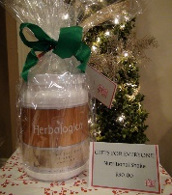
The Inside Story: “Give Yourself the Gift of a Healthy Lifestyle This Christmas Season!”
Product Spotlight + Coupon: Solutions4 Nutritional Shake!
This Month’s Pain-Free Patient: Congrats Brandy!
Break Time: Sudoku and a Dark Chocolate Macadamia Nut Recipe!
Ask a Doctor: “What healthy treats can I use as stocking stuffers this Christmas?”
Sidebar: “Do Your Christmas Shopping at Our Clinic!”
Event Listings & Info
Give Yourself the Gift of a Healthy Lifestyle This Christmas Season!




December is here, which means that Santa is on his way! Before you write your annual letter to Santa, stop and think about what is most important in your life. Do you really need a new iPhone? Or would you rather heal your body and begin feeling a million times better? Christmas is the perfect time to make changes to your diet and lifestyle. Keep reading to learn about the four ways that you can improve your health this December! activities. There’s no reason why Thanksgiving dinner needs to be so unpleasant! Keep reading to discover 6 reasons why you should avoid overfilling your plate this year…

a million times better? Christmas is the perfect time to make changes to your diet and lifestyle. Keep reading to learn about the four ways that you can improve your health this December!

Maximize Your Nutritional Intake for Better Health

Poor nutrition is the main reason that most people develop chronic health conditions like neuropathy and back pain. What you eat affects EVERYTHING that goes on in your body and determines your level of health! Unfortunately, most Americans don’t even realize that they’re eating so poorly. For example, many people think that a plain, white cream cheese bagel is a perfectly healthy breakfast! Other people think that pasta is healthy enough to eat every night of the week. With these popular misconceptions floating around, it’s no wonder that chronic health conditions are on the rise! If you want to eat a truly healthy diet this Christmas season, the main thing you need to do is avoid processed foods – including refined grains like bagels and pasta. To maximize your nutritional intake, it’s also very important to eat several servings of vegetables each day (especially dark leafy greens like spinach, romaine, and kale). Over time, all of these healthy choices will add up! You’ll find that your body is healing faster than you thought possible.
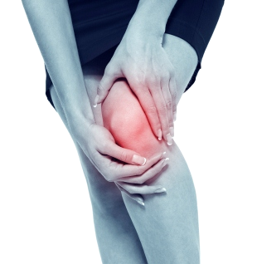
Get rid of your KNEE PAIN without drugs or surgery!
Don’t live with your pain for another day! We can help. Call our office to schedule a FREE Evaluation.

Find the Lemon!
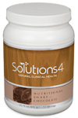
Rewards for Referrals
Find the hidden lemon somewhere in this newsletter! Be the first one to find it and we’ll give you a FREE SMT Treatment! Normally valued at $50! Call our office to redeem your prize!
*This prize is non-transferable and cannot be exchanged for product.

We have a mission to help our entire community live happier and healthier lives. Refer a friend today and we’ll reward you with a FREE Nutritional Shake!

To: _______________________________________
From: _____________________________________
I had an amazing experience at my doctor’s office and I know you will too! They have some incredible solutions for neuropathy and back pain.
Present this coupon and receive a FREE EVALUATION with the doctor.
December Events
WELLNESS EVENT
FREE BACK & NECK PAIN EVALUATION

REJUVENATION CLASS
Offered weekly

This Breakthrough Rejuvenation Class will teach you how to get better sleep, have more energy, lose weight, reduce your stress levels, and maintain a positive outlook in life! You’ll be able to make big changes based on the information you receive in this class alone. Come alone or bring a friend!
Call our office for dates and times, and to register for a spot!
Help Has Arrived for Excruciating Back and Neck Pain!

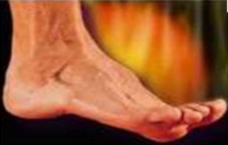
Neuropathy Sufferers!
If you suffer from serious back and neck pain or pain related to a herniated or bulging disc, we can help you resolve it! Call our office to take advantage of this offer.

Finally get help with the pain, tingling, and numbness in your feet!
If you’re suffering from neuropathy, we can help! Call our office to schedule a FREE EVALUATION.
This month’s winner will receive
FREE LIPOLIGHT SESSIONS!
“Give Yourself the Gift of a Healthy Lifestyle This Christmas Season!”– From Page 1
Meet Brandy: She’s suffered from neuropathy since undergoing chemotherapy, but she’s finally getting well!
Exercise to Get Fit
Inactivity increases your risk of developing back pain, neuropathy, and other uncomfortable conditions. If you or your loved ones suffer from these conditions, it’s not too late to prevent them from controlling your life. Regular physical activity will make you feel so much better throughout the holidays! Each time you exercise, you pump nutrient-rich blood to every cell in your body, providing them with the resources they need to heal. Regular physical activity may not be a magical cure-all, but it comes pretty close!
Don’t miss out on the benefits that your body can naturally provide.

Sleep More to Help Your Body Heal

Insufficient sleep is a public health epidemic. Before the invention of the light bulb, people slept an average of 10 hours each night. Today, most Americans average a mere 6.9 hours each night! Getting enough sleep is essential for optimal health and healing. Most people need at least 7-9 hours each night, beginning by at least 10 pm. If you get in bed by 10 pm, your body will be able to get into REM sleep – the deep sleep that your body needs – from 12 to 2 am. During this time, your body rejuvenates, recharges, and prepares itself for a new day.
Healthy Tip:
Reduce Stress for Best Results
High stress levels make it very difficult for your body to heal during the holidays. Chronic stress raises cortisol levels in your body, increasing your pain levels and thwarting your body’s natural healing process. This, in turn, can cause even more stress, creating a vicious cycle that’s difficult to escape. If you’re struggling with chronic pain, relaxation is absolutely key! Take time for yourself to pursue an activity that you love. Find ways to lower your stress levels – whether that involves a spiritual practice, meditation, or some other calming activity. You’ll feel better before you know it!
Do Your Christmas Shopping at Our Clinic!

This Month’s Pain-Free Patient
If you’re running low on energy, it’s time to hit the gym. Exercise will boost your energy levels and help you survive the hectic holidays!
WHAT WAS LIFE LIKE BEFORE YOUR PROGRAM?
“Before my program, life was pain. I had breast cancer, so I was undergoing chemotherapy (which did a lot of damage physically).
I developed neuropathy, and I came here to heal from that.
I remember being sick and in pain all of the time.”

HAS YOUR LIFE CHANGED AT ALL SINCE YOUR PROGRAM?
“I just finished a 12-Week Candida Program. My pain has gone down, and I now have sensation in one of my feet, which I haven’t had for years. I’ve learned a lot about myself and how to be healthier, so I’m going to continue making healthy choices. I’m grateful for the staff – all the folks here have been so supportive and incredible, and I want to keep coming back! If you’re thinking about doing a program, do it. It will change your life!”
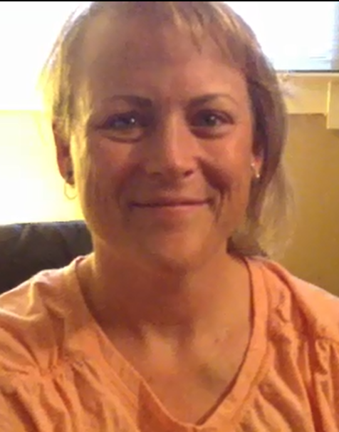
Now you can purchase high-quality, organic Solutions4 products in fun, discounted bundles – just in time for Christmas! Let Lighthouse Health be your one-stop shop this Christmas: You will save time and money while giving your family and friends the special gift of health and wellness! Don’t forget to pick up something for yourself too. These are our lowest prices of the year!

Did You Know…?

You can save up to 10% on all your favorite Solutions4 supplements when you order online!
Ask a staff member for details on how you can take
Gifts for Everyone!
Nutritional Shake
$40.00 (20% Off)

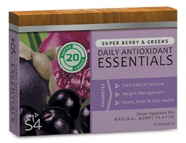
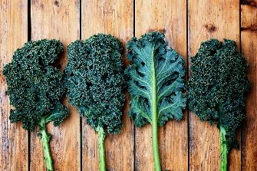

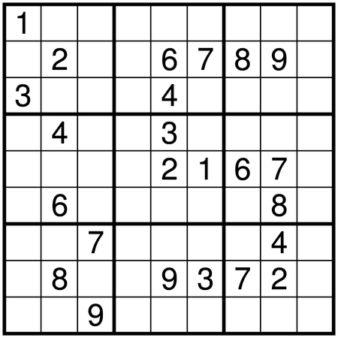
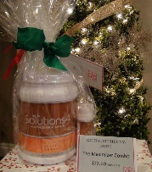
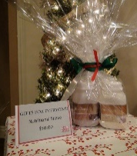
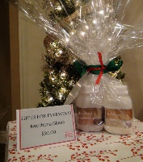
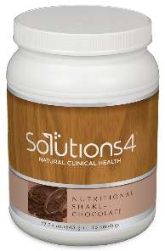
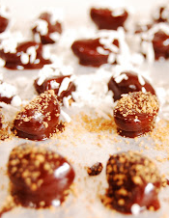






Directions:
1. Chop unsweetened chocolate into fine pieces. 2. Melt chocolate, honey, oil, and dash of sea salt in a double broiler. 3. Prepare a cookie sheet lined with wax paper.
4. Dip each macadamia nut by dropping it into the chocolate and fishing it out with a fork, shaking off the excess and placing it on the cookie sheet. 5. Before the chocolate hardens, sprinkle your choice of topping over it. 6. Allow your treats to harden, then enjoy!

Gifts for
Women!
Complete
Facial Kit!
$41.60 (20% Off)

advantage of this amazing offer!
Break Time
Dark Chocolate Macadamia Nuts!
If you’re looking for the perfect stocking-stuffer, you’re in luck! This honey-sweetened recipe is one of our very best.
Treat yourself to this guilt-free recipe and enjoy the holidays!

“It’s Christmas in the heart that puts Christmas in the air!”
We can’t wait to feature YOU as next month’s Pain-Free Patient! Keep setting your goals and working hard and you could be featured here!
Ask a Doctor
Gifts for
Women!
Complete
Facial Kit!
$41.60 (20% Off)

“What healthy treats can I use as stocking stuffers this Christmas?”
With Christmas just around the corner, you’re probably looking for ways that you can keep up
for ways that you can keep up your new, healthy lifestyle without falling off the wagon. So what in the world are you going to use as stocking
stuffers? Fortunately, there are several delicious options that you don’t have to feel guilty about.

To get started, there are the Single-Serve Nutritional Shake Packs! These packs are as delicious as they are nutritious, and they’re something that everyone will love. You’ll have a blast whipping up healthy “milkshakes” after opening presents!

We also recommend sprouted nuts that you can make yourself or find in your local health food store. Sprouted nuts are even crunchier than regular nuts, making them exceptionally delicious! If you’re feeling decadent, try coating your sprouted nuts in dark chocolate or another seasoning of your choice.

You can also use fruit as a healthy stocking stuffer, especially if you’re able to find interesting or exotic fruits that make the gift that much more exciting. For something really special, try dipping strawberries in dark chocolate!
December’s Featured Solutions4 Product: Nutritional Shake!
Gifts for Women!
Complete
Facial Kit!
$41.60 (20% Off)

Ingredients:
8 oz. macadamia nuts
8 oz. unsweetened chocolate
1/3 cup raw honey
2 tbsp. extra virgin coconut oil
Dash of sea salt

Optional toppings:
Unsweetened coconut flakes
Coarse sea salt
Granulated maple sugar
Gifts for Everyone!
Nutritional Shake
$40.00 (20% Off)

Gifts for Mom!
Ageless Beauty Combo!
$32.80 (20% Off)
Let’s be honest. Many beverages that are available today are loaded with processed sugar and other harmful ingredients. The Nutritional Shake, on the other hand, is all-natural and sugar-free, making it a great substitute for soda or coffee!
The Solutions4 Nutritional Shake provides you with the nutrients you need to heal your body safely and effectively. The nutrients in this one-of-a-kind beverage can boost your immune system, facilitate digestion, improve brain function, and support muscle building. The shake doesn’t contain any artificial colors, artificial flavors, preservatives, or other unwanted additives. It’s 100% pure and free from allergens like gluten and lactose. For something creamy and delicious, try blending the chocolate shake with a frozen banana or the vanilla shake with a handful of leafy greens!
For a fun Christmas activity, try whipping up “milkshakes” made with the Nutritional Shake, fruit, homemade almond milk, and ice! You’ll love how delicious nutrition can be.
$2 off Solutions4 Nutritional Shake!
Bring this Coupon in and Receive
$2 off this product!
*Cannot be combined with any other offer. Coupon expires 12/31/2021
Gifts for Dad!
Exercise Gel!
$23.20 (20% Off)

Gifts for the Gym Buff!
The Maximizer Combo!
$53.60 (20% Off)

Gifts for Everyone!
Nutritional Shake
$40.00 (20% Off)

Gifts for Everyone!
Nutritional Shake
$40.00 (20% Off)

Gifts for Everyone!
Nutritional Shake
$40.00 (20% Off)

