
[Your Clinic Name Here]
[Address]
[Hours]
[Phone Number]
What’s the
SKINNY
Make sure to Bring a Friend and Join Us for These Free In-Office Events!
------------- The Monthly Dish

[Patient Name]
[Address]

August 2018
What’s Inside the Skinny:
The Monthly Dish: “Top 6 Reasons to Give Up Processed Food This Summer!”
Product Spotlight + Coupon: Solutions4 Quick Start Kits!
This Month’s Skinny Star: Congrats Ivetteh!
Ask A Doctor: “How do processed foods prevent me from losing weight?”
Break Time: Sudoku and a Tropical Green Smoothie Recipe
Sidebar: “5 Ways to Avoid Gaining Weight on Vacation!”
Event Listings & Information

Top 6 Reasons to Give Up Processed Food This Summer!


The world we live in provides us with junk food at almost every corner. Grocery stores are filled with packaged, boxed, canned, and processed foods that are loaded with harmful additives and preservatives. Though most of these foods have little nutritional value, we continue to eat the, day in and day out. Americans eat an alarming average of 3,800 calories each day and consume only 7% of their calories from fruits and vegetables. On top of that, the average


American drinks 600 cans of soda each year. With a diet like this, it’s no wonder that Americans are so overweight! If you need even more motivation to change your diet, keep reading…
1. Sugar makes you sick.
If you seem to come down with every cold that goes around, it’s time to reflect on what you eat. If you’re eating refined sugar, you’ve found your culprit! Refined sugar wreaks havoc on the immune system and makes your body more susceptible to illness and disease. The ingestion of only 100 grams of refined sugar reduces the immune system’s function by 50% within two hours of eating!
2. Refined grains make you fat.
The saying that “the whiter the bread, the sooner you’re dead” isn’t far off. When it comes to weight gain, refined carbohydrates are the real culprit. These empty calories end up directly on your body as fat. And refined grains
Bring a friend to our Breakthrough Weight Loss Seminar, and you will both receive FREE Body Wraps!
If you haven’t attended our seminar, now is a great time to come! If you’ve already been, come for a refresher!
We look forward to seeing you soon!
Find the Lemon!

Find the hidden lemon somewhere in this newsletter! Be the first one to find it and we’ll give you a FREE Body Wrap! Normally valued at $125! Call our office to redeem your prize!
*This prize is non-transferable and cannot be exchanged for product.
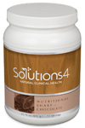

Rewards for Referrals
We have a mission to help our entire community live happier and healthier lives. Refer a friend today and we’ll reward you with a FREE Nutritional Shake!

To: _______________________________________
From: _____________________________________
I had an amazing experience at my doctor’s office and I know you will too! They have amazing services like inch-loss body wraps and all-natural, organic skincare. When you attend the Free Breakthrough Weight Loss Seminar, present this coupon and receive a FREE One-On-One Evaluation with the doctor. (Normally it’s $125!)
August Events
WEIGHT LOSS EVENT
MAINTENANCE PROGRAM

We offer Maintenance Programs!

WEIGHT LOSS SEMINAR
Offered weekly

This breakthrough Weight Loss Seminar will teach you exactly what is keeping you from your goal weight and what you can do to start taking control of your life! Come alone or bring a friend!

Call our office for dates and times, and to register for a spot!

are everywhere! Refined grains are used to make bread, pasta, cookies, breakfast cereals, crackers, and other snack foods.

See page 2 for more….

August’s Skinny Contest!
Are you worried about gaining back all the weight you worked so hard to lose? Don’t worry! We’ve found that the best way to keep weight off permanently is through maintenance! We want to hold your hand through the process!
Pay as little as $10 a month!

This month’s winner will be whoever loses the most weight (lbs).

Contest rules:
1. Come into our office anytime in the month of March – the sooner the better! Let our staff know you’d like to enter this month’s contest.
2. Return to our office on the last day of the month for your final weigh-in.
“He who takes medicine and neglects his diet wastes the skill of his physicians.” – Chinese Proverb
This month’s winner will receive
FREE LIPOLIGHT SESSIONS!
5 Ways to Avoid Gaining Weight on Vacation

are dangerous because they oxidize rapidly in the digestive system, releasing a deadly bombardment of free radicals that destroy cells and cause widespread damage.
6. MSG is bad for your brain.
MSG is used to enhance the flavor of foods, making cheap ingredients taste delicious. Though many people report that they experience adverse reactions to MSG immediately upon eating, most people experience a slower onset of more insidious symptoms. In the long0term, MSG can damage your neurons and increase you risk of developing conditions like Alzheimer’s and Parkinson’s disease. This happens because MSG is an excitotoxin – a substance that overstimulates brain cells to the point of death.
for humans. It may make you feel sluggish, upset your stomach, or cause you to produce excess mucus. You may be in such poor health that you don’t even notice when dairy affects you in this way! Even if you don’t react poorly to dairy, most of the dairy products you find at the store are loaded with fillers, chemicals, and preservatives.
5. Trans fats hurt your heart.
Studies show that cutting trans fats out of the American diet would prevent as many as 20,000 heart attacks and 7,000 coronary heart disease deaths each year. These numbers are startling, considering that trans fats are found in almost all processed foods, baby formulas, non0dairy creamers, and salad dressings. Trans fats
3. Processed meats contribute to cancer.
Your choice to eat double-bacon cheeseburgers for lunch may eventually prove deadly. Much of the meat you find in a fast food establishment is laced with antibiotic and hormone residues, preserved with carcinogenic nitrates, and “flavored” with a variety of questionable chemicals. These substances increase your risk of dying from cancer by as much as 43%! Choosing to eat these types of meat – even in moderation – is a risky business.
4. Dairy makes you sluggish.
Because cow’s milk is designed for baby cows, it isn’t an ideal source of food
Meet Ivetteh – She lost 40 pounds and transformed her entire family’s health!
This Month’s Skinny Star
“Top 6 Reasons to Give Up Processed Food…” – From Page 1
Healthy Tip:
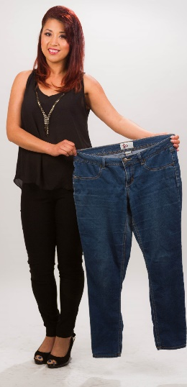
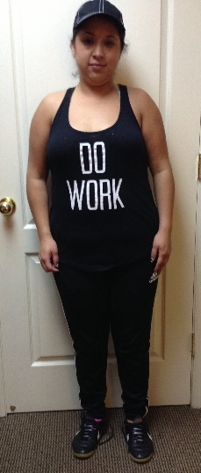
To overcome cravings, get more sleep. When you’re well-rested, you won’t feel like you need a sugary snack.
WHAT WAS LIFE LIKE BEFORE YOUR PROGRAM?
“I was always sad and never felt good about myself. I tried every diet and exercise, but nothing worked. My parents have diabetes, and I didn’t want that to happen to me so young. I also couldn’t play soccer anymore because I was too heavy.”
HOW HAS THIS PROGRAM CHANGED YOUR LIFE?
“I lost 40 pounds and I feel great! Now, I can go to the store and buy whatever clothes I want. I don’t have to worry about my soccer games because I know I’m in shape. My kids are eating better, and my husband lost 10 pounds right along with me. It was a life-changing experience, and I’m grateful for everything.
Now that summer is in full swing, vacation season is here. When you’re traveling, it can be challenging to find healthy options along the way. Use these tips to keep unwanted pounds at bay!
1. Use the Nutritional Shake.
Using the Nutritional Shake will leave you free to enjoy your trip without constantly worrying about what you’ll eat next! It’s available in single-serve packets that you can take with you wherever you go.
2. Plan Ahead.
Locate restaurants with healthy options or find ways to prepare your own food. If you’re going to eat out, call ahead to find out what’s on the menu. Many restaurants even have their menus available online!
3. Avoid Dining-Out Disasters.
It isn’t easy to find healthy options in restaurants, and it’s even harder to find “healthy” options that are really as good as they claim. Consider talking to the chef to find out what’s really in the food.
4. Pack Meals To-Go.
If you’re driving to your destination, bring healthy food with you in a cooler. You can have plenty of food ready to eat at a moment’s notice!
5. When in Doubt, Eat a Salad.
Salads are generally quite healthy, and they’re also widely available. Many grocery stores have salad bars or ready-to-eat lettuce mixes that only require dressing and toppings. Most restaurants have a salad on the menu too!

Did You Know…?

You can save up to 10% on all your favorite Solutions4 supplements when you order online!
Ask a staff member for details on how you can take


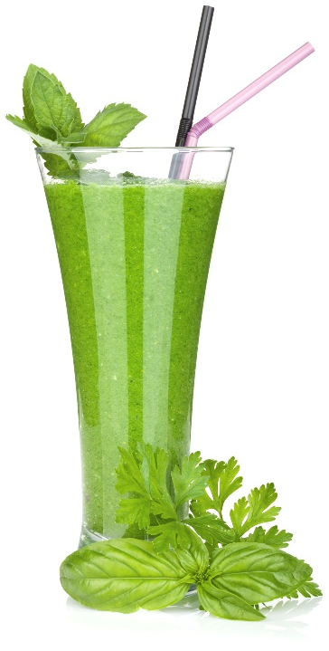

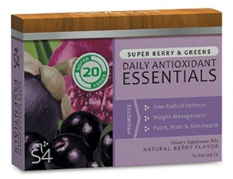

“Life is not merely to be alive, but to be well.”
Break Time
August’s Featured Solutions4 Product: Quick Start Kits!
1. Toxins Build Up in Fat Cells. Each time you give in to a temptation and scarf down a slice (or three) of pepperoni pizza, your body tries to eliminate that toxins you’ve ingested. However, if you’ve consumed more toxins than your body can handle, your body will store these toxins in your fat cells to be removed later. These toxins make it difficult for your body to let go of unwanted pounds.
2. Processed Foods Activate Fat-Storing Hormones. When you eat a slice of bread, the carbohydrates break down into simple sugars almost immediately. These sugars cause a spike in blood sugar, which increases your body’s production of insulin. Excess insulin in the blood lets your body know that it’s time to hold onto fat, rather than burn it off!
3. Processed Foods Lack Nutrients. Because a slice of pizza doesn’t provide your body with sufficient nutrition, your body will think that it needs t keep eating long after you’re full. The next time you walk by the fridge, you won’t be able to resist a snack! These habits become a vicious cycle.
Ask a Doctor
We can’t wait to feature YOU as next month’s Skinny Star! Keep setting your goals and working hard and you could be featured here!
advantage of this amazing offer!


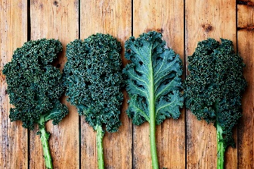
Tropical Green Smoothie!

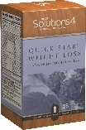
“How do processed foods prevent me from losing weight?”
Processed foods interfere with weight loss in several different ways. Let’s discuss the top three:

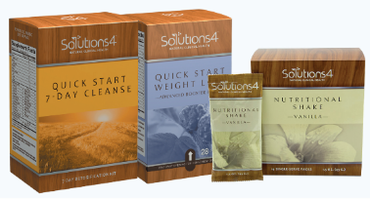

The 7-Day Quick Start Cleanse and Quick Start Weight Loss Kits make weight loss quicker and easier than ever before! With these two kits – and the Solutions4 Nutritional Shake – you’ll have everything you need to deep clean your body, lose excess weight, and change your life! With the 7-Day Cleanse, you’ll get a week’s supply of powerful detoxifying supplements and Essential Greens. The supplements help to flus the toxins out of your system while the greens provide your body with energizing nutrients. With the Quick Start Weight Loss Kit, you’ll get a 14-day supply of supplements designed to reduce cravings, boost your metabolism, and facilitate healthy weight loss. For best results, we recommend you use these kits together to create a 21-day program. Using this system, you would complete a 7-day cleanse followed by the 14-day weight loss program. For even better results, use it in conjunction with the Nutritional Shake!
Green smoothies are a great way to maximize your nutritional intake in the most delicious way possible. This smoothie provides your full daily value of vitamin A, vitamin C, vitamin K, and manganese! For all its nutritional value, it tastes a lot like a piña colada!

$2 off Quick Start Weight Loss!
Bring this Coupon in and Receive $2 OFF this product!

Coupon expires 8/31/2018
Ingredients:
--2 cups fresh spinach
--2 cups coconut water
--1 cup chopped pineapple
--1 cup chopped mango
--2 bananas
--Ice (for desired thickness)

Directions:
1. Put all ingredients in a blender and puree until smooth.
2. Add ice until you reach your desired consistency.
3. Pour into glasses, serve, and enjoy!

