
[Your Clinic Name Here]
[Address]
[Hours]
[Phone Number]
What’s the
SKINNY
Make sure to Bring a Friend and Join Us for These Free In-Office Club Reduce Events!

[Patient Name]
[Address]
------------- The Monthly Dish

June 2019
What’s Inside the Skinny:
The Monthly Dish: “Shocking New Dietary Guidelines Are Actually Right This Time!”
Product Spotlight + Coupon: Solutions4 Fiber Sweetener!
This Month’s Skinny Star: Congrats Summer!
Ask A Doctor: “Help! I’m addicted to sugar. What can I do?”
Break Time: Sudoku and a Creamy Key Lime Pie Popsicles Recipe!
Sidebar: “5 Frightening Risks from Eating Sugar!”
Event Listings & Information
Shocking New Dietary Guidelines Are Actually Right This Time!


The government has a pretty terrible track record when it comes to nutrition. In the past, the government has mistakenly encouraged us to replace butter with margarine, replace sugar with artificial sweeteners, and choose low-fat versions of our favorite foods. As research has evolved, we’ve learned that much of this advice has been misguided. We now know that these processed substitutes are actually making Americans sicker and fatter!


Americans sicker and fatter!
Given this history, it comes as a big surprise that the government is now recommending that Americans dramatically reduce their intake of sugar, avoid artificial sweeteners, and eat a more natural diet. We’re thrilled that the government is finally recognizing how harmful sugar and artificial sweeteners can be, and how important real, whole foods are!
Now that the government sees sugar as a legitimate threat to our health, the new guidelines all but prohibit it. The government now recommends that Americans limit added sugars to less than 10% of their calories each day! Given that most Americans eat about three times this much, the new guidelines are really rocking the boat. If you eat a standard 2,000 calorie diet, 10% of your diet adds up to a mere 200 calories. That’s less sugar than you’d get in a bowl of cereal! Unless you’ve been checking nutritional labels meticulously, you probably don’t realize how many different products contain added sugars. Many foods that you would consider healthy – salad dressings, condiments, and granola-based breakfast cereals – are actually loaded with regular white, refined sugar.

Bring a friend to our Breakthrough Weight Loss Seminar, and you will both receive FREE Body Wraps!
If you haven’t attended our seminar, now is a great time to come! If you’ve already been, come for a refresher!
We look forward to seeing you soon!
Find the Lemon!

Find the hidden lemon somewhere in this newsletter! Be the first one to find it and we’ll give you a FREE Body Wrap! Normally valued at $125! Call our office to redeem your prize!
*This prize is non-transferable and cannot be exchanged for product.


Rewards for Referrals
We have a mission to help our entire community live happier and healthier lives. Refer a friend today and we’ll reward you with a FREE Nutritional Shake!

To: _______________________________________
From: _____________________________________
I had an amazing experience at my doctor’s office and I know you will too! They have amazing services like inch-loss body wraps and all-natural, organic skincare. When you attend the Free Breakthrough Weight Loss Seminar, present this coupon and receive a FREE One-On-One Evaluation with the doctor. (Normally it’s $125!)
June Events
WEIGHT LOSS EVENT
MAINTENANCE PROGRAM

We offer Maintenance Programs!

WEIGHT LOSS SEMINAR
Offered weekly

This breakthrough Weight Loss Seminar will teach you exactly what is keeping you from your goal weight and what you can do to start taking control of your life! Come alone or bring a friend!

Call our office for dates and times, and to register for a spot!

June’s Skinny Contest!
Are you worried about gaining back all the weight you worked so hard to lose? Don’t worry! We’ve found that the best way to keep weight off permanently is through maintenance! We want to hold your hand through the process!
Pay as little as $10 a month!

This month’s winner will be whoever loses the most weight (lbs).

Contest rules:
1. Come into our office anytime in the month of March – the sooner the better! Let our staff know you’d like to enter this month’s contest.
2. Return to our office on the last day of the month for your final weigh-in.
“A man too busy to take care of his health is like a mechanic too busy to take care of his tools.” – Spanish Proverb
This month’s winner will receive
FREE LIPOLIGHT SESSIONS!
5 Frightening Risks from Eating Sugar!
We now live in a world where it’s possible to eat more sugar in a salad (especially one with a low-fat salad dressing) than you’d get from a donut. Most people consume more than 200 calories from sugar at breakfast alone! If you’re struggling to keep unwanted pounds at bay, your body can’t afford to ignore these new guidelines.
The new guidelines also recommend that Americans avoid artificial sweeteners. So if you think your diet soda habit is harmless, it’s time to think again! While chemically-created sweeteners may seem innocent, they can cause your body to hold on to excess fat – much like regular sugar would. For example, the type of sugar found in diet coke (aspartame) has recently been shown to cause greater weight gain than regular refined sugar. For these reasons, the new guidelines recommend that you ditch the diet soda and start drinking more water instead!
Though the guidelines specifically prohibit sugar and artificial sweeteners,
they also encourage Americans to eat a more natural diet full of
nutrient-rich foods like fruits, vegetables, and fish. Whether they know
it or not, this is what we’ve been doing in our clinic for years! We’re
excited that the government is finally starting to catch up.

If you’re a big fan of wild-caught seafood, fresh fruit, and large servings
of organic veggies, these new guidelines are great news! But if
you’re still struggling to break your sugar habit, we can help.
Now that summer is here, it’s time to let go of bad habits and
start working towards the body of your dreams. We want
you to have a fun-filled summer without worrying that
your weight is holding you back! If you need help,
don’t hesitate to make an appointment today.

Meet Summer – She lost 34 pounds and doesn’t crave sugar anymore!
This Month’s Skinny Star
“Shocking New Dietary Guidelines…” – from page 1
Healthy Tip:


WHAT WAS LIFE LIKE BEFORE YOUR PROGRAM?
“I did a 12-Week Candida Program. I was a huge sugar junkie, so I was really nervous at first because I didn’t think I could do it. Once I started, it was a lot easier than I expected.”

HOW HAS THIS PROGRAM CHANGED YOUR LIFE?
“Even though I didn’t think I could do it, I felt so good that I had to keep going. Now that I’ve made it this far, I have TONS of energy. The best part is that I don’t have the sugar cravings that I used to!”
To get rid of a belly bulge in time for swimsuit season, eat more salads. The fiber in leafy greens will clean you out and help you slim down!

You probably know that sugar isn’t good for you, but you might not realize how severe the consequences of eating sugar can be. Here are five of the most frightening risks that you face each time you eat something containing sugar!

1. Low Energy and Fatigue
When you eat refined sugar, you cause a sharp spike in your blood sugar levels. Soon after, your energy levels plummet. This sudden drop in blood sugar can make you weak, hungry, and tired!
2. An Achy, Foggy Brain
Consuming too much sugar can impact your cognitive abilities. Sugar damages communication between brain cells, eventually leading to conditions like Alzheimer's.
3. Poor Digestion
Sugar inflames the stomach, ferments in the gut, and isn't digested efficiently because it can’t be broken down into nutrients. Sugar slows your metabolism too.
4. Adult Acne Breakouts
Constant spikes and drops in blood sugar create inflammation and internal stress in the body, which in turn causes breakouts. Sugar can contribute to dehydration too, making your skin age prematurely and take on a dull appearance.
5. Cavity-Riddled Teeth
The natural bacteria in your mouth thrive on sugar. These bacteria eat away at your teeth and cause cavities.

Did You Know…?

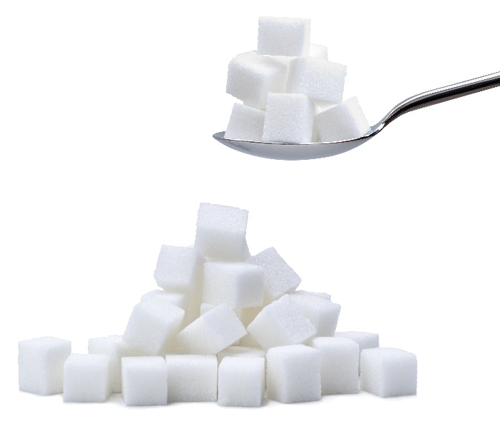

You can save up to 10% on all your favorite Solutions4 supplements when you order online!
Ask a staff member for details on how you can take


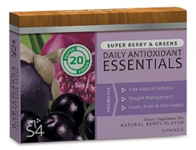

“Just because you’re not sick doesn’t mean you’re healthy.”
Creamy Key Lime Pie Popsicles
Break Time
$2 off Solutions4 Fiber Sweetener!
Bring this Coupon in and Receive
$2 off this product!
*Cannot be combined with any other offer. Coupon expires 6/30/2019
June’s Featured Solutions4 Product: Fiber Sweetener!
Ask a Doctor
We can’t wait to feature YOU as next month’s Skinny Star! Keep setting your goals and working hard and you could be featured here!
advantage of this amazing offer!
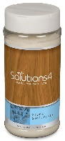
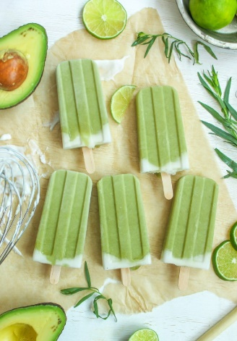


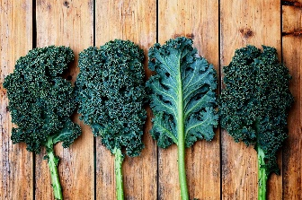
The Solutions4 Fiber Sweetener is a sugar-free, chemical-free, low-calorie, low-glycemic soluble fiber supplement and sweetener. Though you can use this product to sweeten anything – smoothies, sorbet, or even apple pie – it also contains a healthy dose of fiber! Fiber helps to speed up digestion, normalize bowel movements, lower cholesterol levels, and help you achieve a healthy weight!
Unlike other natural sweeteners, the Solutions4 Fiber Sweetener contains two special forms of fiber – chicory root and acacia – that help stabilize your blood sugar levels. This helps to reduce inflammation and prevents your energy levels from plummeting after a big meal.
With all of your newfound energy, you might feel like squeezing in another workout or doing something else that you love!
When you add the Solutions4 Fiber Sweetener to your food, the fiber instantly dissolves. You’re left with a delicious natural sweetener with no artificial aftertaste! This makes the Fiber Sweetener perfect for just about everything.

few of us realize how addictive sugar can be. A recent study showed that sugar can actually be more addictive than cocaine! Because sugar is so readily available – in every grocery store, gas station, and restaurant – it’s a hard drug to quit. Though quitting a sugar habit may be challenging, it’s possible! Here are a few things you can do:
1. Eat plenty of healthy fats. Healthy fats are found in extra virgin olive oil, unrefined coconut oil, avocados, and wild-caught fish. Eating enough fat helps nip sugar cravings in the bud before they begin!

2. Improve your sleep habits. If you’re sleepy, you’ll be much more likely to reach for a
sugary treat to get you through the day. When you’re well-rested, you’ll make better choices.

3. Stay away from artificial sweeteners. Unlike regular sugar, artificial sweeteners confuse
your appetite and cause you to eat more calories – and more sugar – throughout the day. You’re better off switching to raw honey, pure maple syrup, or the Solutions4 Fiber Sweetener instead!

“Help! I’m addicted to sugar. What can I do?”
A sugar addiction is no laughing matter.
Though most of us know that sugar
makes us sick and fat, few of us realize how
addictive sugar can actually be. A
Directions:

1. Put all main filling ingredients in a blender and puree until smooth. 2. Pour mixture into popsicle molds, leaving space for coconut cream. 3. Mix coconut milk with raw honey and pour into the remaining space. 4. Freeze for 4-6 hours and enjoy!

Main Filling:
3/4 cup lime juice
1/3 cup raw honey
1/2 cup coconut oil
1/4 cup organic coconut milk
1 cup mashed avocado
2 teaspoons vanilla
Pinch of sea salt

Coconut Cream:
1/2 cup organic coconut milk
1 tablespoon raw honey

