

What’s the
SKINNY
Make sure to Bring a Friend and Join Us for These Free In-Office Club Reduce Events!

[Patient Name]
[Address]
[Your Clinic Name Here]
[Address]
[Hours]
[Phone Number]
------------- The Monthly Dish

March 2019
What’s Inside the Skinny:
The Monthly Dish: “7 Healthy Habits that Will Boost Your Energy and Help You Lose Weight!”
Product Spotlight + Coupon: Solutions4 Super Berry Greens!
This Month’s Skinny Star: Congrats Denise!
Ask Dr. Goodman: “Why can’t I just use an energy drink for a boost?”
Break Time: Sudoku, Grilled Cabbage with Spicy Lime Dressing
Sidebar: The 5 Best Green Foods
Event Listings & Information
7 Healthy Habits That Will Boost Your Energy and Help You Lose Weight!



Life is just plain exhausting. Admit it, you’re tired. February has already come and gone, and there’s still so much to do! Lucky for you, we’re here to educate you on how to keep your energy up. If you follow these guidelines, you can put a spring in your step this March, and you may even lose weight!
First, let’s talk about consumption. Foods boost our energy by supplying calories. However, some foods provide better,


Bring a friend to our Breakthrough Weight Loss Seminar, and you will both receive FREE Body Wraps!
If you haven’t attended our seminar, now is a great time to come! If you’ve already been, come for a refresher!
We look forward to seeing you soon!
Find the Lemon!

longer-lasting energy than others. So, what are some everyday all-natural, energy-boosting foods? Leafy green vegetables pack an energy punch! Just ask Popeye. Spinach, kale, arugula, chard, virtually every variety, are chockfull of vitamins and minerals that provide a sustained energy boost. Outside of the leafy green family, there’s a huge variety of fruits and vegetables that’ll keep you energized too. Snack on your favorites throughout the day. Grapes, peaches, and citrus fruits are particularly energizing. The same goes for broccoli, parsley, and of course, cabbage – a St. Patrick’s Day classic (see recipe on pg. 3).
Find the hidden lemon somewhere in this newsletter! Be the first one to find it and we’ll give you a FREE Body Wrap! Normally valued at $125! Call our office to redeem your prize!
*This prize is non-transferable and cannot be exchanged for product.


Rewards for Referrals
We have a mission to help our entire community live happier and healthier lives. Refer a friend today and we’ll reward you with a FREE Nutritional Shake!

To: _______________________________________
From: _____________________________________
I had an amazing experience at my doctor’s office and I know you will too! They have amazing services like inch-loss body wraps and all-natural, organic skincare. When you attend our Free Breakthrough Weight Loss Seminar, present this coupon and receive a FREE One-On-One Evaluation with the doctor. (Normally it’s $125!)
March Events
WEIGHT LOSS EVENT
MAINTENANCE PROGRAM
Here’s another idea. Consider trading in your morning coffee for a nutrient-packed green smoothie! Make sure to include a base of dark greens and then add some fruit. These creamy green blends are very effective at boosting energy and they taste like indulgent desserts!
In addition, lean meats prevent blood sugar spikes and give you more steady energy. They help you feel more alert, focused, and fuller longer. Plus they’re an excellent source of protein. Good choices include fish and other seafood, eggs, chicken, and turkey.

We offer Maintenance Programs!

WEIGHT LOSS SEMINAR
Offered weekly

This breakthrough Weight Loss Seminar will teach you exactly what is keeping you from your goal weight and what you can do to start taking control of your life! Come alone or bring a friend!

Call our office for dates and times, and to register for a spot!

March’s Skinny Contest!
Are you worried about gaining back all the weight you worked so hard to lose? Don’t worry! We’ve found that the best way to keep weight off permanently is through maintenance! We want to hold your hand through the process!
Pay as little as $10 a month!
This month’s winner will be whoever loses the most weight (lbs).

Contest rules:
1. Come into our office anytime in the month of March – the sooner the better! Let our staff know you’d like to enter this month’s contest.
2. Return to our office on the last day of the month for your final weigh-in.

This month’s winner will receive
FREE LIPOLIGHT SESSIONS!
“May your blessings outnumber the shamrocks that grow and may trouble avoid you wherever you go!” – Irish Blessing
Denise finally found a program that works for her.
She lost 27 inches and 27 pounds!
This Month’s Skinny Star
The 6 Best Green Foods for All-Day Energy!

2. Don’t Skip Meals! We eat for energy. So it goes without saying that missing any meal during the day leads to greater fatigue by the day’s end. Eat three meals a day to keep your blood sugar steady and your energy up long-term!
3. Drink Water! Did you know that thirst causes fatigue? There’s a simple solution – drink more water! An ice-cold glass of water can help you wake up and feel alive. Drink half your body weight in oz. of water every day!
4. Get Enough Sleep! This may seem obvious, but we’re going to say it anyway: Make sure you get enough sleep! Have a regular sleep schedule and sleep at least 8 hours each night for full-energy. Why resist? Sleep is wonderful!
5. Socialize with High-Energy Friends! If you surround yourself with positive people, you’ll increase your energy. Negative people can bring down your mood and cause a stress reaction in your body. Negative energy drains your energy and inhibits weight loss – So, choose your tribe carefully!
6. Reduce Stress! Stress burns out the adrenals, and when those are gone, you are left physically and mentally exhausted. Combat stress by taking regular breaks and doing relaxation activities. One short break will make a difference!
7. Breathe! Taking a few deep, controlled breaths is one of the best energizers. Breathe in for five seconds, hold for four, and release for four seconds. You’ll relax your body, reduce stress, and increase the level of oxygen in the blood!
1. Eat Breakfast! Breakfast is a gold mine if you want more energy. The best breakfasts deliver plenty of fiber and nutrients through whole fruits and vegetables, good fats, and some type of lean protein. And the food tastes great!
“7 Healthy Habits that Will Boost Your Energy” – From Page 1
Healthy Tip:


WHAT WAS LIFE LIKE BEFORE YOUR PROGRAM?
I hated vegetables. I thought I was huge and I didn’t feel great. I was very lethargic. I experienced heartburn frequently. My triglyceride level was 480mg/DL, much too high for comfort.

HOW HAS YOUR LIFE CHANGED SINCE?
I like vegetables now. All kinds. I lost 27 inches and 27 pounds! I have a lot more energy and I like how I look in clothes. I feel great. On top of that, my triglyceride level decreased from 480 to 190 mg/DL! To anyone who is considering a program, do it! I tried every single diet out there and none of them have ever worked for me except this one!
Sneak outside to soak up some sunshine for 15-20 minutes each day. Sunlight energizes and elevates mood!

- Kale

- Spinach

- Celery

- Cucumber

- Avocado

- Kiwi

Did You Know…?
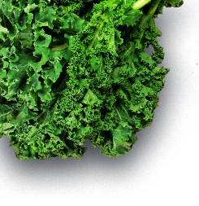


You can save up to 10% on all your favorite Solutions4 supplements when you order online!
Ask a staff member for details on how you can take

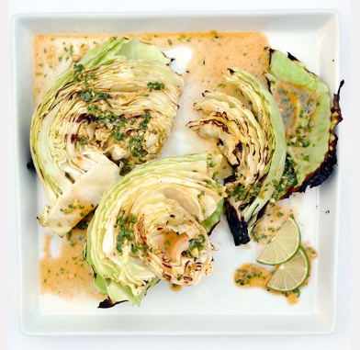
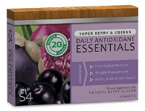

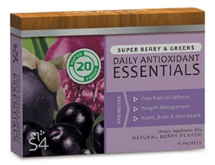
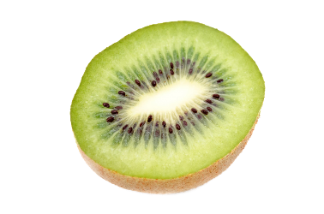
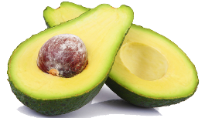

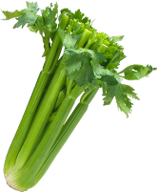
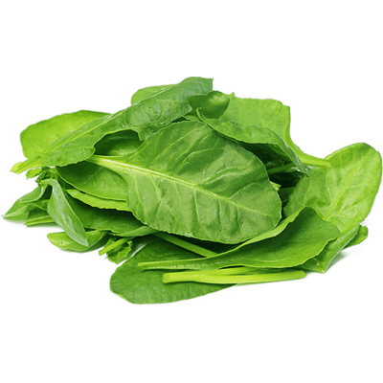


Directions:
1. Heat a gas or charcoal grill. Whiz the limes, olive oil, garlic, cilantro, salt, cayenne and Fiber Sweetener in a small chopper or blender until the sauce is pale orange and the garlic is pulverized. Set aside.
2. Remove the loosest, toughest outer leaves from the cabbage, and cut into 8 evenly-sized wedges. Do not remove the stalk or inner core. Lightly brush the wedges with grapeseed oil.
3. Place the wedges on the grill and cover. Cook for 5 to 7 minutes, or until the edges of each layer are blackened and the cabbage is beginning to soften. Flip each wedge over, cover the grill, and cook for an additional 5-7 minutes on the other side. Remove the cabbage when it is beginning to wilt but is still firm in the middle. Don’t be afraid of those blackened edges; you want a lot of grill and char marks to give it a smoky flavor.
4. Pour the dressing over top of cabbage on plate and serve immediately. Enjoy!

Ingredients:
--Juice of 3 limes (¼ cup)
--¼ cup olive oil
--2 garlic cloves
--¼ cup cilantro leaves
--½ teaspoon salt
--½ teaspoon cayenne
--¼ teaspoon Solutions4 Fiber Sweetener
--1 head green cabbage
--Drizzle of grapeseed oil

St. Patrick’s Day Grilled Cabbage with Spicy Lime Dressing!
Break Time
$2 off Solutions4 Super Berry Greens!
Bring this Coupon in and Receive
$2 off this product!
*Cannot be combined with any other offer. Coupon expires 3/31/2019
This March, the pot of gold at the end of the rainbow is Solutions4 Super Berry Greens! This exciting product has been created just for you – to help you stick to a healthy lifestyle throughout March and beyond!
Getting your daily dose of nutritious super foods has never been so easy. Each serving of Solutions4 Super Berry Greens Mix is jam-packed with the essential vitamins, enzymes, antioxidants, and phyto-nutrients that your body needs. Super Berry Greens helps to improve digestion and balance the pH of the body, while also delivering high-ORAC value of antioxidants and assisting in cleaning the blood.
This product has been shown to boost energy, cleanse the blood, aid in the removal of free radicals, manage weight, improve skin tone, repair cells, fight disease, improve digestion and help detoxify the body. Drop one stick pack into 8 oz. of water to mix instantly. One box contains 15 convenient stick packs. You can have one every morning, or just before you exercise. Good luck!

March’s Featured Solutions4 Product: Super Berry Greens!
may provide quick energy, ultimately they will lower your energy levels. The more you drink them, the more you rely on them to get you through the day. That’s why you should be wary of using caffeine for energy boosts. With high-calorie, low-nutrient energy drinks, or just your everyday cup of joe, you will certainly get a rush of energy, but in the end it will cause fatigue (and a whole host of other problems). In addition, it’s important for you to know that sugar – in whatever form – is not a solution to low energy. You might think “candy bar!” when your energy dips, but a sugar boost will just leave you lagging again in an hour. High-sugar foods spike your blood sugar for a brief burst of energy, followed by a rapid drop in blood sugar, leaving you feeling burnt out and moody.
If you can’t use “quick fixes” like coffee, candy bars, and 5-hour energy shots, what can you do? Strive to live an energy-producing lifestyle! It seems counterintuitive, but if you cut caffeine and sugar out of your diet, you will live with much more energy! Read the main article for more information on how to boost your energy naturally through healthy habits!
“Why can’t I just use an energy drink for a boost?”
Energy drinks contain large doses of caffeine, sugar, or other stimulants. While certain drinks
Ask a Doctor
We can’t wait to feature YOU as next month’s Skinny Star! Keep setting your goals and working hard and you could be featured here!
“Why should you never iron a four-leaf clover? You don’t want to press your luck!”
-Daryl Stout
advantage of this amazing offer!

