
[Your Clinic Name Here]
[Address]
[Hours]
[Phone Number]
What’s the
SKINNY
Make sure to Bring a Friend and Join Us for These Free In-Office Club Reduce Events!

[Patient Name]
[Address]
------------- The Monthly Dish

May 2020
What’s Inside the Skinny:
The Monthly Dish: “Top 10 Contenders for the Worst Nutrition Advice in U.S. History!”
Product Spotlight + Coupon: Solutions4 Essential Greens!
This Month’s Skinny Star: Congrats Karlissa!
Ask A Doctor: “What type of exercise is best for weight loss?”
Break Time: Sudoku and a Creamy Carrot Ginger Soup Recipe
Sidebar: “Which of these foods is best for weight loss?”
Event Listings & Information
Top 10 Contenders for the Worst Nutrition Advice in U.S. History!

Over the years, society has changed its mind about what’s “healthy” more times than we can count. Recently, the popular website Authority Nutrition published an article on the top 5 worst pieces of advice that have been given over the years. We’ve taken their list and added 5 additional pieces of bad advice that we think deserve attention!
1. Throw away the egg yolks.
If you’ve been avoiding eggs because of their



cholesterol content, think again! New research shows that dietary cholesterol doesn’t have much effect on blood cholesterol levels.
2. Everyone should eat a low-fat, high-carb diet.
Eating too little fat can stimulate your appetite and cause you to overeat other foods – especially sugar! Keep eating healthy fats (like olive oil) and ditch refined carbs instead.
3. A calorie is a calorie.
Unfortunately, this isn’t true either. Different foods can have varying effects on your metabolism, your level of satiety, and even your hormones. A plate of veggies and a soda may have the same number of calories, but guess which one will make you gain weight?
4. Use vegetable oils for cooking.
Vegetable oils (canola, soybean, peanut, sunflower, and safflower) are
Bring a friend to our Breakthrough Weight Loss Seminar, and you will both receive FREE Body Wraps!
If you haven’t attended our seminar, now is a great time to come! If you’ve already been, come for a refresher!
We look forward to seeing you soon!
Find the Lemon!

Find the hidden lemon somewhere in this newsletter! Be the first one to find it and we’ll give you a FREE Body Wrap! Normally valued at $125! Call our office to redeem your prize!
*This prize is non-transferable and cannot be exchanged for product.
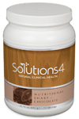

Rewards for Referrals
We have a mission to help our entire community live happier and healthier lives. Refer a friend today and we’ll reward you with a FREE Nutritional Shake!

To: _______________________________________
From: _____________________________________
I had an amazing experience at my doctor’s office and I know you will too! They have amazing services like inch-loss body wraps and all-natural, organic skincare. When you attend the Free Breakthrough Weight Loss Seminar, present this coupon and receive a FREE One-On-One Evaluation with the doctor. (Normally it’s $125!)
May Events
WEIGHT LOSS EVENT
MAINTENANCE PROGRAM

We offer Maintenance Programs!

WEIGHT LOSS SEMINAR
Offered weekly

This breakthrough Weight Loss Seminar will teach you exactly what is keeping you from your goal weight and what you can do to start taking control of your life! Come alone or bring a friend!

Call our office for dates and times, and to register for a spot!

actually loaded with harmful omega-6 fatty acids. Each time you consume vegetable oil, you increase your overall level of inflammation. Over time, eating too much vegetable oil can lead to weight gain and chronic disease.
May’s Skinny Contest!
Are you worried about gaining back all the weight you worked so hard to lose? Don’t worry! We’ve found that the best way to keep weight off permanently is through maintenance! We want to hold your hand through the process!
Pay as little as $10 a month!

This month’s winner will be whoever loses the most weight (lbs).

Contest rules:
1. Come into our office anytime in the month of March – the sooner the better! Let our staff know you’d like to enter this month’s contest.
2. Return to our office on the last day of the month for your final weigh-in.
“If it came from a plant, eat it; if it was made in a plant, don’t.” -Michael Pollan, Food Rules
This month’s winner will receive
FREE LIPOLIGHT SESSIONS!

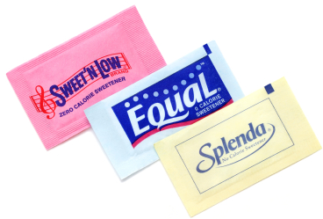
7. Watch what you eat during the week, but take the weekends off.
If you’re eating processed foods on the weekends, you’re exposing your body to toxins that confuse your hormones and prevent you from losing weight throughout the week.
8. Artificial sweeteners are a great substitute for sugar.
Unfortunately, the chemicals in artificial sweeteners convince your body to lower its metabolism and reduce its production of many fat-burning hormones. Your body isn’t tricked as easily as your taste buds!
9. Choose meats that don’t contain much fat.
This advice is true for conventional grain-fed beef,
5. Replace butter with margarine.
Mainstream nutrition got this one wrong in a big way. Margarine is a heavily processed product that actually increases your risk of heart disease and obesity. You’re better off eating butter.
6. Everybody should be eating whole wheat bread.
Unfortunately, whole wheat bread is a processed food that does not promote health in any significant way. To lose weight, try gluten-free whole grains like brown rice and quinoa instead.
Which of these foods is best for weight loss?

Meet Karlissa – She lost 23 pounds and bought a whole new wardrobe!
This Month’s Skinny Star
“7 Healthy Habits that Will Boost Your Energy” – From Page 1
Healthy Tip:


To satisfy your sweet tooth, keep fresh fruit on hand. You never know when the craving will strike!
HOW HAS THIS PROGRAM CHANGED YOUR LIFE?
“I did a 12-Week Candida Program, and I lost 23 pounds! I feel great! The biggest difference I’ve seen is in my clothes. About a month into my program, I had to buy a brand new wardrobe! My pants felt like they were falling off.

I would strongly recommend this program to other people. It’s not only good your health, but it completely changes your perspective on food.

It taught me to think much more carefully about what I eat.”

You know that pizza, ice cream, and soda aren’t good for weight loss, but do you know what is? Take this quiz and put your nutrition knowledge to the test! Choose the food that would help the very most.
- Papaya

- Acai berries

- Quinoa

- Kale

- Dark chocolate

Did you guess right? Read the small print below to find out!
Answer: Kale is actually the best food for weight loss! Kale is an incredible source of Vitamin A, Vitamin C, and Vitamin K! Because kale is on of the most nutritious foods on the planet, it helps curb cravins for sugar and sweets!
but false for wild-caught salmon. Wild-caught salmon is loaded with anti-inflammatory omega-3 fatty acids that can actually help you lose weight!
10. Milk prevents osteoporosis.
Contrary to popular opinion, milk doesn’t actually reduce your risk of osteoporosis. Unless you’re a baby cow, it’s probably not very good for you at all. If you want to strengthen your bones, you’re better off eating leafy greens (like spinach, kale, collards, and chard) and other vegetables instead!
Did You Know…?

You can save up to 10% on all your favorite Solutions4 supplements when you order online!
Ask a staff member for details on how you can take
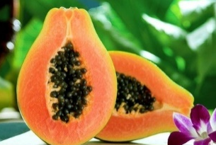
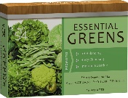
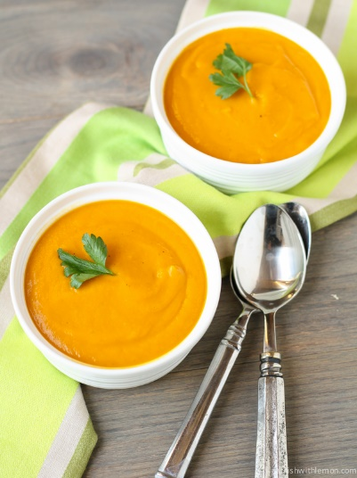


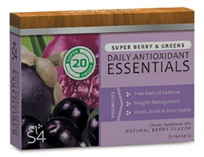

“Let food be thy medicine, and medicine be thy food.”
Directions:
- In a 6-quart pan, sauté onions, in butter over medium heat.
- Once onions are translucent, add broth, carrots, and ginger.
- Bring to a boil and then reduce heat, simmering until carrots are tender.
- Pour into a blender, adding coconut milk, salt, and pepper.
- Puree until smooth, then serve.

Enjoy!

Creamy Carrot Ginger Soup!
Ingredients:
--2 tbsp. organic butter
--3 onions, chopped
--6 cups chicken broth
--2 lbs. carrots, sliced
--2 tbsp. grated ginger
--1 cup organic coconut milk
--Salt and pepper
--Parsley for garnish

Break Time
$2 off Solutions4 Super Berry Greens!
Bring this Coupon in and Receive
$2 off this product!
*Cannot be combined with any other offer. Coupon expires 5/31/2019
This March, the pot of gold at the end of the rainbow is Solutions4 Super Berry Greens! This exciting product has been created just for you – to help you stick to a healthy lifestyle throughout March and beyond!
Getting your daily dose of nutritious super foods has never been so easy. Each serving of Solutions4 Super Berry Greens Mix is jam-packed with the essential vitamins, enzymes, antioxidants, and phyto-nutrients that your body needs. Super Berry Greens helps to improve digestion and balance the pH of the body, while also delivering high-ORAC value of antioxidants and assisting in cleaning the blood.
This product has been shown to boost energy, cleanse the blood, aid in the removal of free radicals, manage weight, improve skin tone, repair cells, fight disease, improve digestion and help detoxify the body. Drop one stick pack into 8 oz. of water to mix instantly. One box contains 15 convenient stick packs. You can have one every morning, or just before you exercise. Good luck!

May’s Featured Solutions4 Product: Essential Greens!
may provide quick energy, ultimately they will lower your energy levels. The more you drink them, the more you rely on them to get you through the day. That’s why you should be wary of using caffeine for energy boosts. With high-calorie, low-nutrient energy drinks, or just your everyday cup of joe, you will certainly get a rush of energy, but in the end it will cause fatigue (and a whole host of other problems). In addition, it’s important for you to know that sugar – in whatever form – is not a solution to low energy. You might think “candy bar!” when your energy dips, but a sugar boost will just leave you lagging again in an hour. High-sugar foods spike your blood sugar for a brief burst of energy, followed by a rapid drop in blood sugar, leaving you feeling burnt out and moody.
If you can’t use “quick fixes” like coffee, candy bars, and 5-hour energy shots, what can you do? Strive to live an energy-producing lifestyle! It seems counterintuitive, but if you cut caffeine and sugar out of your diet, you will live with much more energy! Read the main article for more information on how to boost your energy naturally through healthy habits!
“Why can’t I just use an energy drink for a boost?”
Energy drinks contain large doses of caffeine, sugar, or other stimulants. While certain drinks
Ask a Doctor
We can’t wait to feature YOU as next month’s Skinny Star! Keep setting your goals and working hard and you could be featured here!
advantage of this amazing offer!

