
SKINNY
[Your Clinic Name Here]
[Address]
[Hours]
[Phone Number]
What’s The
Make sure to Bring a Friend and Join Us for These Free In-Office Club Reduce Events!

[Patient Name]
[Address]


What’s Inside The Skinny:
February 2021
------------- The Monthly Dish
The Monthly Dish: “How Your Body Image Can Make or Break Your Weight Loss Goals!”
Product Spotlight + Coupon: Solutions4 Vitamin B12!
This Month’s Skinny Star: Congratulations Christine!
Ask a Doctor: “With Valentine’s Day just around the corner, I know that I’ll be tempted to eat a box of chocolate. Is there something healthy (but equally satisfying) that I could eat instead?”
Break Time: Sudoku and an Organic Berry Cobbler Recipe!
Sidebar: “5 Healthy Ways to Treat Yourself This Valentine’s Day!”
Event Listings & Information

How Your Body Image Can Make or Break Your Weight Loss Goals!


Oscar Wilde once said, “To love oneself is the beginning of a lifelong romance.” If you’re struggling to lose weight, it’s time to think about your relationship with yourself.
If you’re not in love with you¸ no amount of self-improvement will change that. Self-loathing cannot be cured with weight loss. You won’t come to love and accept yourself more as the pounds fall away. That’s not how it works. It’s time to get yourself out of the “I’ll be happy when…” mindset and start loving who you are here and now.
Begin by addressing yourself mentally. Tell yourself that you will love yourself, no matter what. Once you’ve taken this first mental step, you’ll find that the physical part of losing weight is that much easier! With Valentine’s Day just around the corner, you don’t want to wait for someone else to show you that they care. Instead, show yourself a little love by making healthier choices and really investing in your future.
If you embark on this journey with the wrong mindset, you’ll fall victim to the same cycles and patterns as before. If you’re subconsciously telling yourself that you’ll only really be happy when you lose weight, you may find yourself making poor choices (for example, eating too little during the day, and then binging later when you have less self-control). You may try following fad diets that only encourage this cycle of under-eating and binging. This can make it even harder to cultivate a positive self-image! You’ll be right back where you started, and the cycle will continue on and on.



Rewards for Referrals
Bring a friend to our Breakthrough Weight Loss Seminar, and you will both receive FREE Body Wraps!
If you haven’t attended our seminar, now is a great time to come! If you’ve already been, come for a refresher!
We look forward to seeing you soon!

Find the Lemon!

We have a mission to help our entire community live happier and healthier lives. Refer a friend today and we’ll reward you with a FREE Nutritional Shake!
Find the hidden lemon somewhere in this newsletter! Be the first one to find it and we’ll give you a FREE Body Wrap! Normally valued at $125! Call our office to redeem your prize!
*This prize is non-transferable and cannot be exchanged for product.


To: _______________________________________
From: _____________________________________
I had an amazing experience at my doctor’s office and I know you will too! They have amazing services like inch-loss body wraps and all-natural, organic skincare. When you attend the Free Breakthrough Weight Loss Seminar, present this coupon and receive a FREE One-On-One Evaluation with the doctor. (Normally it’s $125!)
February Events
WEIGHT LOSS EVENT
MAINTENANCE PROGRAM



We offer Maintenance Programs!

January’s Skinny Contest!

WEIGHT LOSS SEMINAR
Offered weekly

This breakthrough Weight Loss Seminar will teach you exactly what is keeping you from your goal weight and what you can do to start taking control of your life! Come alone or bring a friend!

Call our office for dates and times, and to register for a spot!

This month’s winner will be whoever loses the most weight (lbs).

Are you worried about gaining back all the weight you worked so hard to lose? Don’t worry! We’ve found that the best way to keep weight off permanently is through maintenance! We want to hold your hand through the process!
Pay as little as $10 a month!

Contest rules:
1. Come into our office anytime in the month of March – the sooner the better! Let our staff know you’d like to enter this month’s contest.
2. Return to our office on the last day of the month for your final weigh-in.

Meet Christine: She lost 37 lbs. and is amazed by how quickly the weight fell off!
“How Your Body Image Can Make or Break…” – From Page 1
5 Ways to Treat Yourself This Valentine’s Day!

To break free from this vicious cycle, you must address the root cause of your problem – your headspace! When you’re unhappy with yourself, you’ll make choices that reinforce your negative self-image. When you learn to practice greater love and acceptance, you’ll feel more optimistic about your decision to live a healthier lifestyle. Just keep in mind that “loving yourself” doesn’t mean that you have to stay as you are. If you truly love yourself, you’ll make the choices that make you feel your very best – not because others expect it of you, but because it’s what you want for yourself.

To take charge of your health and lose those extra pounds for good, start by improving your relationship with yourself this Valentine’s Day. Take some personal time to think about where you’re at in life, where you’re going, and what goals you want to reach. Practice radical self-acceptance and learn to love yourself no matter what. This Valentine’s Day, don’t focus on receiving love from others. Focus on your relationship with yourself, because you are PERFECTLY IMPERFECT, inside and out!

If you need any help as you embark
upon this journey, don’t be afraid
to give us a call! That’s what we’re
here for. We’d love to sit down with
you and talk about the progress you’ve
been making so far! If you’re facing
obstacles that seem insurmountable
in your personal life, we’re happy to
talk about that too. Everything that
happens in your life is interrelated –
your personal problems, your food
choices, and even your sleep habits!
To overcome obstacles in any one of these categories,
you may need help overcoming obstacles in other areas. We’re always here to help!

This Month’s Skinny Star

WHAT WAS LIFE LIKE BEFORE YOUR PROGRAM?
“I felt really down. I didn’t have any energy. I was tired all the time. I didn’t want to get out of bed. I wanted to sleep all day. I knew I had to do something. I found this place, and it has changed my life. It’s been a good journey for me.”

WHAT SURPRISED YOU ABOUT YOUR PROGRAM?
“How fast the weight was coming off. I didn’t feel like I was doing that much. I simply followed the program and all this weight just kept falling off. I thought how in the world is that possible? How can you do a program and - without that much effort - cause your weight to fall off? It just falls off! To anyone who is considering doing a program, do it! Don’t even hesitate! I’ve tried so many programs and this is the only one that has really worked for me.”

Healthy Tip:
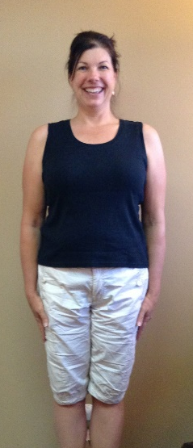
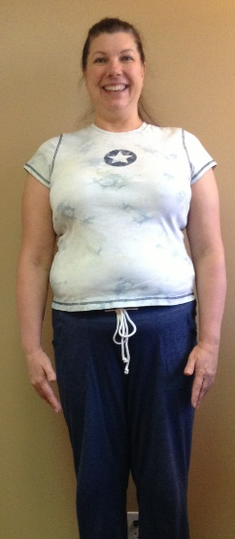
This February, don’t depend on food to make you feel good. There are plenty of other ways to treat yourself that won’t make you feel guilty after. Use these five tips to treat yourself to a guilt-free holiday!
1. Do something you love!
Take the time to do something you’re passionate about, whether that means playing your favorite sport, reading a good book, or sitting down to a good movie.
2. Take a night to yourself to de-stress! Life can be hectic, and sometimes the best of us need a breather. Schedule some time just for you to unwind and recharge your batteries.
3. Get together with loved ones! Spending quality time with those you love can be enormously restorative. Don’t miss out on the stress-reducing benefits of this quality time.
4. Buy yourself something nice! Maybe it’s time to splurge on that sweater you’ve had your eyes on for months. It’s time to start looking as good as you feel!
5. If you must treat yourself with food, choose a healthier alternative! Try the Organic Berry Cobbler listed on page 3. This recipe will satisfy your sweet tooth and deliver a healthy dose of antioxidants!

Plan ahead. If you know you’re going to be in a situation where tempting food is available, plan to bring a healthy alternative.

Did You Know…?


You can save up to 10% on all your favorite Solutions4 supplements when you order online!
Ask a staff member for details on how you can take


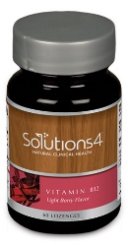

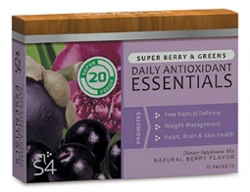


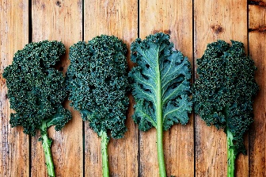

Directions:
1. To make the crust, pulse pumpkin seeds, almonds, salt and olive oil in a food processor until it’s dough-like. 2. Slowly add dates and mix into a “dough.” 3. Use it to cover the bottom of a small pie dish. 4. To make the syrup, blend blueberries and dates, adding water as needed, into a thick syrup. 5. Pour the syrup mixture over the crust, covering the dish. 6. Top with the 1 ½ cups of berries.
Your body needs antioxidants to ward off the free-radicals that contribute to premature aging and poor health. This recipe packs in high levels of health-boosting antioxidants without adding any sugar! It’s just as delicious as it is nutritious.
Ingredients: Syrup
Crust 1 cup organic blueberries
1 cup dry pumpkin seeds ½ cup pitted organic dates
1 cup dry almonds ¼ cup water
¾ tsp. sea salt
4 Tbsp. extra virgin olive oil Topping
½ cup pitted dates 1 ½ cups blueberries
“With Valentine’s Day just around the corner, I know that I’ll be tempted to eat a box of chocolate. Is there something healthy (but equally satisfying) that I could eat instead?”
Vitamin B12 is a fast-acting lozenge that provides you with an all-natural energy boost. This useful vitamin plays a key role in keeping your brain functioning at peak performance. When your vitamin B12 levels dip too low, you’ll notice that you’re often fatigued, constipated, and experience “brain fog” throughout the day. If your levels dip too far, you can even develop more serious disorders of the nervous system!
In addition to increasing your energy, vitamin B12 can boost your mood, improve your digestive health, improve your memory, bolster your immune system, reduce your risk of cancer, and make you look like a million bucks!
If you want to make this Valentine’s Day your best yet, Vitamin B12 is your secret weapon. You could even use it as a nice Valentine’s Day gift!
This Valentine’s Day, we’re featuring our favorite energy-boosting supplement. Whether you’re single or in a relationship, Solutions4 Vitamin B12 is exactly what you need to get you through Valentine’s Day.

Vitamin B12 is a fast-acting lozenge that provides you with an all-natural energy boost. This useful vitamin plays a key role in keeping your brain functioning at peak performance. When your vitamin B12 levels dip too low, you’ll notice that you’re often fatigued, constipated, and experience “brain fog” throughout the day. If your levels dip too far, you can even develop more serious disorders of the nervous system!

In addition to increasing your energy, vitamin B12 can boost your mood, improve your digestive health, improve your memory, bolster your immune system, reduce your risk of cancer, and make you look like a million bucks!

If you want to make this Valentine’s Day your best yet, vitamin B12 is your secret weapon. You could even use it as a nice Valentine’s Day gift for a friend or family member! With just one lozenge daily, you can see big results in your health.
Taking your Daily Essentials will help to ensure that your body is receiving the nutrients it needs to maintain optimal health and achieve your weight loss goals. If you want this year to finally be the year that you reach your goal weight, supplementation is essential. Your body needs to receive 100% nutrition on a daily basis to keep your “fat burning” hormones at work!

Each day that you take your Daily Essentials, you’ll find yourself a step closer to finally checking off your New Year’s resolutions. One box will last approximately 30 days: the perfect amount to last you through the month!
We can’t wait to feature YOU as next month’s Skinny Star! Keep setting goals and working hard, and you could be featured here!
February’s Featured Solutions4 Product: Vitamin B12!
Though the standard box of chocolates you’d find at a chocolatier or grocery store will almost always contain unhealthy additives and unwanted ingredients, it’s possible to find dark chocolate that’s additive-free and very lightly sweetened. If this sounds appealing for you, go ahead and buy yourself a bar from your local health food store!

If you’re not into dark chocolate, look for another way to satisfy your sweet tooth. There are hundreds of sugar-free recipes out there that are just as healthy as they are delicious (like the Organic Berry Cobbler recipe on pg. 3).

If you don’t know where to start with healthy desserts, try looking for recipes online. If you want to know whether something is suitable for your program, just give us a call! We’re always here to answer any questions you may have.

Organic Berry Cobbler
$2 off Solutions4 Vitamin B12!
Bring this Coupon in and Receive
$2 off this product!
*Cannot be combined with any other offer. Coupon expires 2/28/2021

Break Time
“Make peace with the mirror and watch your reflection change.”
Ask a Doctor
advantage of this amazing offer!

