
SKINNY
What’s the
[Your Clinic Name Here]
[Address]
[Hours]
[Phone Number]
Make sure to Bring a Friend and Join Us for These Free In-Office Events!

[Patient Name]
[Address]

September 2021
What’s Inside the Skinny:
------------- The Monthly Dish
The Monthly Dish: “6 Secret Superfoods for a Slimmer Body!”
Product Spotlight + Coupon: Solutions4 Salmon Oil!
This Month’s Skinny Star: Congrats Nancy!
Ask A Doctor: “I’ve hit a plateau and I’m having trouble losing weight. What can I do?”
Break Time: Sudoku and a Healthy Homemade Sushi Recipe
Sidebar: “Think You Know How to Read a Nutrition Label? Take this Quick Test…”
Event Listings & Information
6 Secret Superfoods for a Slimmer Body

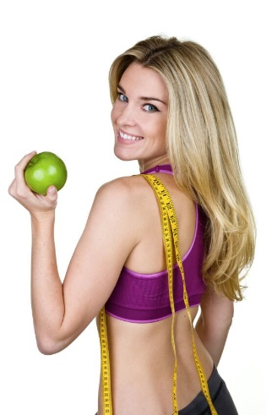
While there is no official definition of a “super food,” it’s widely recognized that these foods pack in mega-doses of essential vitamins, minerals, antioxidants, and other substances that your body needs! Super foods are known to reduce your risk of chronic disease, promote optimal health, and help you shed unwanted pounds (there’s a reason why potato chips don’t make the list!). If you’re ready to kick your fat-burning hormones into gear, keep reading to learn about these incredible foods and what you can do to incorporate them into your life!


Dark Leafy Greens
The Standard American Diet is woefully lacking in the delicious, nutritious, dark leafy greens that keep our bodies healthy. Dark leafy greens like spinach, arugula, and kale are low in calories and loaded with a potent blend of antioxidants, vitamins, minerals, and fiber! They keep you full, help control your appetite, and moderate your blood sugar by slowing the absorption of carbs into your bloodstream.
Cruciferous Vegetables
Cruciferous vegetables like broccoli and cauliflower are rich in potent phytochemicals that are essential for good health and weight loss. These powerful veggies reduce your risk of cancer and protect you from free radical damage. Eating plenty of these “super veggies” will provide your body with the nutrients it needs to slim down the all-natural way!
Brightly Colored Veggies
Bring a friend to our Breakthrough Weight Loss Seminar, and you will both receive FREE Body Wraps!
If you haven’t attended our seminar, now is a great time to come! If you’ve already been, come for a refresher!
We look forward to seeing you soon!

Find the Lemon!
Find the hidden lemon somewhere in this newsletter! Be the first one to find it and we’ll give you a FREE Body Wrap! Normally valued at $125! Call our office to redeem your prize!
*This prize is non-transferable and cannot be exchanged for product.
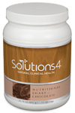

Rewards for Referrals
We have a mission to help our entire community live happier and healthier lives. Refer a friend today and we’ll reward you with a FREE Nutritional Shake!

To: _______________________________________
From: _____________________________________
I had an amazing experience at my doctor’s office and I know you will too! They have amazing services like inch-loss body wraps and all-natural, organic skincare. When you attend the Free Breakthrough Weight Loss Seminar, present this coupon and receive a FREE One-On-One Evaluation with the doctor. (Normally it’s $125!)
September Events
WEIGHT LOSS EVENT
MAINTENANCE PROGRAM

WEIGHT LOSS SEMINAR
Offered weekly

This breakthrough Weight Loss Seminar will teach you exactly what is keeping you from your goal weight and what you can do to start taking control of your life! Come alone or bring a friend!

Call our office for dates and times, and to register for a spot!
We offer Maintenance Programs!

September’s Skinny Contest!
Are you worried about gaining back all the weight you worked so hard to lose? Don’t worry! We’ve found that the best way to keep weight off permanently is through maintenance! We want to hold your hand through the process!
Pay as little as $10 a month!
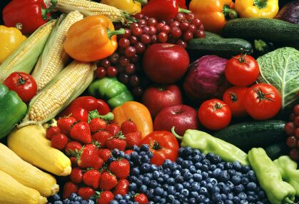
To slim down, it’s important to eat a rainbow of brightly colored vegetables! Bright colors – red, orange, yellow, green, blue, or purple – indicate the presence of valuable nutrients.

See page 2 for more….

This month’s winner will be whoever loses the most weight (lbs).

Contest rules:
1. Come into our office anytime in the month of March – the sooner the better! Let our staff know you’d like to enter this month’s contest.
2. Return to our office on the last day of the month for your final weigh-in.
“Take care of your body. It’s the only place you have to live.” – Jim Rohn
This month’s winner will receive
FREE LIPOLIGHT SESSIONS!
“Top 6 Reasons to Give Up Processed Food…” – From Page 1
For example, red vegetables like tomatoes and peppers are rich in lycopene, a nutrient that can reduce your risk of heart disease. When you eat a rainbow of veggies every day, your body will also have the nutrients it needs to stay alert and energetic throughout the day!

Sea Vegetables
Sea vegetables are an excellent source of important micronutrients that aren’t available elsewhere. Many sea vegetables (kelp, dulse, wakame, kombu, nori, etc.) are packed with some of the densest nutrition on the planet! Though these foods might seem a little weird at first, they can make a delicious addition to healthy

meals. You can try making homemade sushi rolls with nori, adding a little dulse to your salad, or sprinkling wakame in your soup!

Seasonal Fruit
Seasonal fruit isn’t just less expensive and more flavorful – it’s also more nutritious! When you buy fruits out of season, they must be picked before they’re ripe so that they can be shipped around the world and arrive at your local grocery store. This means that the fruit may be lacking in many important nutrients that never have a chance to fully develop. This is why seasonal fruits can be up to three times more nutritious than their out-of-season counterparts! This September, choose seasonal fruits like blackberries, apples, and figs.
Fresh Sprouts and Microgreens
Fresh sprouts and microgreens may be some of the most underrated superfoods available in your grocery store! Studies show that tiny microgreens can contain up to 40 times higher levels of vital nutrients than their mature counterparts! Sprouts contain similarly high levels of many nutrients and are packed with fiber and plant-based protein. This makes them uniquely able to regulate your blood sugar levels and thereby prevent inflammation. Sprouts and microgreens are two incredible foods that can help you slim down this fall!

This Month’s Skinny Star
Think You Know How to Read a Nutrition Label?
Take This Quick Test…

Meet Nancy – She lost 49 pounds and feels so much better than she did before!
Healthy Tip:


If you find yourself feeling unnecessarily hungry, drink a big glass of water. Wait ten minutes and then see how you feel before snacking.
WHAT WAS LIFE LIKE BEFORE YOUR PROGRAM?
“Before my program, I felt sluggish and had a hard time doing the things I enjoy. I’ve wanted to clean up my diet before, but I could never quite do it on my own.”
HOW HAS THIS PROGRAM CHANGED YOUR LIFE?
“I did a 12-Week Candida Program, and it’s been great to have recipes and healthy foods that I know I can eat. I lost 49 pounds and I feel so much better! I feel like I want to do things again that I couldn’t before. I used to jump rope, and I’m excited to start doing that again. Walking and taking the stairs are so much easier. I also know that when I look in the mirror, I look so much better, which makes me feel so much better! If you’re thinking about doing a program, do it! It’s worth it.”
You probably know how to read a nutrition label to determine how many calories you ate in a serving. But do you know how to determine whether a product contains too much junk or too few nutrients? Let’s find out!
One of the three statements below is false. Which one is it?
- This food is high in iron.
- If I ate the whole package, I would consume more calories than my body needs in a day (if I’m trying to lose weight).
- This food is an excellent source of protein.
To find out if you’re right, read the small print below!

The third statement is false. This food only contains 4 grams of protein, which isn’t a lot! However, this food is an excellent course of iron. It’s also extremely high in calories. If you ate the entire package, you’d end up eating a whopping 1,840 calories! When you’re snacking, it’s easy to overlook how quickly the calories add up.

Did You Know…?

You can save up to 10% on all your favorite Solutions4 supplements when you order online!
Ask a staff member for details on how you can take



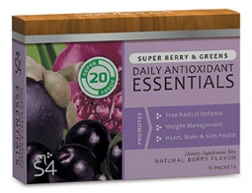
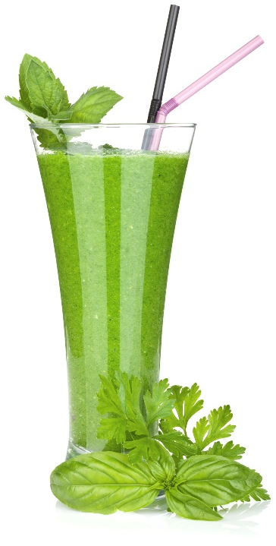

advantage of this amazing offer!
Break Time
We can’t wait to feature YOU as next month’s Skinny Star! Keep setting your goals and working hard and you could be featured here!
Ask a Doctor
September’s Featured Solutions4 Product: Salmon Oil!
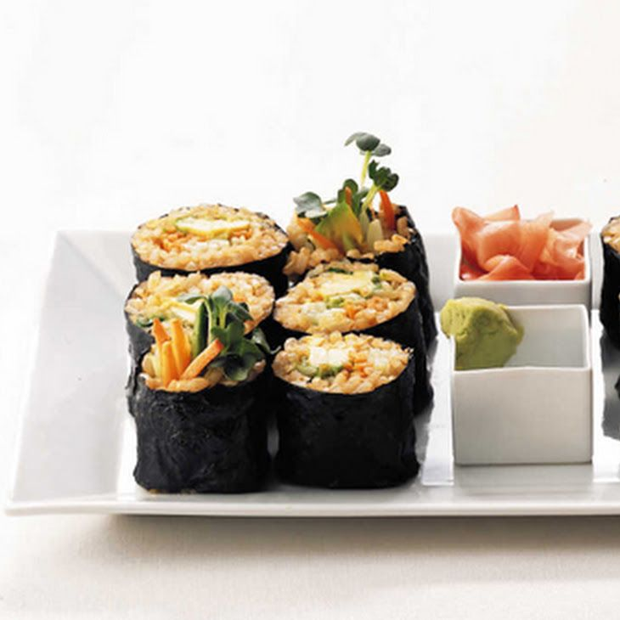
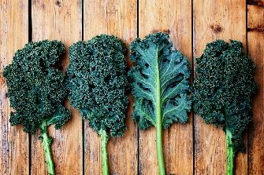

Healthy Homemade Sushi Rolls!


“I’ve hit a plateau and I’m having trouble losing more weight. What can I do?”
As frustrating as a plateau may be,

Wild salmon oil does not suffer from the faults that plague traditional fish oils. A salmon’s cold-water habitat and relatively short lifespan dramatically reduce the exposure to common environmental toxins, resulting in a higher quality oil with greater purity.
This salmon oil is derived from sockeye salmon, a breed that feeds solely on krill – which has the highest potency of DHA and EPA available anywhere. A salmon’s high dietary intake of protective carotenoids such as astaxanthin make their oil more resistant to spoilage and rancidity than other fish oils. Also, taking salmon oil very day can assist the body in losing weight by reducing inflammation and helping to support the heart, brain, and all functions of good health. On top of all this, salmon are a renewable, self-sustaining resource.
Other fish oils, which are commonly a blend of several specials of fish, have a much less consistent level and blend of healthy omega acids, especially EPA and DHA. Our Salmon Oil contains 180 mg of EPA and 220 mg of DHA, two of the most beneficial constituents of omega-3 fatty acids. Getting your daily dose of omega acids has never been easier!


there are several things that you can do to shed the weight for good. If you’re sticking to your program, you should be using the daily checklists in the back of your program manual. Double check these pages to make sure that you’re eating the right amount of calories each day. If you’re eating too little, your body will go into “fat storing” mode and refuse to let go of any additional weight. If you’re eating too much, your body will store the excess calories as fat! That’s why it’s so important to find a healthy, happy medium where your body can thrive. If you know that you’re eating the right amount of food, it’s time to look into other lifestyle factors. Too little sleep, too much stress, and too little exercise can all cause a plateau. Make sure that you’re getting 8 hours of sleep each night, finding ways to manage your stress levels – as tough as that may be – and exercising regularly throughout the week. If it seems like you’re doing everything right, try switching up what you’re eating and what you’re doing for exercise. Sometimes your body just needs to be startled out of complacency!
This super-healthy recipe combines the benefits of sea vegetables (nori) and fresh sprouts! You’ll be surprised how easy it is to make this exciting and delicious dish at home.

“The greatest wealth is health.” - Virgil
Ingredients:
--2/3 cup short-grain brown rice
--1 cup water
--2 tbsp rice vinegar
--2 sheets roasted nori
--1/2 cucumber, cut into matchsticks
--1/2 carrot, cut into matchsticks
--1/2 small avocado
--3/4 oz. radish sprouts
--Bragg’s Liquid Aminos for dipping
*Equipment: bamboo sushi mat

$2 off Solutions4 Salmon Oil!
Bring this Coupon in and Receive $2 OFF this product!

Coupon expires 9/30/2021

Directions:
1. Cook rice in 1 cup water. 2. Stir in vinegar and allow to cool. 3. Arrange one sheet of nori on the bamboo mat, shiny side down. Using damp fingers, gently press half the rice onto the nori in a single layer, leaving a 1.5 inch border at the top. 4. Layer vegetable slices and sprouts in an even horizontal strip across the rice. 5. Roll your sushi while holding the filling in place with your fingers. 6. Repeat with your second roll. 7. Slice into 1-inch rounds and enjoy!

