
SKINNY
What’s the

[Patient Name]
[Address]
[Your Clinic Name Here]
[Address]
[Hours]
[Phone Number]
Make sure to Bring a Friend and Join Us for These Free In-Office Club Reduce Events!


December 2022
What’s Inside the Skinny:
------------- The Monthly Dish
The Monthly Dish: “Give Yourself the Gift of a Healthy Lifestyle This Christmas Season!”
Product Spotlight + Coupon: Solutions4 Solutions4 Nutritional Shake!
This Month’s Skinny Star: Congrats Ivetteh!
Ask A Doctor: “What healthy treats can I use as stocking stuffers this Christmas?”
Break Time: Sudoku and a Dark Chocolate Macadamia Nut Recipe!
Sidebar: “Do Your Christmas Shopping at Our Clinic!”
Event Listings & Information
Give Yourself the Gift of a Healthy Lifestyle This Christmas Season!




December is here, which means that Santa is on his way! Before you write your annual letter to Santa, stop and think about what is most important in your life. Do you really need a new iPhone? Or would you rather have the body you’ve always dreamed of? Christmas is the perfect time to make changes to your diet and lifestyle. You’ll get a head start on your New Year’s resolutions and be more likely to succeed! Keep reading to learn about the four ways that you can transform your health this December…

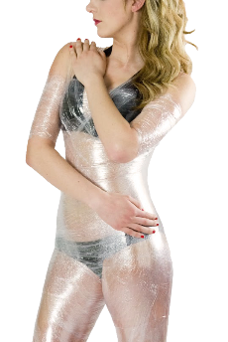
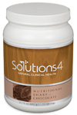
Rewards for Referrals
Bring a friend to our Breakthrough Weight Loss Seminar, and you will both receive FREE Body Wraps!
If you haven’t attended our seminar, now is a great time to come! If you’ve already been, come for a refresher!
We look forward to seeing you soon!

Find the Lemon!
Maximize Your Nutritional Intake for Better Health
Poor nutrition is the main reason that most people gain weight and develop chronic health conditions. What you eat affects EVERYTHING that goes on in your body and determines your level of health! Unfortunately, most Americans don’t even realize that they’re eating so poorly. For example, many people think that a plain, white cream cheese bagel is a perfectly healthy breakfast! Other people think that pasta is healthy enough to eat every night of the week. With these popular misconceptions floating around, it’s no wonder that obesity is on the rise! If you want to eat a truly healthy diet this Christmas season, the main thing you need to do is avoid processed foods – including refined grains like bagels and pasta. It’s also very important to eat several servings of vegetables each day. If you take these steps, you’re sure to look and feel your best throughout the holidays!
Find the hidden lemon somewhere in this newsletter! Be the first one to find it and we’ll give you a FREE Body Wrap! Normally valued at $125! Call our office to redeem your prize!
*This prize is non-transferable and cannot be exchanged for product.
We have a mission to help our entire community live happier and healthier lives. Refer a friend today and we’ll reward you with a FREE Nutritional Shake!


To: _______________________________________
From: _____________________________________
I had an amazing experience at my doctor’s office and I know you will too! They have amazing services like inch-loss body wraps and all-natural, organic skincare. When you attend the Free Breakthrough Weight Loss Seminar, present this coupon and receive a FREE One-On-One Evaluation with the doctor. (Normally it’s $125!)
December Events
WEIGHT LOSS EVENT
MAINTENANCE PROGRAM

WEIGHT LOSS SEMINAR
Offered weekly

This breakthrough Weight Loss Seminar will teach you exactly what is keeping you from your goal weight and what you can do to start taking control of your life! Come alone or bring a friend!

Call our office for dates and times, and to register for a spot!
We offer Maintenance Programs!
December’s Skinny Contest!


Are you worried about gaining back all the weight you worked so hard to lose? Don’t worry! We’ve found that the best way to keep weight off permanently is through maintenance! We want to hold your hand through the process!
Pay as little as $10 a month!
This month’s winner will be whoever loses the most weight (lbs).

Contest rules:
1. Come into our office anytime in the month of March – the sooner the better! Let our staff know you’d like to enter this month’s contest.
2. Return to our office on the last day of the month for your final weigh-in.
Meet Ivetteh – She lost 40 pounds and transformed her entire family’s health!
“Give Yourself the Gift of a Healthy Lifestyle This Christmas Season!” – From Page 1
Exercise to Build Muscle
Inactivity makes you more likely to become obese, increases your risk of diabetes, and makes you more likely to develop heart disease. If you or your loved ones suffer from these conditions, it’s not too late to prevent them from controlling your life. Regular physical activity can help you improve your health throughout the holidays! Though weight loss is mainly accomplished through nutrition, exercise can make you more likely to successfully keep your weight off for life. That’s because muscle increases your resting
Reduce Stress for Best Results
High stress levels make it almost impossible to lose weight during the holidays. Chronic stress raises cortisol levels in your body, increasing the rate at which you store fat. It also raises your blood sugar levels, makes you hungry, and increases the storage of fat around the stomach and liver. Under chronic stress, weight loss is extremely difficult. So relax! Take time for yourself to pursue an activity that you love. Find ways to lower your stress levels – whether that involves a spiritual practice, meditation, or some other calming activity. Be optimistic about your future! You’ve embarked on a journey of self-healing that will change your life.

metabolic rate, making it easier to burn more calories with less effort!
Sleep More to Lose More Weight
Insufficient sleep is a public health epidemic. Before the invention of the light bulb, people slept an average of 10 hours each night. Today, most Americans average a mere 6.9 hours each night! Getting enough sleep is essential for good health and for weight loss. Most people need at least 7-9 hours each night, beginning by at least 10 pm. If you get in bed by 10 pm, your body will be able to get into REM sleep – the deep sleep that your body needs – from 12 to 2 am. During this time, your body increases its production of fat-burning hormones, which helps with weight loss.

Do Your Christmas Shopping at Our Clinic!

This Month’s Skinny Star
Healthy Tip:
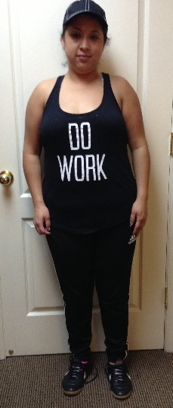
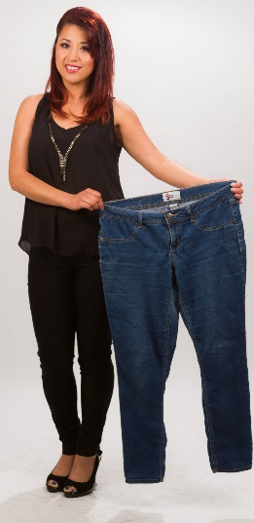
If you’re running low on energy, it’s time to hit the gym. Exercise will boost your energy levels and help you survive the hectic holidays!
WHAT WAS LIFE LIKE BEFORE YOUR PROGRAM?
“I was always sad and I never felt good about myself.
I tried every diet and exercise, but nothing worked. My parents have diabetes, and I didn’t want that to happen to me so young. I also couldn’t play soccer anymore because I was too heavy.”

HOW HAS THIS PROGAM CHANGED YOUR LIFE?
“I lost 40 pounds, and I feel great! Now, I can go to the store and buy whatever clothes I want. I don’t have to worry about my soccer games, because I know I’m in shape. My kids are eating better, and my husband lost 10 pounds along with me. It was a life-changing experience, and I’m grateful for everything.”
Now you can purchase high-quality, organic Solutions4 products in fun, discounted bundles – just in time for Christmas! Let our office be your one-stop shop this Christmas: You will save time and money while giving your family and friends the special gift of health and wellness! Don’t forget to pick up something for yourself too. These are some of our lowest prices of the year, so don’t miss out!

Did You Know…?

You can save up to 10% on all your favorite Solutions4 supplements when you order online!
Ask a staff member for details on how you can take

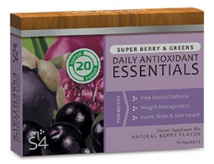
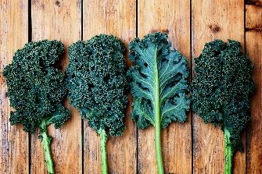

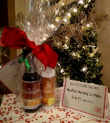

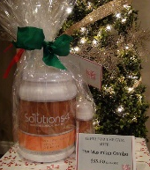

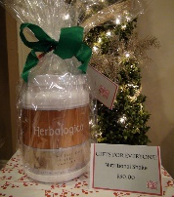


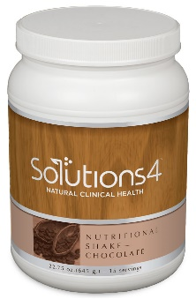

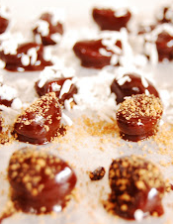

substitute for soda or coffee!
The Solutions4 Nutritional Shake provides you with the nutrients you need to lose weight safely and effectively. The nutrients in this one-of-a-kind beverage can boost your immune system, facilitate digestion, improve brain function, and support muscle building. The shake doesn’t contain any artificial ingredients, preservatives, or other unwanted additives. It’s 100% pure and free from allergens like gluten and lactose. For something creamy and delicious, try blending the chocolate shake with a frozen banana or the vanilla shake with a handful of leafy greens!

For a fun Christmas activity, try whipping up “milkshakes” made with the Nutritional Shake, fruit, homemade almond milk, and ice! You’ll love how delicious nutrition can be.
$2 off Solutions4 Nutritional Shake!
Bring this Coupon in and Receive
$2 off this product!
*Cannot be combined with any other offer. Coupon expires 12/31/2022

Gifts for Dad!
Exercise Gel!
$23.20
(20% Off)

Gifts for Mom!
Ageless Beauty Combo!
$32.80
(20% Off)

Gifts for the
Gym Buff!
The Maximizer Combo!
$53.60
(20% Off)

Gifts for
Women!
Complete
Facial Kit!
$41.60
(20% Off)

“It’s Christmas in the heart that puts Christmas in the air!”
Gifts for Everyone!
Nutritional Shake
$40.00 (20% Off)

Dark Chocolate Macadamia Nuts!
Break Time
If you’re looking for the perfect stocking-stuffer, you’re in luck! This honey-sweetened recipe is one of our very best.
Treat yourself to this guilt-free recipe and enjoy the holidays!
Ingredients:
8 oz. macadamia nuts
8 oz. unsweetened chocolate
1/3 cup raw honey
2 tbsp. extra virgin coconut oil
Dash of sea salt

Optional toppings:
Unsweetened coconut flakes
Coarse sea salt
Granulated maple sugar
Optional toppings:
Unsweetened coconut flakes
Coarse sea salt
Granulated maple sugar

Directions:
1. Chop unsweetened chocolate into fine pieces. 2. Melt chocolate, honey, oil, and dash of sea salt in a double broiler. 3. Prepare a cookie sheet lined with wax paper. 4. Dip each macadamia nut by dropping it into the chocolate and fishing it out with a fork, shaking off the excess and placing it on the cookie sheet. 5. Before the chocolate hardens, sprinkle your choice of topping over it. 6. Allow your treats to harden, then enjoy!
We can’t wait to feature YOU as next month’s Skinny Star! Keep setting your goals and working hard and you could be featured here!
Ask a Doctor
“What healthy treats can I use as stocking stuffers this Christmas?”
With Christmas just around the corner, you’re probably looking for ways that you can keep up your new, healthy lifestyle without
falling off the wagon. So what in the world are you going to use as stocking stuffers?
Fortunately, there are several delicious options that you don’t have to feel guilty about.

To get started, there are the Single-Serve Nutritional Shake Packs! These packs are as delicious as they are nutritious, and they’re something that everyone will love. You’ll have a blast whipping up healthy “milkshakes” after opening presents!

We also recommend sprouted nuts that you can make yourself or find in your local health food store. Sprouted nuts are even crunchier than regular nuts, making them exceptionally delicious! If you’re feeling decadent, try coating your sprouted nuts in dark chocolate or another seasoning of your choice.

You can also use fruit as a healthy stocking stuffer, especially if you’re able to find interesting or exotic fruits that make the gift that much more exciting. For something special, try dipping strawberries in dark chocolate! These options are no less delicious even though they’re so healthy.

December’s Featured Solutions4 Product: Nutritional Shake!
advantage of this amazing offer!
Let’s be honest. Many beverages that are available today are loaded with processed sugar and other harmful ingredients. The Nutritional Shake, on the other hand, is all-natural and sugar-free, making it a great substitute for soda or coffee!

