

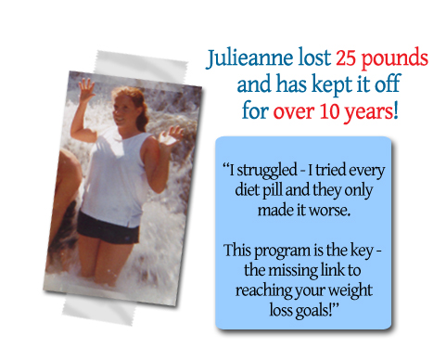
Call (888) 888-8888  www..WeightSeminar.com

We are looking for people like you… ✓people who have tried every diet ✓people who can’t control their cravings✓people who have failed with exercising ✓people who cannot sleep at night ✓people who cannot think clearly ✓people who are sick of being so tired
If you are ready to lose weight, we mean seriously lose weight and keep it off, then we want you in our office for a special program!
If you are chosen to participate in this program, your entire life is about to change for the better!
This opportunity is extremely limited. We only have room to accept 20 individuals into this specially monitored program. There is a chance all slots will be full if you don’t call now. One of our knowledgeable staff members is waiting to speak with you about your current situation, and they will help determine the next step to see if you qualify for this special weight loss program.
20 People to Lose 30 to 50 lbs.
Serious Inquiries Only! Call (888) 888-8888

This opportunity is extremely limited. We only have room to accept 20 individuals into this specially monitored program. There is a chance all slots will be full if you don’t call now. One of our knowledgeable staff members is waiting to speak with you about your current situation, and they will help determine the next step to see if you qualify for this special weight loss program.

for a special program!
If you are chosen to participate in this program, your entire life is about to change for the better!
This opportunity is extremely limited. We only have room to accept 20 individuals into this specially monitored program. There is a chance all slots will be full if you don’t call now. One of our knowledgeable staff members is waiting to speak with you about your current situation, and they will help determine the next step to see if you qualify for this special weight loss program.
If you are ready to lose weight, we mean seriously lose weight and keep it off, then we want you in our office for a special program!
If you are chosen to participate in this program, your entire life is about to change for the better!

for a special program!
If you are chosen to participate in this program, your entire life is about to change for the better!
This opportunity is extremely limited. We only have room to accept 20 individuals into this specially monitored program. There is a chance all slots will be full if you don’t call now. One of our knowledgeable staff members is waiting to speak with you about your current situation, and they will help determine the next step to see if you qualify for this special weight loss program.
We are looking for people like you…
✓people who have tried every diet
✓people who can’t control their cravings
✓people who have failed with exercising
✓people who cannot sleep at night
✓people who cannot think clearly
✓people who are sick of being so tired

for a special program!
If you are chosen to participate in this program, your entire life is about to change for the better!
This opportunity is extremely limited. We only have room to accept 20 individuals into this specially monitored program. There is a chance all slots will be full if you don’t call now. One of our knowledgeable staff members is waiting to speak with you about your current situation, and they will help determine the next step to see if you qualify for this special weight loss program.
Call (888) 888-8888  subdomain.WeightSeminar.com

20 People to Lose 30 to 50 lbs.
Serious Inquiries Only! Call (888) 888-8888

