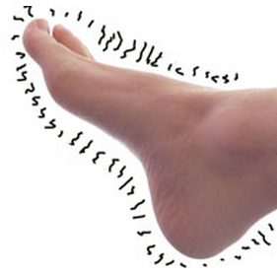
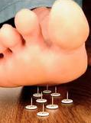
“I drove 120 miles to get this treatment because I had not been able to feel my feet for 15 years. I work on a farm and I would stumble and fall because I could not feel the ground under my feet. I’m getting older and I can’t afford to fall and break something. After the treatments, I was able to feel my feet and toes again. Now for the first time in over a decade I have feelings in my feet. “
Patient M.H., Age 85

type of technology and because of the almost immediate type of pain relief, I had to have one of these deep tissue treatments in my facility no matter what the cost.

I invested and implemented this new treatment that utilizes cold laser healing and pain relieving therapies.

I traveled to another state and enrolled in extensive training. My staff and I witnessed some amazing reductions and eliminations of some of the worst pain syndromes I had ever seen…
And it was FAST! After just a few minutes of treatment on patients with extreme and chronic pain of the worst kind, including neuropathy of the feet and legs, we had patients telling us how their pain levels had decreased and they were shocked. Some of them had their pain even alleviated after only one treatment.

“I Can’t Live with Excruciating Foot And Leg Pain”
Announcing A New High Tech Method For The Treatment of Peripheral Neuropathy and Type II Diabetes Symptoms...
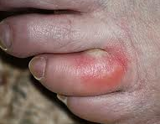
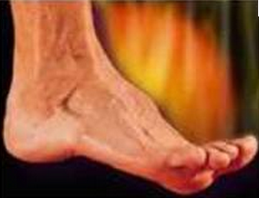
CALL TODAY
For FREE Evaluation
(801) 265-3400
Dr. Todd Singleton, Chiropractic Physician
Lighthouse Pain Relief,
715 E 3900 S, #107, Salt Lake City, UT 84107

Once you’ve been evaluated fully and completely with our very thorough
Neuropathy Treatment Evaluation, we will know if you are a candidate for this new painless and effective Neuropathy Pain Relief Program.

Call our office right away to qualify for one of the 27 Free Neuropathy
Evaluation Appointments!

So just how can you see if Dr. Singleton’s
Neuropathy Pain Relief treatment will help you to reduce or eliminate your foot or leg pain?

For a limited number of callers (we are limiting this to the first 27 callers due to the response to this type of
offer), we are now offering our unique 7-Point FREE Evaluation…

FREE 7-Point Leg and Foot Neuropathy Evaluation!

During your free evaluation, you will be checked for:
-Foot and Leg Circulation
-Nerve Sensitivity
-Pain Fiber Receptors
-Thermal Receptors
-Pressure Receptor
-Light Touch Sensitivity
-Nutritional Sensitivities

Expires 8/31/2011
Here’s what some patients have said about the treatments:

“I was on 14 medications and my doctors had told me I may need to have my foot amputated. I hadn't been able to wear shoes other than sandals for years
because of my swollen and painful feet. After going through this program I’ve lost weight and my foot pain is gone. I can now wear normal shoes.”
Patient, N.S., Age 58

We were able to reduce or even eliminate neuropathy pain of the worst kind.

Using the latest and most recent tech-nologies, I now offer a non-invasive, non surgical and painless neuropathy pain treatment. I help patients reduce or even eliminate their neuropathy pain using nutritional therapies, deep tissue super-pulsed cold laser treatments, combined with specific non-surgical, non-invasive, relaxing re-integration and stimulation treatments of peripheral nerves using whole body vibration to increase their function quickly.

“Doc, I can’t live with this
excruciating foot and leg pain!”

When you hear this from a patient it gets your attention. Typically, I get the worst of the worst pain patients but when I recently heard this exclamation, my attention was particularly peaked. Let’s call this patient Bob. Bob is 62 years old with neuropathy in his hands and feet. He had poorly controlled
Type II Diabetes and his life was literally as he described it “a living hell.” Clearly he was coming to the end of his rope. The nerves in his legs and feet were damaged and he was in HORRIBLE CONSTANT PAIN

“I Can’t Sleep at Night!”

He complained to me, “I can’t sleep at night because my legs feel like they are being eaten by little bugs or chewed on by small animals.”

During the day, he could hardly walk and every step sent shooting pain like lightning from his toes and up his legs up almost to his knees. He had numbness in his feet and couldn’t feel his feet very well and had terrible balance problems. He was worried he might fall and injure himself.

He told me that he could not go on living with this constant, debilitating pain that had made every day a tragedy.

I had to help this man!

I recently was fortunate enough to accidentally discover a new non-invasive and non-drug treatment for severe and constant foot and leg pain caused by neuropathy.

I learned about a new type of non-surgical and painless laser-like high tech treatment that was working wonders with severe, constant chronic pain, including pain caused by
Neuropathy.

It had the ability to quickly increase circulation to an area (much needed in a neuropathy patient). It could reduce and/or eliminate pain in as little as a few treatments and was changing the lives of patients with severe debilitating pain in offices across the nation.

Based on the research about his new

CALL TODAY
For FREE Evaluation
(801) 265-3400
Dr. Todd Singleton, Chiropractic Physician
Lighthouse Pain Relief,
715 E 3900 S, #107, Salt Lake City, UT 84107

