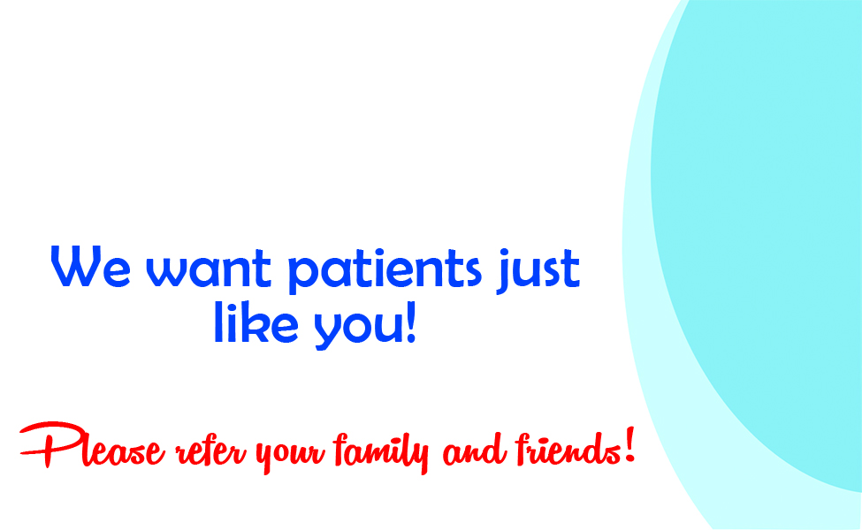

Your Logo Here
Your
Clinic’s
Name

1234 Main St.
Your Town, ST
12345
Monday- Friday
8:00am-8:00pm
(555) 555-5555
YourWebsite.com

