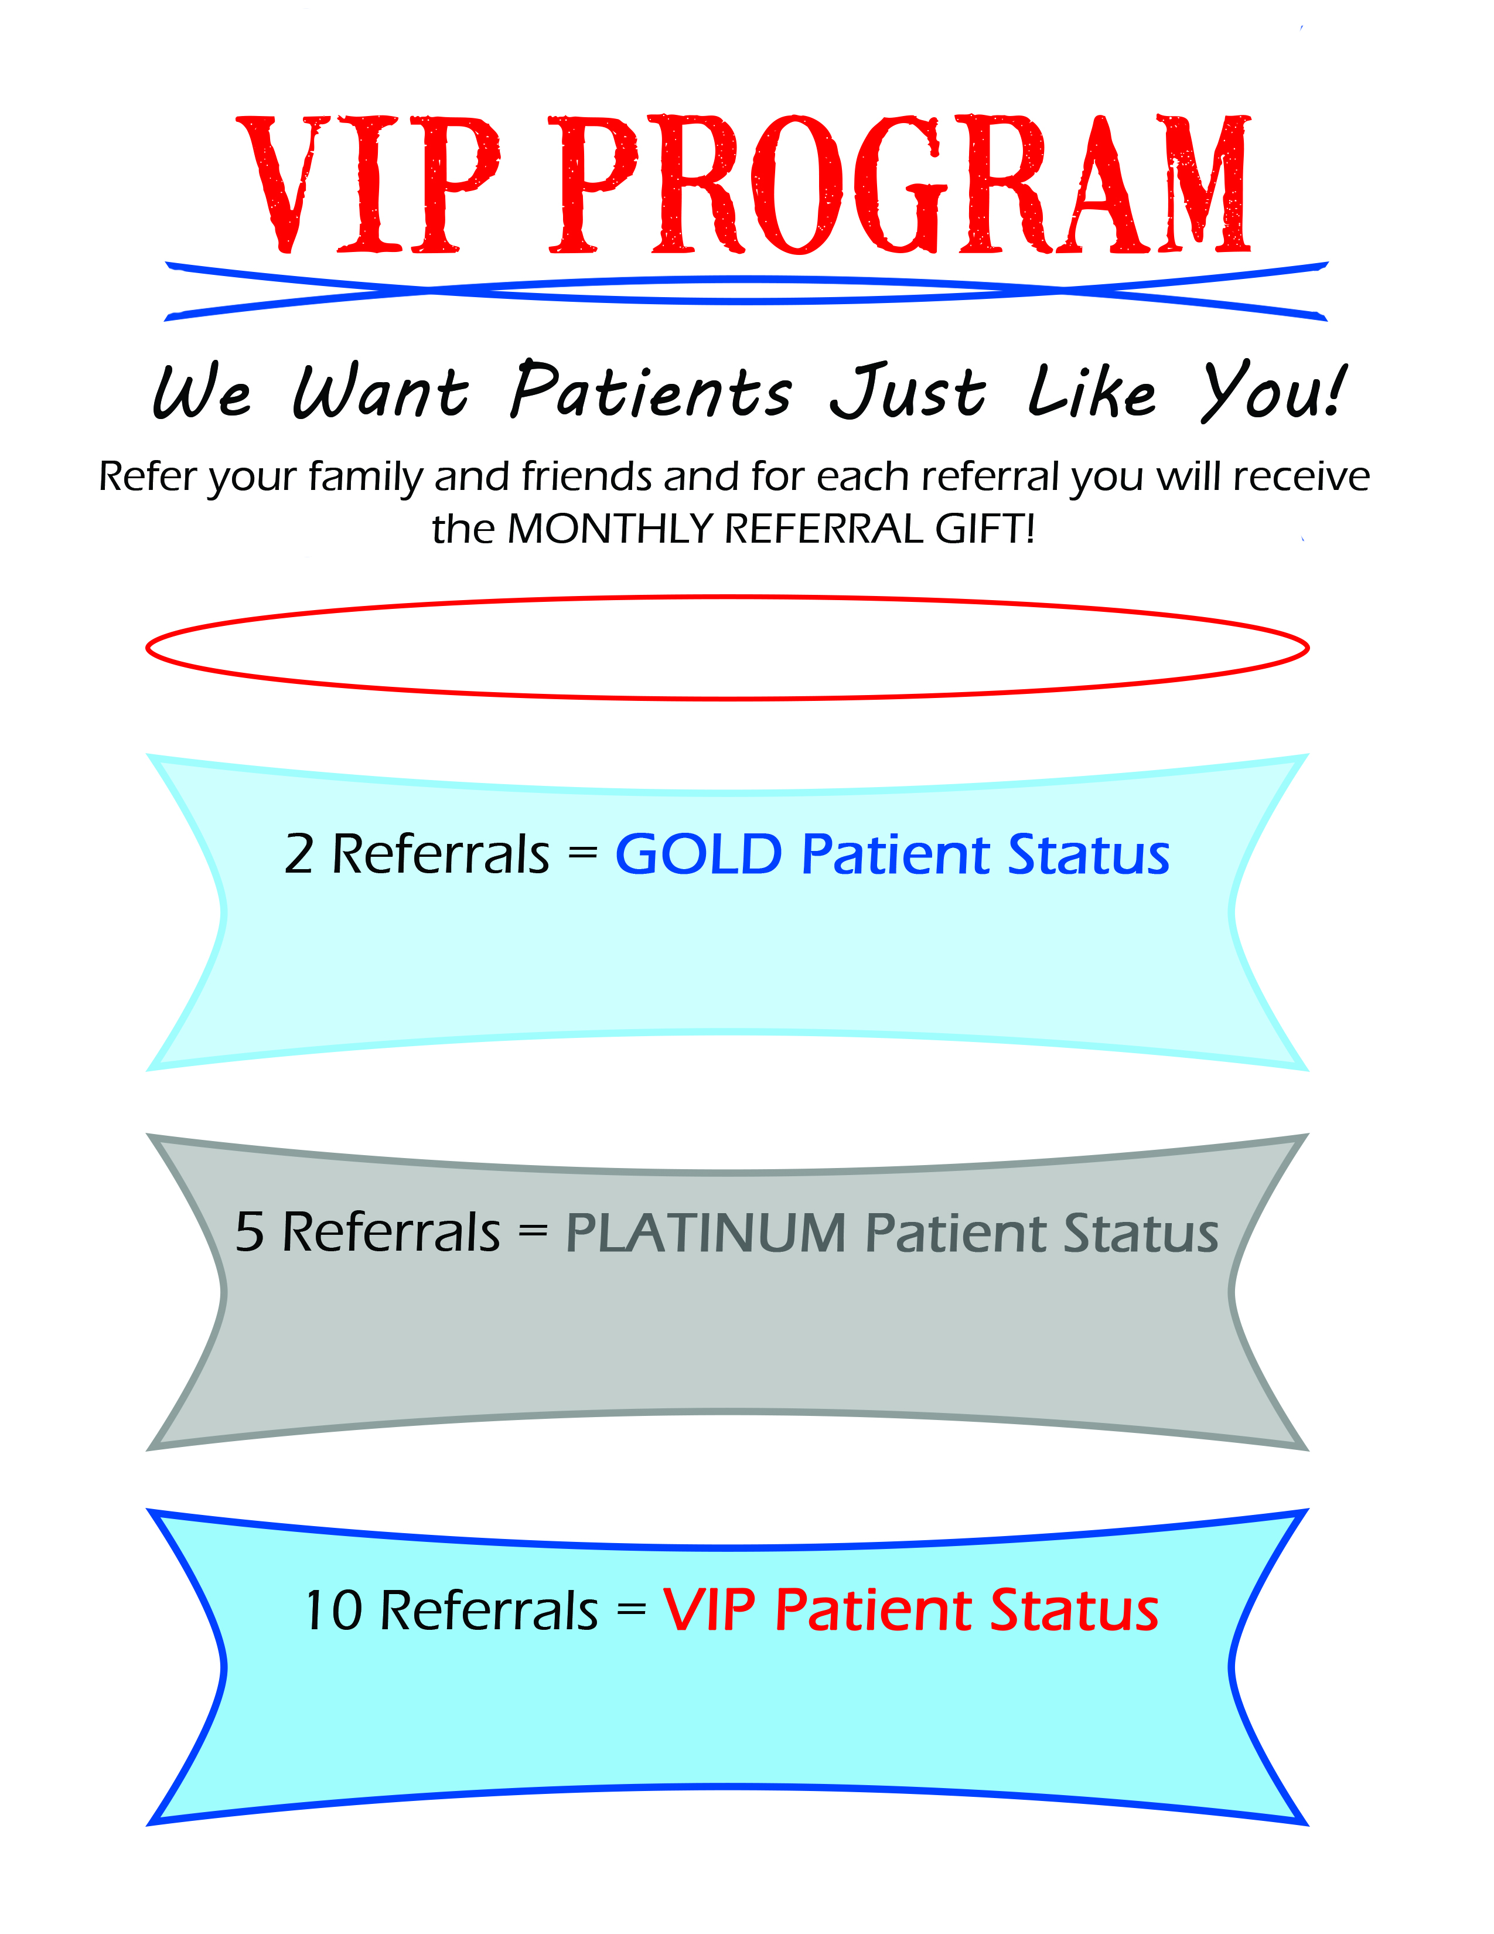
*Receive 5 FREE Body Wraps
*Receive $250 in (Your Clinic) Gift Certificates
*Receive 2 FREE Body Wraps
*Receive $125 in (Your Clinic) Gift Certificates
*Receive 1 FREE Body Wrap
*Receive $50 in (Your Clinic) Gift Certificates
Each Referral = $25 (Your Clinic) Gift Certificate

