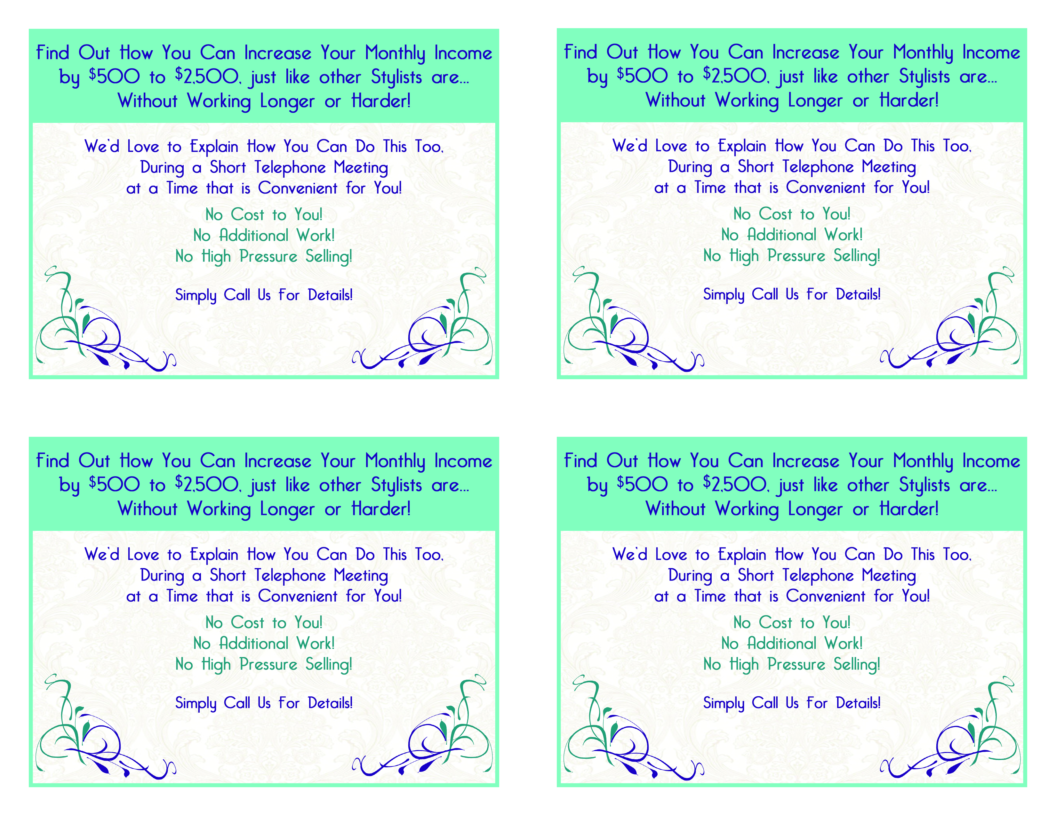
(555) 555-5555
(555) 555-5555
(555) 555-5555
(555) 555-5555
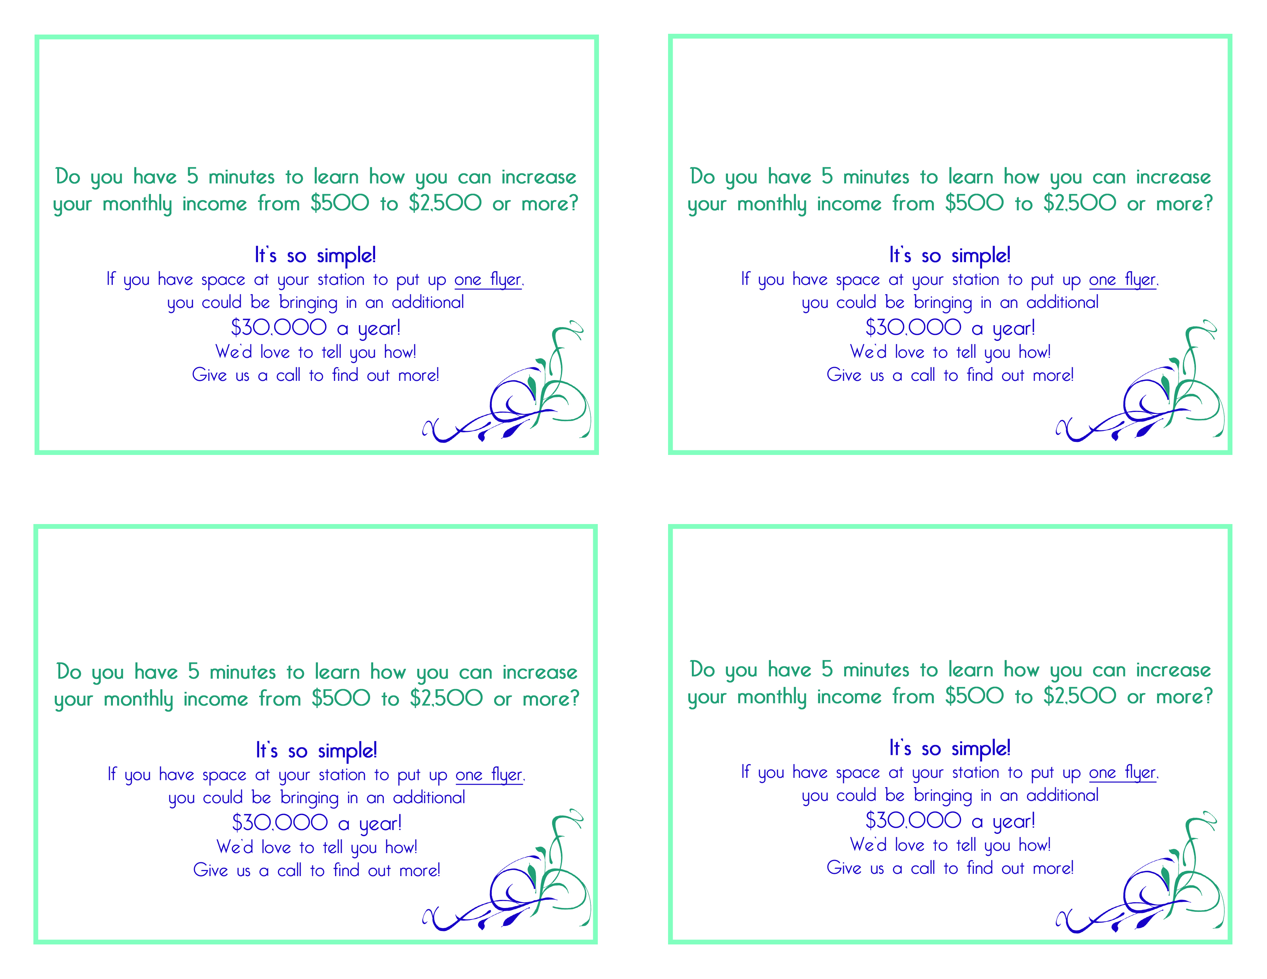
1234 Main Street
Your Town, ST 12345
1234 Main Street
Your Town, ST 12345
1234 Main Street
Your Town, ST 12345
1234 Main Street
Your Town, ST 12345
(555) 555-5555
(555) 555-5555
(555) 555-5555
(555) 555-5555

