Script for the Body Contouring Package
-Trade Shows-

Offering a Body Contouring Package at a Trade Show is a GREAT thing to offer especially if you do Seminars, One-on-One Evals and Body Wraps in your office!

It is a great offer because from the beginning, your new lead will know what they are expected to do and receive with the Package. You can offer this Package for FREE or for a discounted price. It is easier for you and your new lead because they will know that they have to come to a seminar before getting their free Eval or free Body Wrap.

*At the trade show make sure to stand in front of your booth. When sitting or standing behind your booth you are not as approachable.

Hold a clip board in your hand with your sign-up sheets ready for your new leads to fill out.

As people walk by say the following
Script:
“Hi, would you like to sign up to win a FREE (or discounted) Body Contouring Package?”
-Remember to keep things simple and short as they walk by.

If you get their attention and they say yes, then give them the sign-up sheet so they can fill out their information.

As they are filling out their information make sure to talk to them and tell them exactly what they will be getting in their Package!
Script:
“As you’re filling out your information I wanted to tell you a little bit about what you will be receiving in this amazing Body Contouring Package! You get to come to an incredible, very informative, free weight loss and health class (seminar) to learn how to help you lose weight or get healthy. Then you will get to meet with our experienced Doctor and he/she will give you a one-on-one evaluation to help you reach your goals weather you want to lose weight, feel better or just get more healthy! Then you will receive a very relaxing detoxification Body Wrap that helps reduce cellulite and inch loss. This Package is a one of a kind and at this show ONLY we are offering it for FREE (or discounted)”

-Keep it short and simple but make sure to always mention everything they receive in the Body Contouring Package. When you’re talking to them always sound happy and excited about what you are offering!

*Remember you can do whatever works best for you with this package! If you don’t want to do a seminar and offer a lipo treatment instead that’s great! Whatever you do in your office is what you should offer.

Below is the sign-up sheet for the Body Contouring Package.

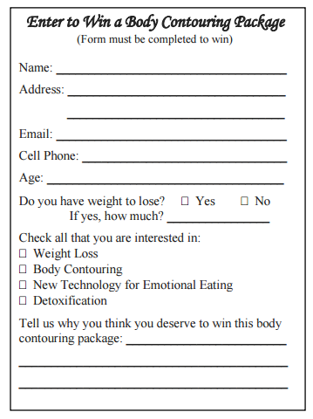
Found under Marketing > All > Trade Shows > Handouts > Enter to Win Form-Body Contour Package
________________________________________________________________________________________________

Below is a flyer you can use at your booth for the Body Contouring Package.

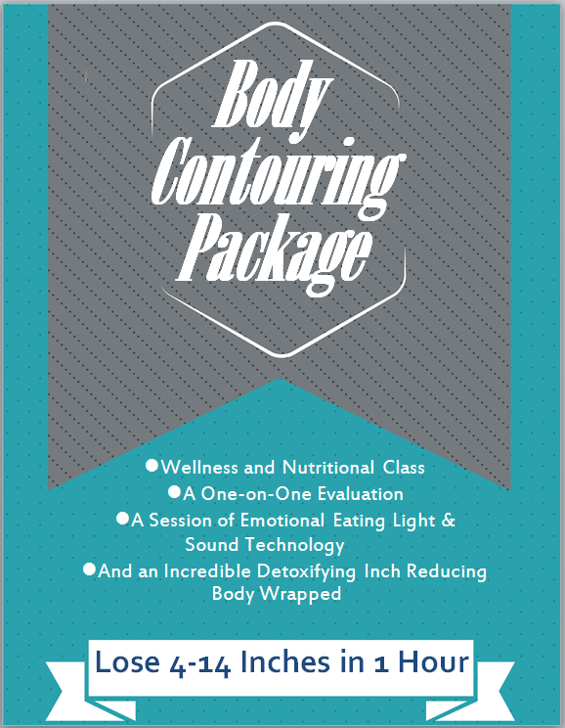

Found under Marketing > All > Trade Shows > Set Up Materials > Body Contouring Package Sign

