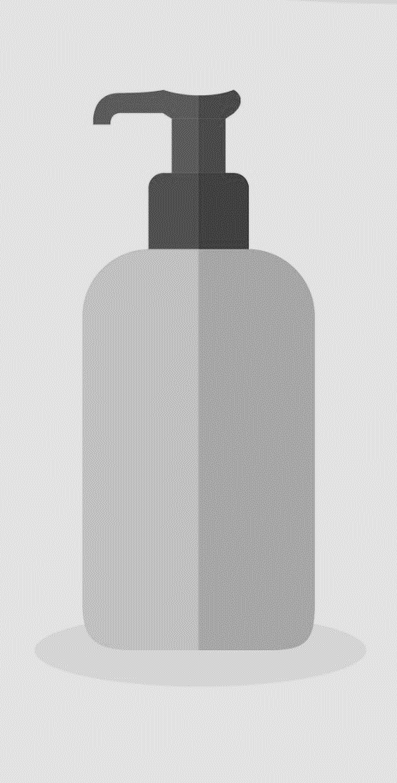



WHAT’S REALLY IN MY SKINCARE PRODUCTS?

- Skincare products are some of the least regulated products on the market. Most skincare products are never tested for safety before they are widely distributed.
- Of the 13,000 chemicals used in cosmetics in the United States, only about 10% have been evaluated for safety.
- Of the 10% of chemicals that have been evaluated, 884 have been shown to be toxic to human health.
- Women use an average of 12 personal care products and cosmetics each day. Through these products, women end up putting an average of 168 chemicals on their skin every single day!

WHY SHOULD I BE WORRIED?

- If you’re putting 168 different chemicals on your skin every single day, imagine how they add up over the course of your entire life!
- The skin is the largest organ in the human body, and also the most permeable. When you use lotions or skincare products, the ingredients are absorbed, and many make it into your bloodstream.
- Toxic ingredients can hinder attempts at weight loss and contribute to poor health. They also contribute to skin problems ranging from acne to premature aging – the very problems that skincare products are supposed to treat!

TOP 20 WORST TOXINS TO WATCH OUT FOR

Polyethylene glycol (PEG) MEA (Monoethanolamine) Dioxins BHA & BHT
Benzoyl Peroxide TEA (Triethanolamine) Avobenzone Coal tar dyes
Propylene Glycol Parabens Ethoxycinnamate Siloxanes
Butylene Glycol Sodium Lauryl/Laureth Sulfate DMDM Hydatoin & Urea PABA
DEA (Diethanolamine) Pthalates Benzphenone Triclosan

OUR ALL-NATURAL SKINCARE LINE

The Green Tea Cleanser is a super-potent cleanser that heals and softens your skin. It includes antioxidants like green tea leaves, CoQ10, and vitamin C to fight off the free radicals that cause premature aging.

The Apple Stem Cell Moisturizer uses stem cells derived from a rare Swiss apple (the Uttwiler Spätlauber) to restore skin to a state of youthful vibrancy. We are able to literally give aging skin a fresh new start.

The Apricot Exfoliator is a grapseed-oil based scrub that uses apricot seeds to provide gentle exfoliation. It also contains collagen and elastin builders to prevent against fine lines and wrinkles.

Hidden Dangers in Your Makeup Bag

