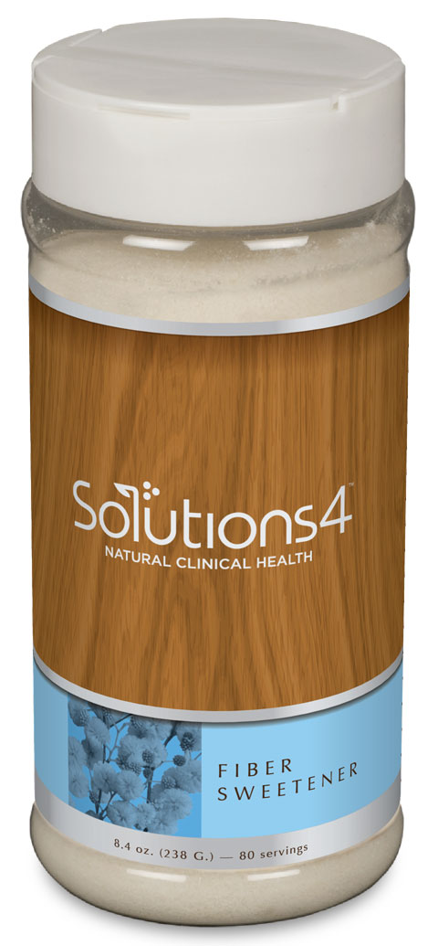
The Harmful Health Effects of Sugar
Sugar
8 g.
12 g.
20 g.
30 g.
WHY IS SUGAR SO BAD FOR ME?

- Sugar contains no nutrients, no protein, no healthy fats, and no enzymes. It provides a source of empty calories that actually pull minerals from the body during digestion.
- Unfortunately, more than 70% of the American diet is composed of refined carbohydrates like white sugar and flour!
- A couple of hours after eating too much sugar, your blood sugar levels will plummet, and you’ll want to reach for something sweet. This new sugary snack will stimulate insulin production, causing your blood sugar to drop even more. You’ll experience low energy, hunger, and cravings — causing the vicious cycle to continue.
- Eventually, if this cycle continues, the pancreas will slow or stop producing insulin altogether.
- Excess sugar in the diet can also lead to metabolic syndrome — a cluster of unhealthy conditions (high blood pressure, high blood sugar, a large waist circumference, and abnormal cholesterol levels) that lead to diabetes and heart disease.

HIDDEN SOURCES OF SUGAR IN YOUR DIET:

Granola bar: Seems healthy, right? Though granola bars contain healthy ingredients like fruit and nuts, they’re mostly held together with sugar. Each bar contains about 8 grams of sugar.

Pasta sauce: If you’ve been thinking of pasta sauce as a health food, think again! 1 cup of sauce contains an average of 12 grams of sugar.

Low-fat yogurt: You might think that low-fat yogurt is healthier than the regular stuff. But when you compare the food labels, you’ll see that a low-fat yogurt really packs in the sugar.

Soda. Your average 8 oz. can of soda contains 30+ grams of sugar. That’s nearly 8 teaspoons! Next time the craving strikes, think about what that much sugar looks like.

SATISFY YOUR SWEET TOOTH WITH THE FIBER SWEETENER

Many people find it hard to cut sweets out of their diet altogether. But with the Solutions4 Fiber Sweetener, you don’t have to! This incredible product is a sugar-free, chemical-free, low-calorie, low-glycemic soluble fiber supplement and sweetener. Though you can use it to sweeten just about anything, it also contains a healthy dose of fiber! Fiber helps to speed up digestion, normalize bowel movements, lower cholesterol levels, and help you lose weight naturally. Unlike other natural sweeteners, it also contains two special forms of fiber – chicory root and acacia – that help stabilize your blood sugar levels. This helps to reduce inflammation and prevents your energy levels from plummeting after a big meal!

