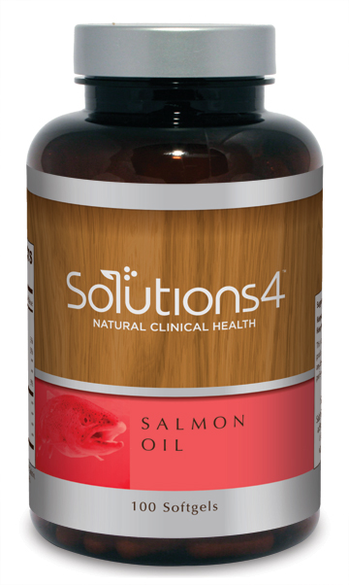
Balancing Omega Ratios for Better Health
WHAT ARE ESSENTIAL FATTY ACIDS AND WHY DO THEY MATTER?

- There are two Essential Fatty Acids (EFAs) that cannot be manufactured by your own body: Omega-3 and Omega-6. They have to be obtained through diet.
- Historically, our ancestors ate diets that were abundant in seafood and other sources of omega-3 fatty acids. Omega-6 fatty acids (primarily from nuts and seeds) were consumed as well, but in much lower quantities than most Americans eat today. The ratio of omega-3 to omega-6 was approximately 1:1. Today, the ratio is closer to 1:20, with far too little omega-3 in the diet.
- Omega-3 fatty acids are a powerful anti-inflammatory that provide incredible healing benefits to the body. They’re also highly metabolically active, meaning that they play an important role in healthy weight loss (by helping your cells respond more effectively to fat burning hormones).
- Omega-6 fatty acids are also necessary for human health, but they’re generally overeaten in the standard American diet. Refined vegetable oils pack in record high levels of omega-6, which when eaten in excess, can have inflammatory effects in the body. Unfortunately, these oils are just about everywhere we turn.

WHERE TO FIND OMEGA-3 FATTY ACIDS: WHERE YOU’LL FIND OMEGA-6 FATTY ACIDS:

Salmon Herring Canola oil Soybean oil
Tuna Rainbow trout Safflower oil Mayonnaise
Anchovies Chia seeds Sunflower oil Red meat
Sardines Flaxseeds Peanut oil Poultry
Mackerel Salmon Oil Margarine

GET MORE OMEGA-3 IN YOUR DIET WITH SOLUTIONS4 SALMON OIL!

- If you don’t get enough omega-3 fatty acids through your diet, you can always take a high quality supplement! The Solutions4 Salmon Oil is uniquely pure and 100% potent.
- Each capsule of Solutions4 Salmon Oil is enteric-coated to ensure maximum absorption and no fishy aftertaste. If you don’t like fish, you don’t have to worry that you might not like the flavor.
- Each serving of Salmon Oil contains 180 mg of EPA and 200 mg of DHA, two of the most beneficial types of omega-3 fatty acids. These omega-3s can boost your mental health, reduce your risk of disease, and make it easier to lose weight safely and effectively!
- The Solutions4 Salmon Oil is far superior to other fish oil products on the market. Solutions4 uses salmon exclusively because this fish lives in a cold water habitat where it isn’t exposed to nearly as many environmental toxins as other types of fish. Salmon’s dietary intake of protective carotenoids also make their oil more resistant to spoilage and rancidity than other fish oils.

