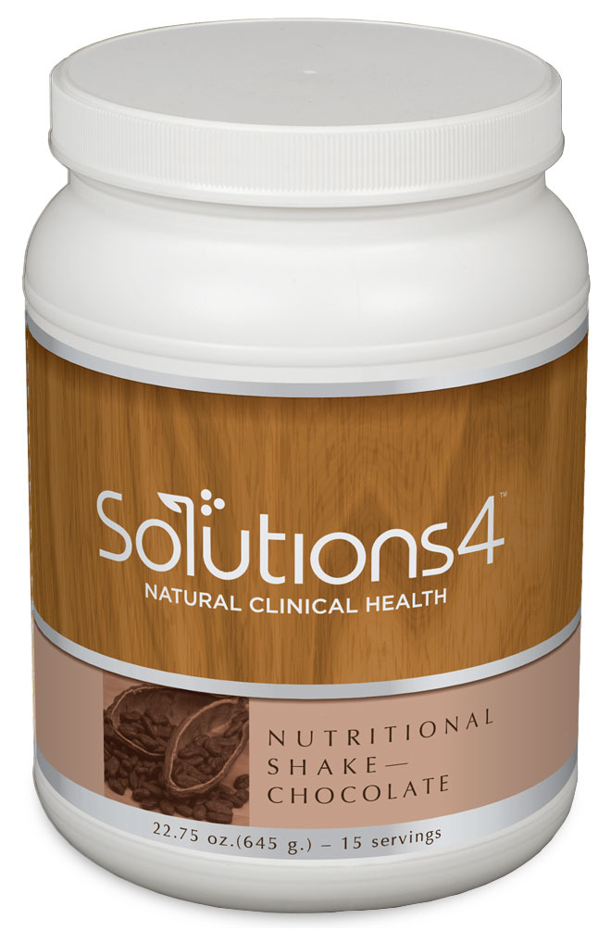
Protein: Balancing Your Intake
WHAT IS PROTEIN AND WHY IS IT SO IMPORTANT?

- Protein helps to regulate fat burning hormones, rebuilds damaged tissue when it breaks down, boosts your metabolism, and balances your energy levels. It also satisfies your appetite and makes it easier to eat a healthy diet!
- When you eat protein, you stimulate your body’s production of glucagon. Glucagon helps to stabilize your blood sugar levels by mobilizing stored fat for energy. This is why protein can be so helpful when you’re trying to lose weight!
- If a meal doesn’t contain enough protein, your body will produce insulin without producing glucagon, making it harder for your body to let go of stored fat.
- Women between the ages of 19 and 70 need approximately 46-53 grams of protein per day. Men in this same age range need about 56-63 grams of protein per day.
- Though protein matters, it’s not enough to just eat any type of protein. Quality matters as well.

UNHEALTHY SOURCES: GOOD SOURCES: BETTER SOURCES:

Processed meat Conventional chicken Organic, grass-fed whey protein
Lunch meat (sliced deli meat) Farm-raised fish Organic, free-range chicken
Conventional red meat Pasture-raised pork Wild-caught fish
Grass-fed beef Organic, farm-fresh eggs
Conventional nuts and seeds Raw, organic nuts and seeds

THE SOLUTIONS4 NUTRITIONAL SHAKE & OTHER SUPPLEMENTS FOR DIETARY SUPPORT

- If you don’t have time to cook up a serving of healthy protein with every meal, use the delicious Nutritional Shake instead! Each serving of this incredible shake provides 20 grams of grass-fed whey protein. This type of protein has been shown to support fat-burning, improve insulin sensitivity, help regulate the appetite, and so much more!
- Though it’s best to choose lighter proteins like chicken and fish, you’ll probably occasionally decide to eat something heavy (like a steak). When you do, you can take the Digestive Enzyme Blend to facilitate digestion so that you don’t experience uncomfortable digestive symptoms. This incredible blend of digestive enzymes contains protease — an enzyme that helps your body break down protein so that you can absorb 100% of the nutrients in your food.
- If you’re used to eating a diet that’s heavy in carbs, you might feel a little different when you start replacing your morning bagel with a protein-rich Nutritional Shake. Though your body will quickly adjust to your healthier choices, Appetite Appeaser can help you make the transition more smoothly. This supplement helps to satiate the appetite and help you feel full, even when you’re eating a lighter, healthier diet.

