
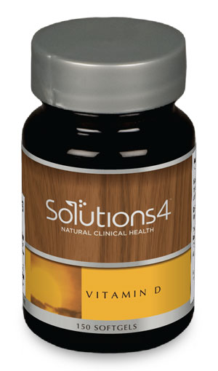
The Importance of Vitamin D
WHY IS VITAMIN D SO IMPORTANT?

- Your body is pretty incredible. It has the power to synthesize vitamin D using nothing but your body’s own natural resources and sunlight! Unfortunately, most people don’t spend enough time outdoors to take advantage of the benefits that the body can naturally offer.
- Vitamin D is also present in certain foods like tuna, salmon, sardines, egg yolks, mushrooms, and liver. Your body needs a combination of sunlight exposure and optimal nutrition to achieve a healthy balance of vitamin D in the body.
- Vitamin D is necessary for calcium absorption in the gut, for bone growth, and for healthy immune function. It plays an integral role in thousands of intricate bodily processes. Nearly every tissue and cell in the body has receptors for vitamin D.
- Unless your body maintains optimal vitamin D levels, you’ll be susceptible to a wide range of disorders including cardiovascular disease and diabetes. For example, a vitamin D deficiency makes you 91% more likely to develop insulin resistance (pre-diabetes) and more than doubles your risk for full-blown diabetes.
- Vitamin D deficiencies can also make you age prematurely and make it easier to gain weight!

HOW COMMON ARE DEFICIENCES?
- Unfortunately, vitamin D deficiencies are widespread around the world. Global studies estimate that up to one billion people are deficient in this important nutrient. In the United States, a full 64% of the population is deficient!

HOW CAN YOU BOOST YOUR VITAMIN D LEVELS?

- Spend more time outdoors in the sunlight, especially when sunlight is plentiful (in the summer, for example).
- Eat foods rich in vitamin D (salmon, sardines, tuna, egg yolks, mushrooms, liver, etc.).
- Take vitamin D in supplemental form to provide your body with a healthy baseline.

THE SOLUTIONS4 VITAMIN D SUPPLEMENT:

We have a top-of-the-line vitamin D supplement available here in our clinic. When you use this incredible supplement, you’ll have no trouble maintaining optimal vitamin D levels year-round! The vitamin D supplement available through Solutions4 comes in an easily absorbable liquid gel capsule. Solutions4 also uses the most potent form of vitamin D – cholecalciferol, or vitamin D3 – to ensure optimal results.

