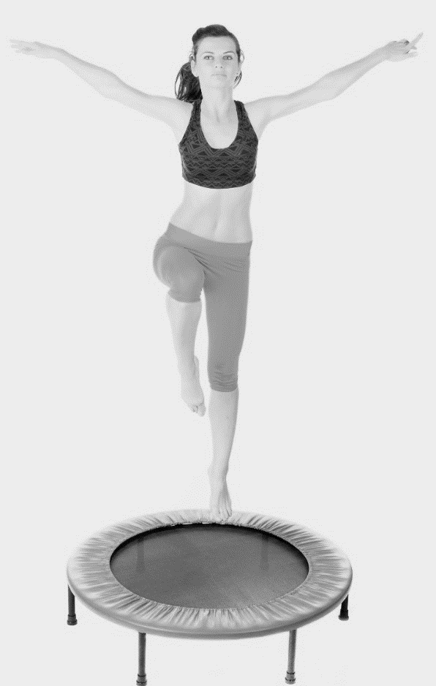
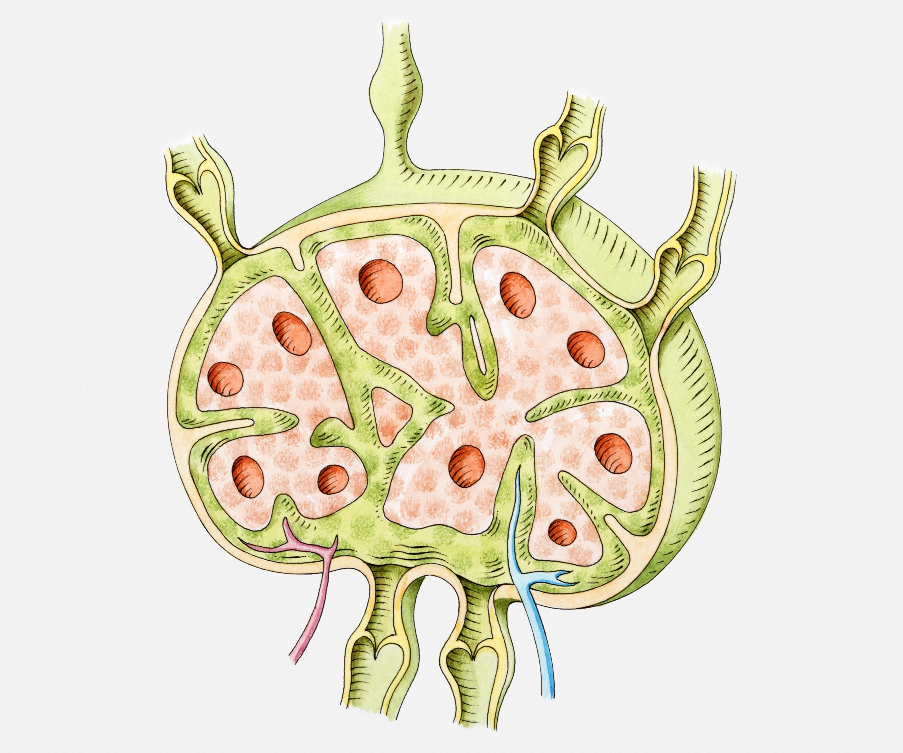
Cleansing Your Lymphatic System
WHAT DOES THE LYMPHATIC SYSTEM DO?

- Unlike the circulatory system, the lymphatic system doesn’t have a heart to pump lymph fluid through lymphatic vessels. The lymphatic system relies on regular physical activity to circulate lymphatic fluid throughout the body.
- Unfortunately, many people don’t move enough – or move in the right ways – to stimulate healthy lymphatic flow.
- The lymphatic system is made up of a series of branching, tree-like tubes that run throughout your body. The lymphatic system is designed to circulate lymph – a colorless fluid containing white blood cells and lymphocytes – and thus rid the body of toxins, waste products, and other unwanted materials.
- Beyond the branching, tree-like vessels that make up the lymphatic system, there are also several organs that also play an important role: the tonsils, the lymph nodes, the thymus, and the spleen.

HOW CAN YOU CLEANSE YOUR LYMPHATIC SYSTEM?

- Rebound exercise is something you can do with a rebounder (a small trampoline) or an exercise ball. The vertical movement helps to move lymph fluid though lymphatic vessels. To get started with rebounding, aim for 15 minutes of activity each day. You can break this into multiple 3-5 minute groups or do it all at once!
- Deep breathing can also help to stimulate lymphatic flow. Pranayama is a type of yoga centered around deep, controlled breathing. In Sanskrit, “prana” means “the extension of breath/life force,” while “ayama” means “to extend or draw out.”
- Whole Body Vibration helps to stimulate your lymphatic system to move toxins and fat out of your cells so that they can’t be reabsorbed. It also helps to reduce the appearance of cellulite, increases muscle strength, boosts the metabolism, and more!
- The Body Purifier is a supplement designed to cleanse the bloodstream and lymphatic system. It can be used to facilitate healthy detoxification or strengthen the immune system when it becomes compromised.

