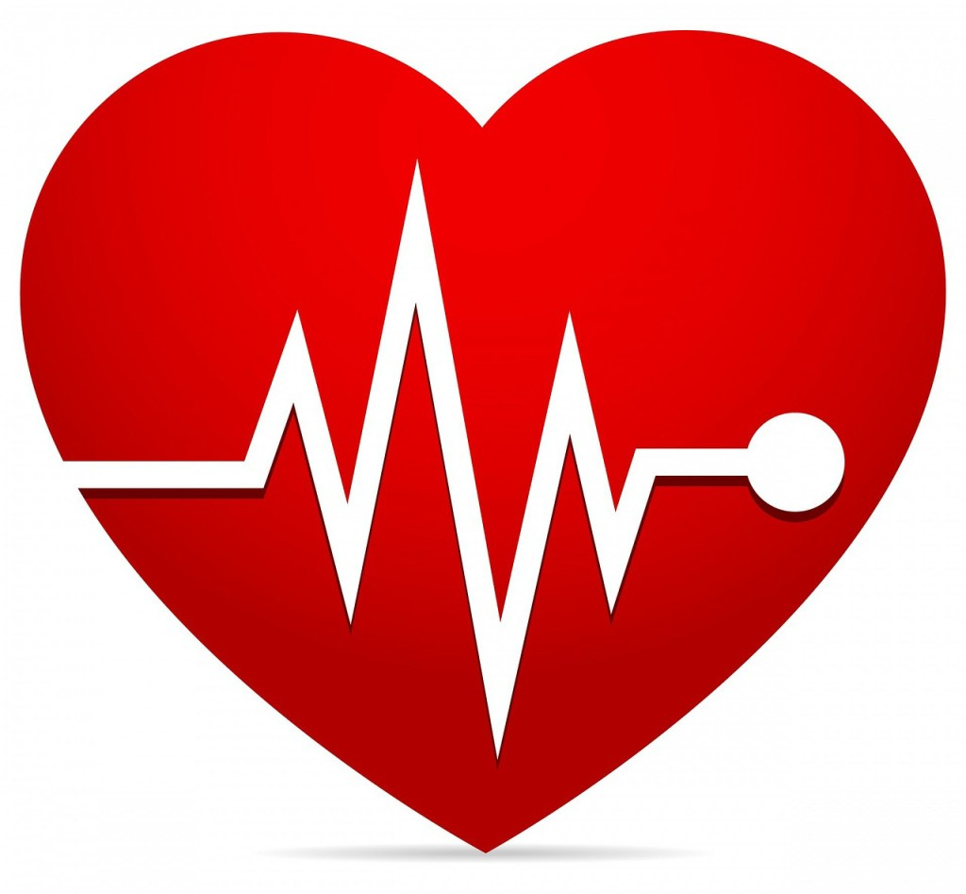
How to Improve Your Circulation in 6 Easy Steps
ARE YOU SUFFERING FROM POOR CIRCULATION?

- Millions of Americans suffer from foot and leg pain due to poor circulation. If you’re one of these Americans, you may experience numbness, tingling, burning, itching, or prickling sensations in your extremities.
- Though this discomfort may be caused by a variety of different factors (ranging from obesity to autoimmune disease), it often comes down to the same basic problem – poor circulation.
- The good news is that you don’t have to suffer from this discomfort forever! In this lesson, we’ll teach you six steps that you can take to find quick and lasting relief.

STEP #1: ENGAGE IN REGULAR PHYSICAL ACTIVITY

Regular physical activity gets your blood moving the all-natural way. Each time you exercise, you boost circulation to every inch of your body. This can help your body begin to heal from foot and leg pain caused by poor circulation.

STEP #2: EAT AN ANTI-INFLAMMATORY, NUTRIENT-RICH DIET

Inflammation can reduce blood flow to your extremities. Because many processed foods promote inflammation, it’s important to avoid them as much as possible. Replace these unhealthy foods with nutrient-rich alternatives (vegetables, fruits, etc.). Don’t forget to choose foods rich in omega-3!

STEP #3: USE CARDIO HEALTH ESSENTIALS

Cardio Health Essentials delivers huge healing benefits in just one easy-to-use power pack. Each pack provides an ample dose of nitric oxide, L-arginine, L-citruline, and CoQ10. These heart-healthy ingredients work together to increase circulation, thereby increasing the flow of oxygen and nutrients to every inch of your body!

STEP #4: TRY THE VESNA

The Vesna is a state-of-the-art machine that increases circulation to your legs and feet. You can experience up to a 3,200% increase in circulation in just one sitting!

STEP #5: SCHEDULE A WHOLE BODY VIBRATION (WBV) SESSION

WBV sessions are effective at restoring feeling to areas of numbness caused by poor circulation. WBV is excellent for people who don’t like exercising – it increases muscle strength, and it’s easy to use!

STEP #6: TAKE ADVANTAGE OF OUR LIGHT THERAPY TREATMENTS

Our Light Therapy treatments utilize non-invasive, painless, infrared lights that increase blood flow to the extremities. The treatments dilate your blood vessels, allowing blood to flow more freely to your tissues. Each session will effectively reduce numbness, tingling, and pain!

