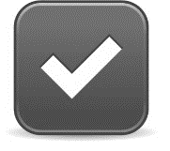
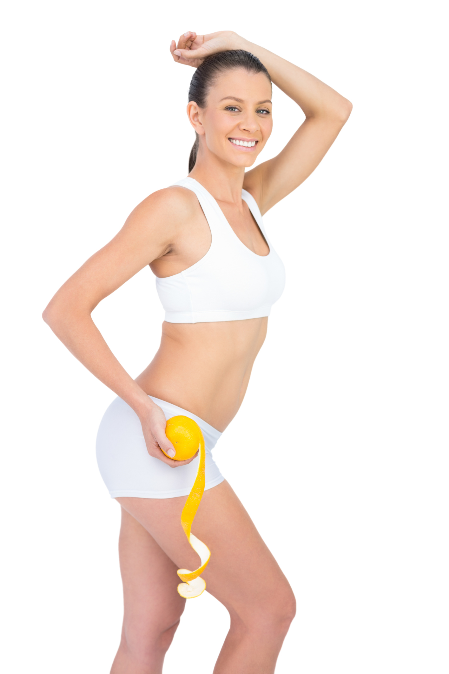
How to Get Rid of Cellulite Naturally
BASIC LIFESTYLE STRATEGIES FOR CELLULITE REDUCTION:

- Cellulite forms when toxins become trapped in fat cells or connective tissues, causing unsightly bumps and dimples to form.
- Detoxification helps to remove these toxins and thus reduce the appearance of cellulite!
- Stress Reduction helps to lower your cortisol levels and balance your hormones. Elevated cortisol levels will activate your “fat-storing” hormones, making it difficult to shrink your fatty deposits.
- Eating fresh fruits and vegetables (rather than processed foods) helps prevent your body from storing toxins in the first place. A healthy diet should be part of everyone’s long-term strategy for combating cellulite!
- Exercise helps to tone and strengthen the muscles underlying your fatty tissues. Firming these muscles helps to prevent unsightly dimples from forming in the fatty tissues above.

CELLULITE-ZAPPING TREATMENTS AVAILABLE THROUGH CLUB REDUCE:

Infrared Sauna. Unlike a regular sauna, the Infrared Sauna causes a deep and detoxifying sweat at the cellular level (where toxins reside). This makes the Infrared Sauna uniquely able to help you lose weight and get rid of unsightly cellulite! In our sauna, the average person will sweat out 20% toxins and 80% water — while in a conventional sauna, the average is only 3% toxins and 97% water!

LipoLight/LipoLaser. To get rid of cellulite, you must get rid of the toxins that are trapped in your fat cells. LipoLight/LipoLaser treatments force your fat cells to unlock, allowing the contents to spill out and be naturally metabolized by your body. Unlike traditional liposuction, there is no pain, no bruising, no drugs, and no downtime! It’s safe, simple, and highly effective! LipoLight/LipoLaser allows us to spot-shrink any area of the body so that you can banish cellulite for good.

Whole Body Vibration (WBV). After a LipoLight/LipoLaser session, the contents extracted from your fat cells need to be expelled from the body. That’s where WBV comes in! WBV helps to stimulate your lymphatic system so that discarded fat can be processed for removal. This machine is excellent for those who don’t have the time, energy, or motivation to hit the gym daily. All you have to do is stand on the vibrating platform and let the machine work its magic. This state-of-the-art system has been shown to reduce cellulite by 25% in just 24 weeks!

Exercise Gel. This revolutionary gel helps you get the most out of every light treatment! When applied to problem areas before exercise, this innovative gel will warm your muscles and increase your circulation. Typically, fatty tissues and areas with cellulite have less circulation, making these areas difficult to target. This gel draws blood to these areas, helping you get maximum results from every workout!

Detoxifying Body Wraps. Body Wraps aid in detoxification and reduce the appearance of cellulite. Your problem areas will look better immediately! The wraps remove cellulite by targeting and removing the toxins trapped in your connective tissue. You can expect to lose 4-14 inches in one hour!

