

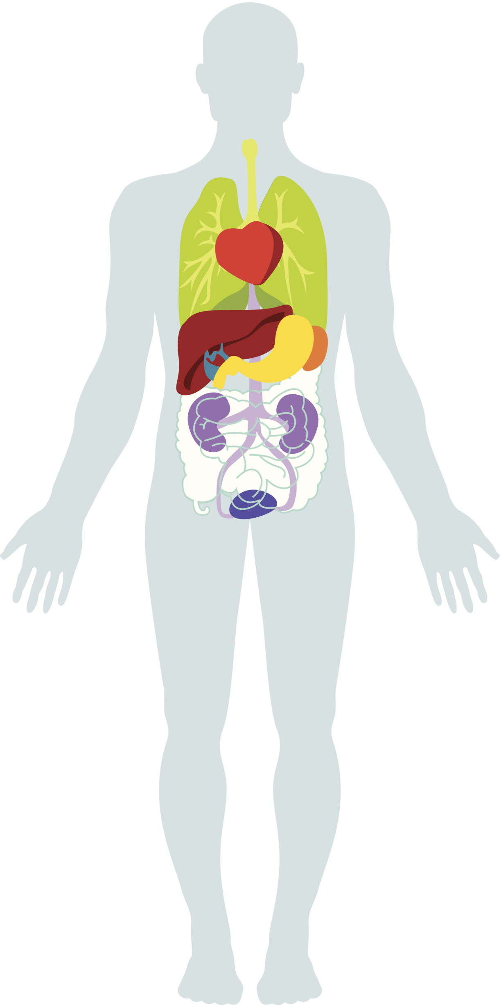
WHY DETOXIFICATION IS SO IMPORTANT

- Your body’s natural healing abilities are really quite incredible. When your body accumulates more toxins than it can handle, it tries to force them out so that they can’t do further damage.
- You don’t even have to think about it – your body knows how to do this automatically.
- Toxins are eliminated through body openings – the pores of the skin, eyes, ears, nose, mouth, rectum, and urinary tract – as a part of your body’s natural cleansing system.
- When we consume more toxins than our body is able to eliminate, we gain weight and develop cellulite!

HOW DETOXIFICATION WORKS

- Your body knows how to heal itself on its own, but is prevented from doing so when processed foods and toxins are continually consumed.
- A detoxification program removes all barriers to your body’s natural healing abilities.
- On a detoxification program, your gut is given a rest and energy is conserved. Your body uses this energy to rid itself of toxins and accumulated waste.

SIGNS THAT YOU NEED TO DETOXIFY

Poor Digestion Weight Gain Water Retention Stomach Bloating
Skin Breakouts Body Odor Protruding Abdomen Stiff Joints
Fatigue/Low Energy Poor Elimination Menstrual Problems Muscle Aches
Lower Back Pain Bad Breath Headaches Brain Fog

WAYS TO DETOXIFY YOUR BODY

Our Infrared Sauna is completely different from the sauna you might find at the gym. While a regular sauna penetrates 1/8 of an inch deep, an Infrared Sauna penetrates all the way to the bone! This causes a deep and detoxifying sweat at a cellular level (where toxins reside).

The Solutions4 Detoxification Kit is designed to deep clean your body from the inside out. Each kit is packed with potent cleansing herbs and greens that facilitate your body’s natural healing abilities. All supplements are 100% pure and extremely potent.

Whole Body Vibration dramatically speeds up weight loss by promoting detoxification. Our state-of-the-art vibration system has been shown to reduce cellulite by 27% in just 24 weeks! It also tones and tightens your body, boosts your metabolism, and provides many other benefits.

Detoxification 101: A Beginner’s Guide

