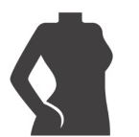


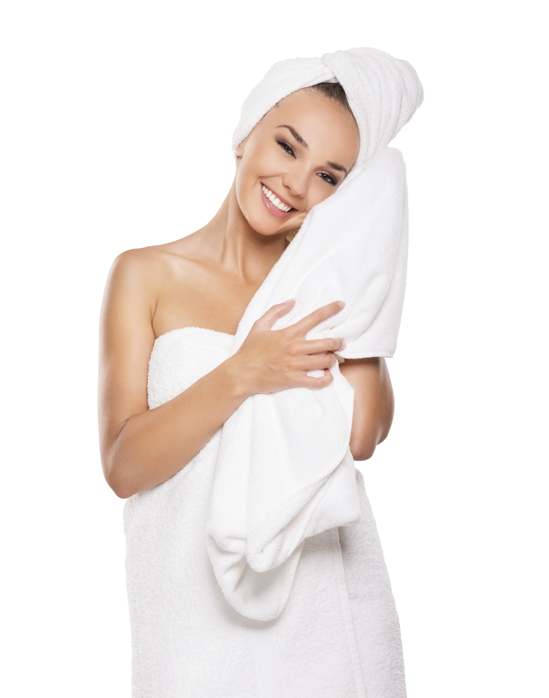
All-Natural Secrets for Radiant Skin
TOP 5 ALL-NATURAL SECRETS FOR RADIANT SKIN:

- Eat plenty of superfoods. This includes dark leafy greens (spinach, kale, watercress, etc.), brightly colored vegetables (tomatoes, peppers, etc.), antioxidant-rich fruits (blueberries, blackberries, etc.), and omega-3 rich fish!
- Don’t stress. Stress plays a major role in the health of your skin. When you’re stressed, your body releases a hormone called cortisol. This hormone can accelerate the aging process, causing wrinkles to become visible.
- Get plenty of sleep. Sleep plays a big role in limiting your body’s production of cortisol. During sleep, your body also repairs any damage that’s been done during the day. Make sure that you’re getting at least 7-8 hours!
- Detox regularly. Regular detoxification helps to cleanse the body of the toxins that contribute to dull, lifeless-looking skin. To let your skin really shine, we recommend that you detox on a quarterly basis.
- Sweat it out. Sweating encourages the release of harmful toxins from the skin. Exercise also stimulates circulation, facilitating the removal of toxins from within the body. This is why exercise is so good for your complexion!

SOLUTIONS4 SKINCARE PRODUCTS FOR RADIANT SKIN:

- The Green Tea Cleanser is a super-potent cleanser that heals and softens your skin. It includes antioxidants like green tea leaves, CoQ10, and vitamin C to fight off the free radicals that cause premature aging.
- The Apricot Exfoliator is a grapeseed-oil based scrub that uses apricot seeds to provide gentle exfoliation. It also contains collagen and elastin builders to prevent against fine lines and wrinkles!
- The Apple Stem Cell Moisturizer uses stem cells derived from a rare Swiss apple (the Uttwiler Spätlauber) to restore skin to a state of youthful vibrancy. This allows us to literally give aging skin a fresh new start.
- The Eye Serum can zap dark circles and under-eye puffiness. When you try this incredible serum, you’ll fall in love on the spot!

INCREDIBLE SKIN SUPPLEMENTS AND TREATMENTS AVAILABLE THROUGH CLUB REDUCE:

The Solutions4 Antioxidant is an incredible skin-saving supplement that will leave you looking your very best! This potent herbal blend contains some of the most powerful antioxidants found in nature (astaxanthin, mozuku, gingko biloba, bilberry fruit, etc.).

The Solutions4 Daily Antioxidant Essentials provides a delicious dose of skin-saving supplements! This product packs in the same healing benefits as the previous supplement, but in a convenient grab-and-go pack. Just mix with water and enjoy!

The Luxana Light Bed utilizes hundreds of tiny LED lights to illuminate your skin and provide a variety of health benefits. Each Luxana session will leave your skin looking tight, toned, and absolutely radiant.

