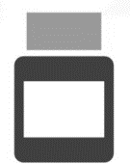
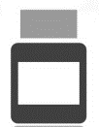
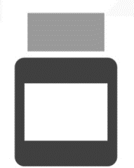
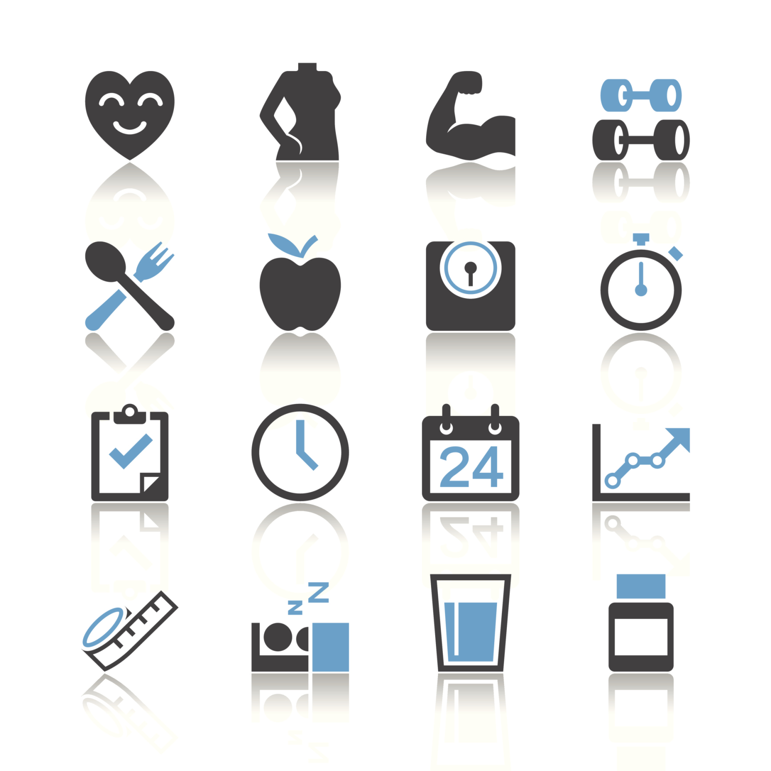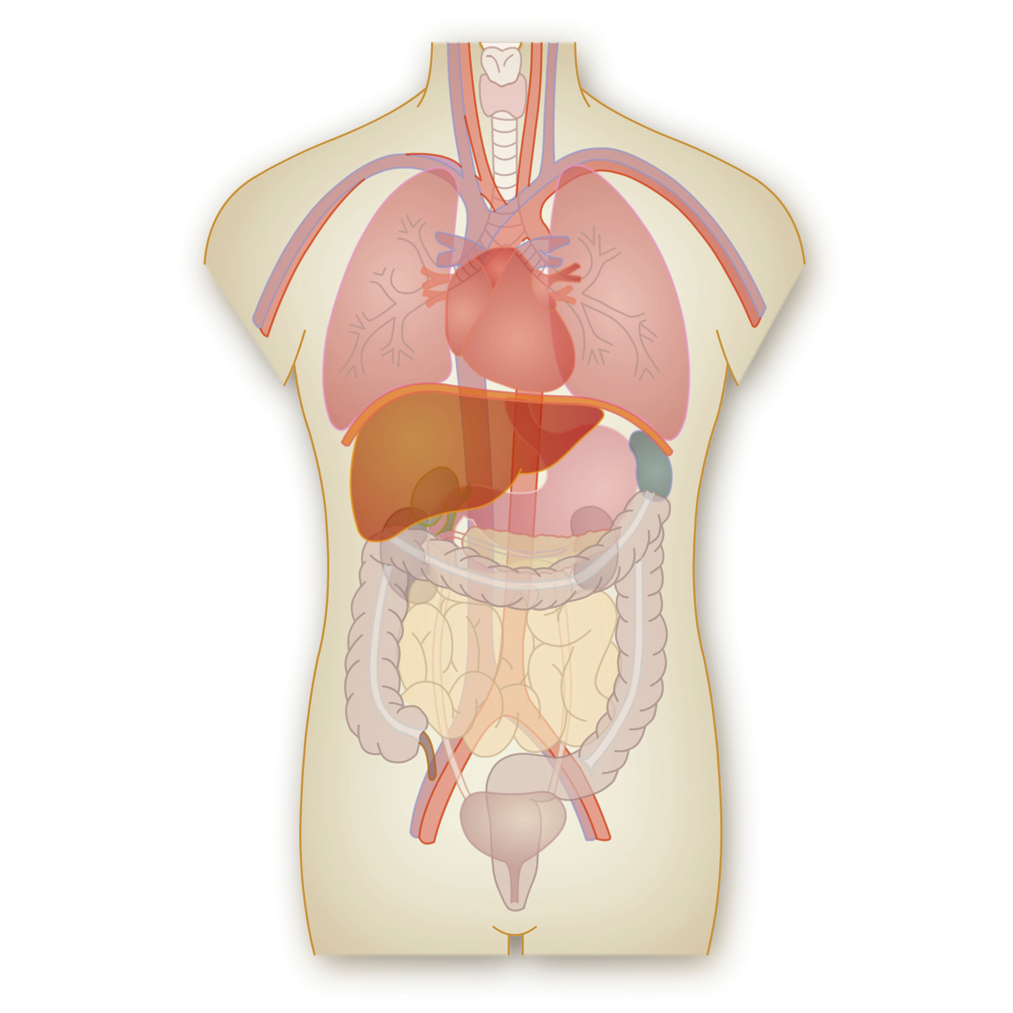
Three Simple Tips for Digestive Health
WHY IS DIGESTIVE HEALTH SUCH AN IMPORTANT ISSUE?

- In the United States today, digestive disorders are more prevalent than ever. 60-70 million Americans suffer from some type of digestive disease, and millions more suffer from occasional bloating, gas, constipation, or diarrhea.
- Today, many people eat processed foods that have been stripped of important nutrients (fiber, enzymes, etc.). People are also more likely to eat meals too quickly or eat snacks on-the-go. These choices can wreak havoc on the digestive system.
- To make matters even worse, many of our foods are exposed to ionizing radiation that’s designed to kill bacteria and extend shelf life. Though this may seem desirable, irradiation depletes many important nutrients from food — including essential enzymes.
- The natural enzymes in raw foods help to facilitate healthy digestion. Without them, your body has to work harder to absorb the same nutrients from food.

A GOOD APPROACH (TIP #1): USE THE PROBIOTIC BLEND

If you don’t always eat a 100% perfect diet (and avoid all irradiated foods), try the Probiotic Blend! Taking a high-quality probiotic can relieve digestive problems, boost immunity, facilitate healthy weight loss, and provide a number of other important benefits! Unlike other probiotics on the market, we’ve “supercharged” ours by adding herbs and nutrients that facilitate the growth of healthy bacteria and inhibit the growth of harmful bacteria in the gut. This ensures that this probiotic accomplishes exactly what it’s been designed to do.

A BETTER APPRAOCH (TIP #2): USE THE PROBIOTIC BLEND + DIGESTIVE ENZYME BLEND

For even better results, you can take the Probiotic Blend in combination with the Digestive Enzyme Blend. These two supplements are a powerful duo that you can use to relieve digestive discomfort and absorb more nutrients from food! The Digestive Enzyme Blend provides enzymes that help you break down foods into individual nutrients that can be better used by the body.

THE BEST APPROACH (TIP #3): USE THE PROBIOTIC + DIGESTIVE ENZYEMS + DIETARY CHANGES

We’ve already told you all about the benefits of the Probiotic Blend and Digestive Enzyme Blend. For optimal digestive health, we recommend that you optimize your diet as well. This means eating plenty of foods rich in fiber, enzymes, and probiotics. We recommend that you limit your exposure to irradiated foods by buying produce that’s organic and in season. We also recommend that you eat reasonably sized portions very slowly and mindfully, avoiding meals on-the-go. Binge eating isn’t good for anyone!

