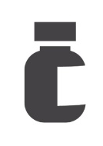
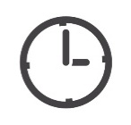
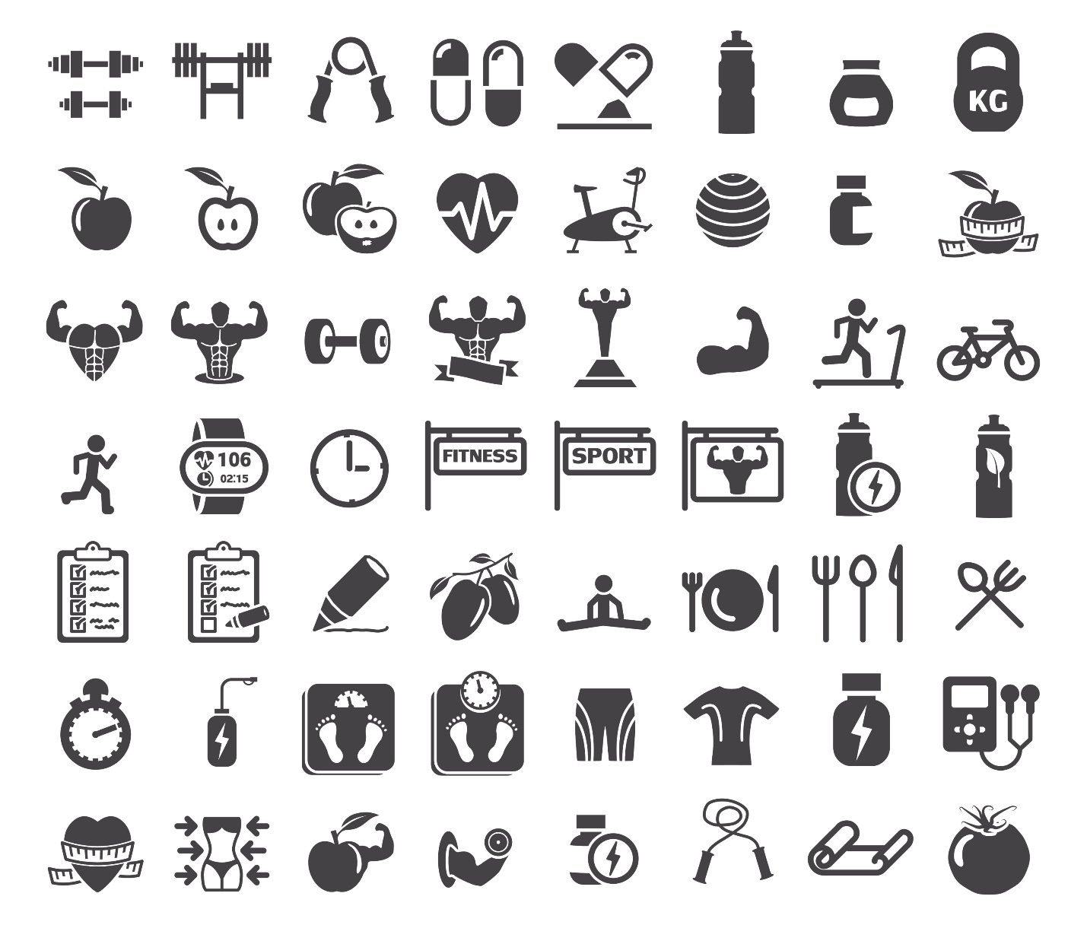
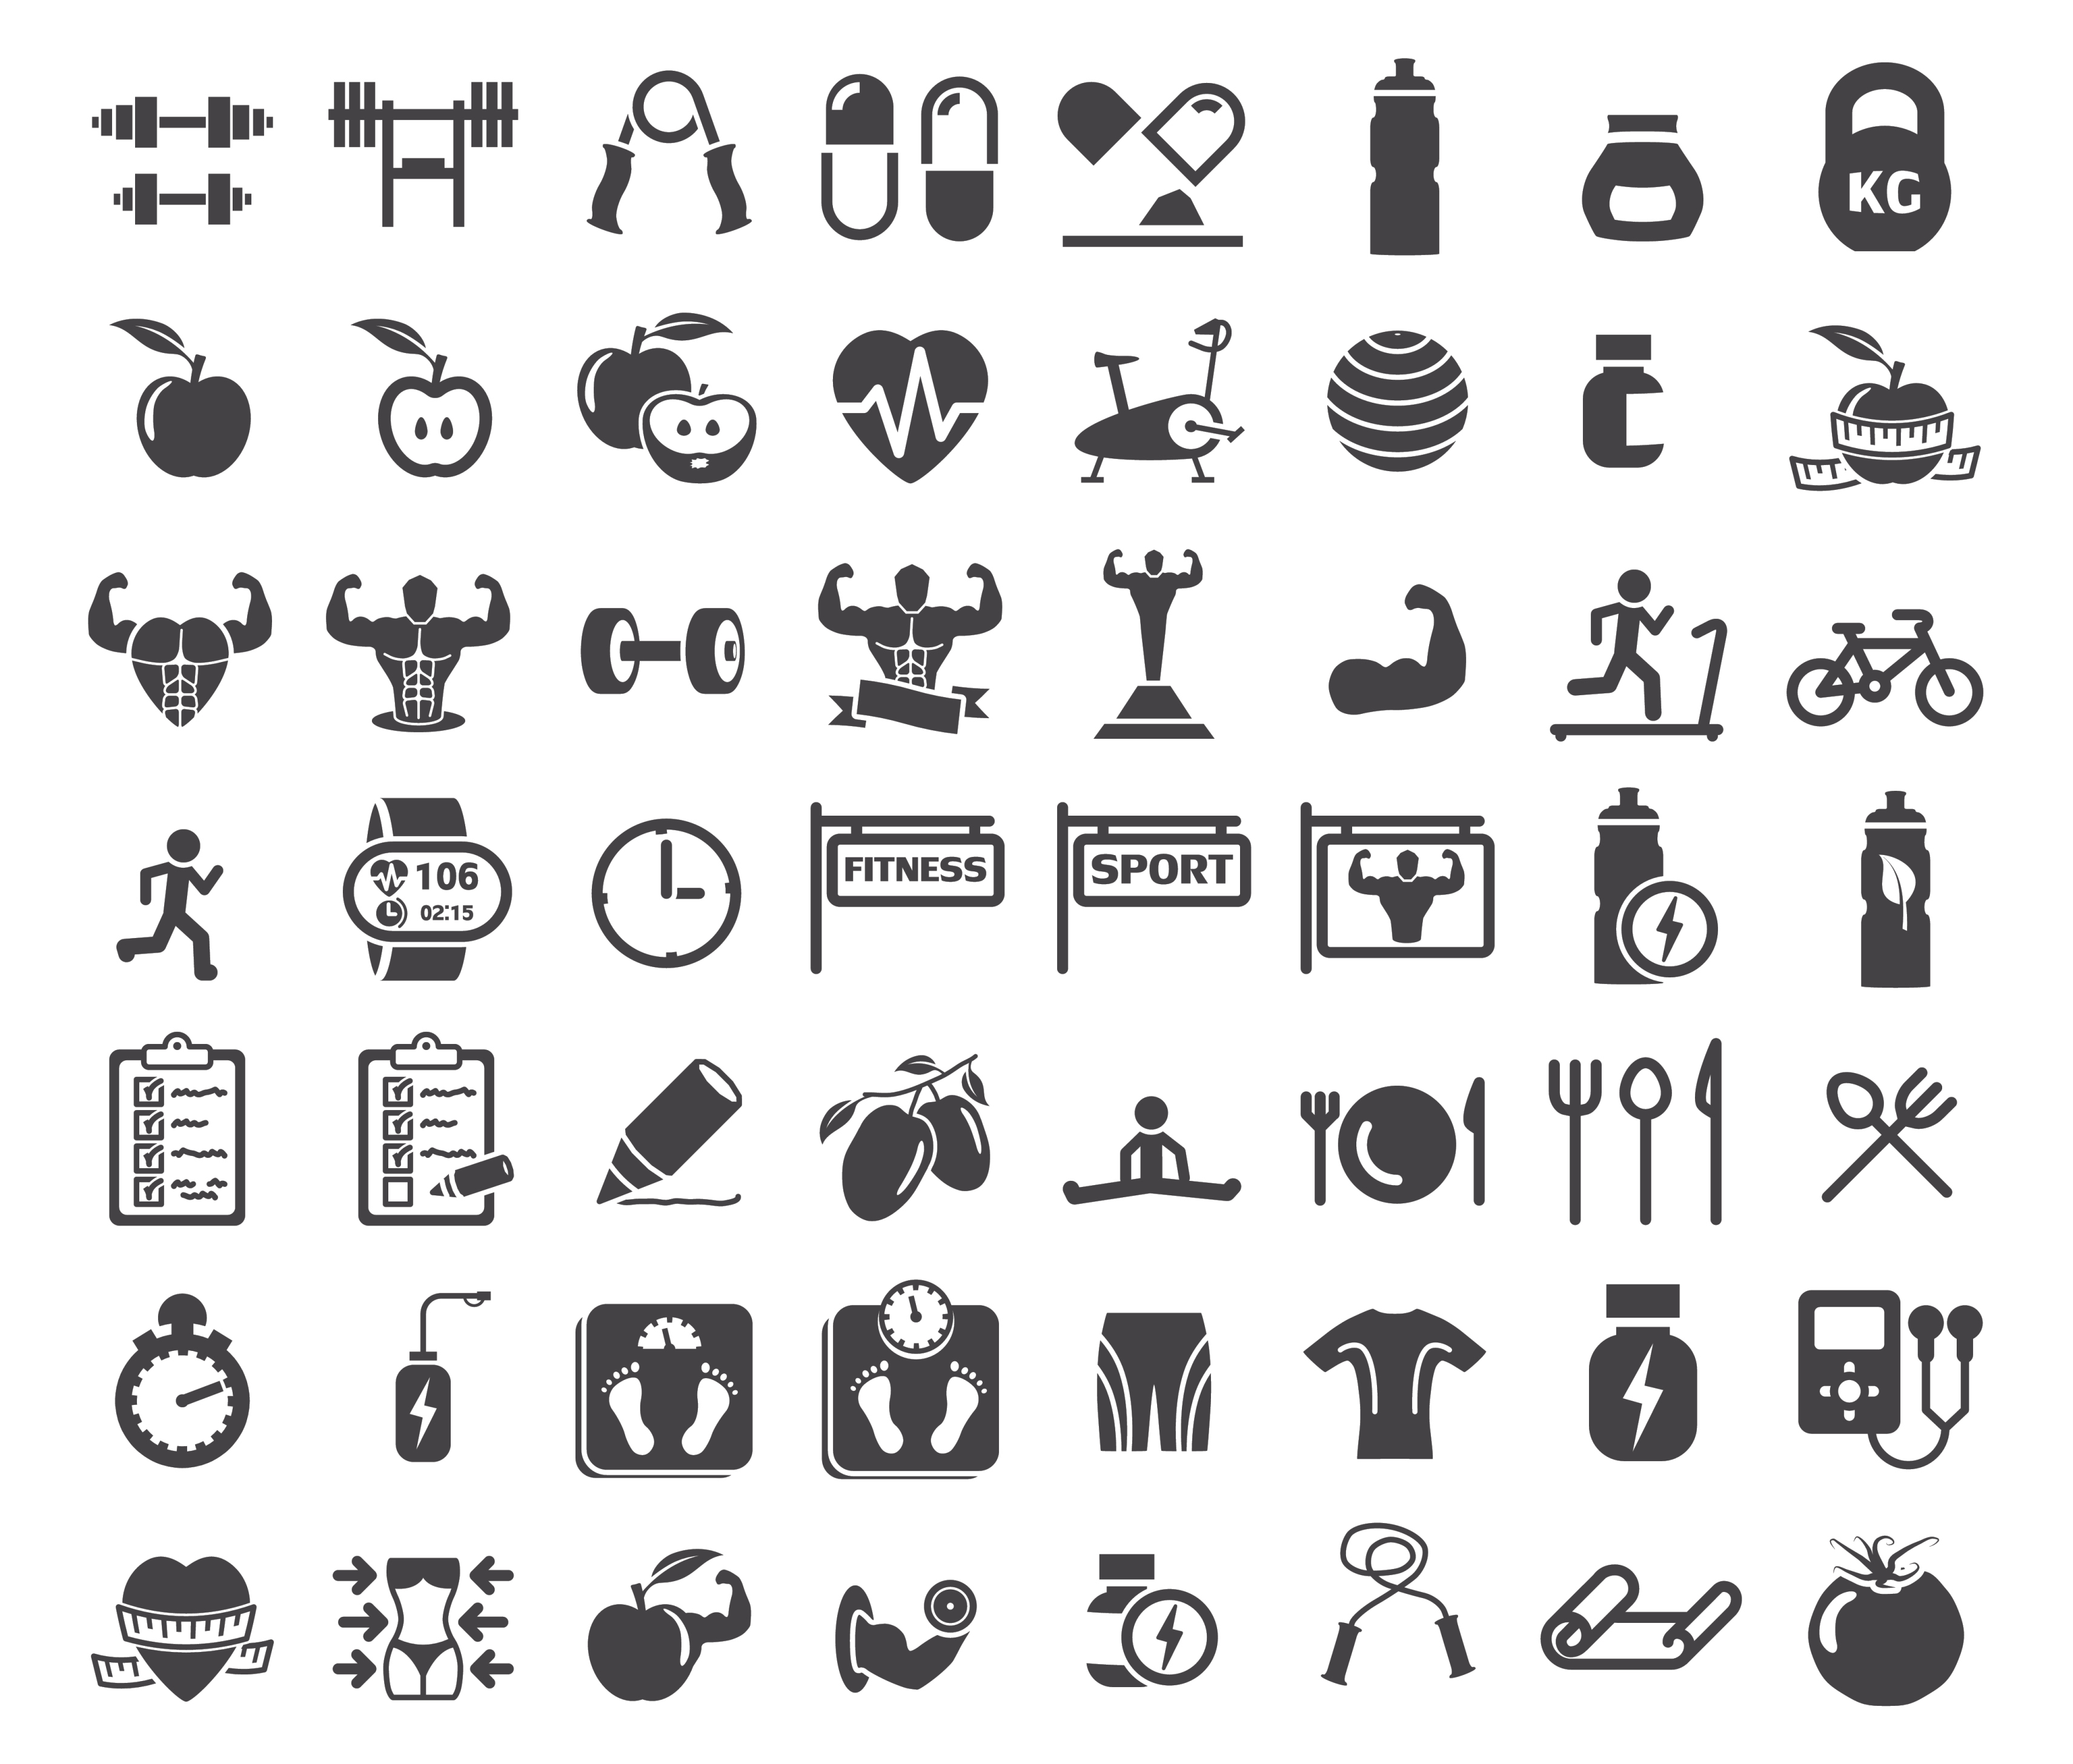
Curb Cravings to Lose Weight!
WHY IS IT SO HARD TO CONQUER FOOD CRAVINGS?

- When it comes to excess weight and obesity, studies show that food addiction is often to blame. Food addiction involves a frequent craving for foods that activate the brain’s pleasure center and produce temporary satisfaction (a type of “high”).
- If you find yourself trapped in a vicious cycle of food craving and addiction, know that you’re not alone. Millions of Americans feel the same way! Food companies have designed processed foods to be enormously addictive. It’s no surprise that you can’t have just one!
- But processed foods aren’t just highly addictive – they’re everywhere. Junk foods line the aisles in grocery stores, await you in the checkout lane, and maybe even stock a vending machine in your place of work. Everyone knows that it’s hard to break an addiction, but it’s even harder when the addictive substance is everywhere you turn.

HOW TO CURB CRAVINGS WITH DIET & LIFESTYLE CHANGES:

Balance Your Blood Sugar: Simple carbs and sugars spike your blood sugar and leave you feeling even hungrier. To curb cravings, go cold turkey on refined sugars and grains.

Maximize Your Nutritional Intake: You probably know what it’s like to eat a large meal and still feel unsatisfied when you’re done. This is because many foods only provide “empty calories” that fill you up without meeting your nutritional needs. Your body knows that it still needs something, so it tells you to keep eating! Your body will continue to crave more food until you provide it with the nutrients it desperately needs.

Manage Stress: Heightened stress levels can be exhausting. To avoid turning to junk food for comfort, manage your stress levels before they get out of hand.

Get to Sleep: If your body isn’t ready for a new day, you’ll have difficulty making wise decisions. For example, not getting enough sleep might tempt you into one (or several) cups of coffee! You might eat something sugary for a quick rush of energy to get you through the day. When you’re tired, you’re also more likely to skip the gym.

HOW TO CURB CRAVINGS WITH SOLUTION4 SUPPLEMENTS:

Appetite Appeaser: To make things even easier, we’ve created an appetite-satiating supplement designed to keep you feeling full even while cutting calories. The Appetite Appeaser provides a potent blend of herbs that make it easier for you to reduce your calorie intake and give your stomach a chance to return to a normal size.

Multivitamin/Mineral: The Multivitamin/Mineral will boost your energy levels and provide your body with 100% nutrition on a daily basis. When your body is getting all of the nutrients it needs, you’ll be less likely to crave empty calories. This can make it much easier to make healthy choices and lose weight!

