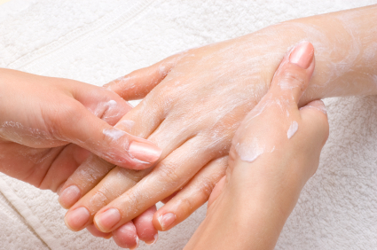

What You Put On Your Skin Matters!

DID YOU KNOW…?
The skin is the largest eliminative organ of the body.

If you’re using generic cleansers or lotions on your skin, you are inadvertently taking in unwanted toxins.

The only way to lose weight permanently and stay healthy is to
eradicate ALL toxins from your body – for good!

The last thing you want to do is work hard on a detoxifying
program and then unknowingly add toxins back into your
body through cleansers and lotions.

Of all the chemicals used in most cosmetics and skin care
products, the National Institute of Occupational Safety and
Health has reported that nearly 900 are toxic!

We have GREAT news!

Solutions 4 Skincare Line

We Apologize!

We ran out of brochures –
Please ask a staff member for more information!
Organic, All-Natural Skincare

Simply spend 2 minutes in the morning and 2 minutes in the evening to FEED, CLEANSE and HYDRATE your skin in 3 easy steps…

Step 1: Green Tea Cleanser
Step 2: Apricot Exfoliator
Step 3: Apple Stem Cell Moisturizer

Ask us for a FREE demo today and experience this amazing doctor’s-only skincare line for yourself!

