
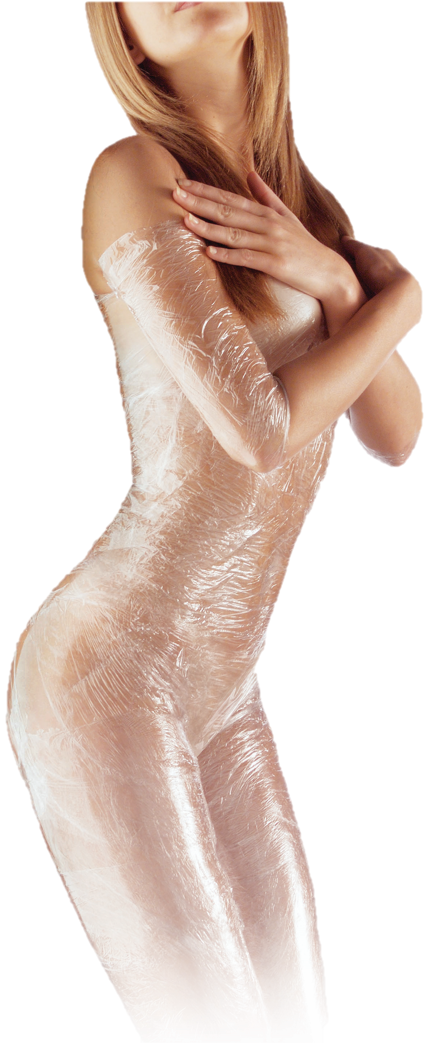
Myth 1: Cellulite is fat.
FALSE! Cellulite is a sign of a toxic body, caused by uneven fat deposits in the connective tissue of the skin, edema, and lack of circulation.

Myth 2: Only overweight people have cellulite.
FALSE! Even skinny people have problems with cellulite. There are two types of cellulite:
soft cellulite, often characterized
by the “cottage cheese” like
appearance; and hard cellulite that
mostly affects individuals in good
physical condition. Often times,
hardcellulite is the most difficult
to eradicate.

Myth 3: Cellulite responds well to
weight loss and exercise programs.
FALSE! Since cellulite is not a fat
condition, weight loss and exercise
can’t touch the unsightly stuff. The
only way to eliminate cellulite is by
detoxifying the body and increasing
circulation to the affected areas.
Ready to lose a few unwanted
inches and iron out unsightly
cellulite?

Come in and unwrap a new
you with the help of the staff
at
Lighthouse Health &
Body Makeover!

715 E 3900 S, Suite #107
Salt Lake City, UT 84107

Monday - Thursday: 9am to 8pm

(801) 265-3400


000
www.LighthouseHealth.com

Myths About
Cellulite
Want to Lose
4”-14” in
One Hour?

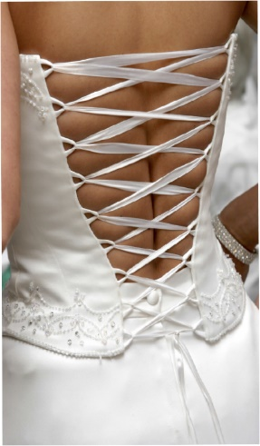
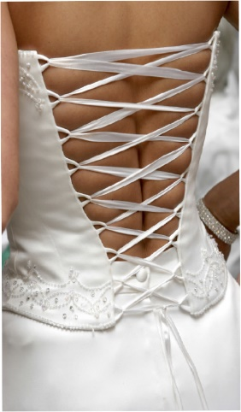
Not only are Body Wraps from Lighthouse Health
& Body Makeover a great way to lose inches, these
Body Wraps are a great way to reverse the
debilitating effects of cellulite. Cellulite is often described as a
condition of uneven fat deposits, water and other wastes that have
become trapped in connective tissues of the body, just below the
surface of the skin. We all know it as cottage cheese thighs and
orange peel skin, not flattering on anyone of any dress size.

A Body Wrap from Lighthouse Health & Body Makeover is the perfect answer to lose unwanted inches and reduce visible cellulite.

You have enough on your mind before your big day - let us help you
relax and ease into your dress without any worry!
Two words... Body Wrap.

It’s painless, relaxing, and it’s an
effortless way to lose inches and iron
out unsightly cellulite. It’s quite
possibly the best 60 minutes you
could ever spend on yourself.

Our Inch Loss and Cellulite
Reducing Body Wraps are unlike
any other wrap; including all those dehydration techniques and painful sweats that parade around as “body wraps.”

We know how amazing our body wraps are - we even guarantee inch loss during your one-hour session, somewhere in the neighborhood of 4” to 14” depending on your current body style.

Not to mention you
can kiss those cottage
cheese thighs goodbye...
Let us smooth out the bumps and wrinkles for the big day…
Lighthouse Health & Body Makeover Inch Loss and
Cellulite Reducing Body Wraps were developed by a UCLA biochemist to encourage circulatory and lymphatic flow, causing a painless cleansing of the tissue. In turn, this healthy cleansing of the body results in a loss of 4 to 14 inches per wrap and a visible decrease of cellulite.
Inch loss is great –
but there’s more…
It’s time to treat yourself to an unbelievable experience…

