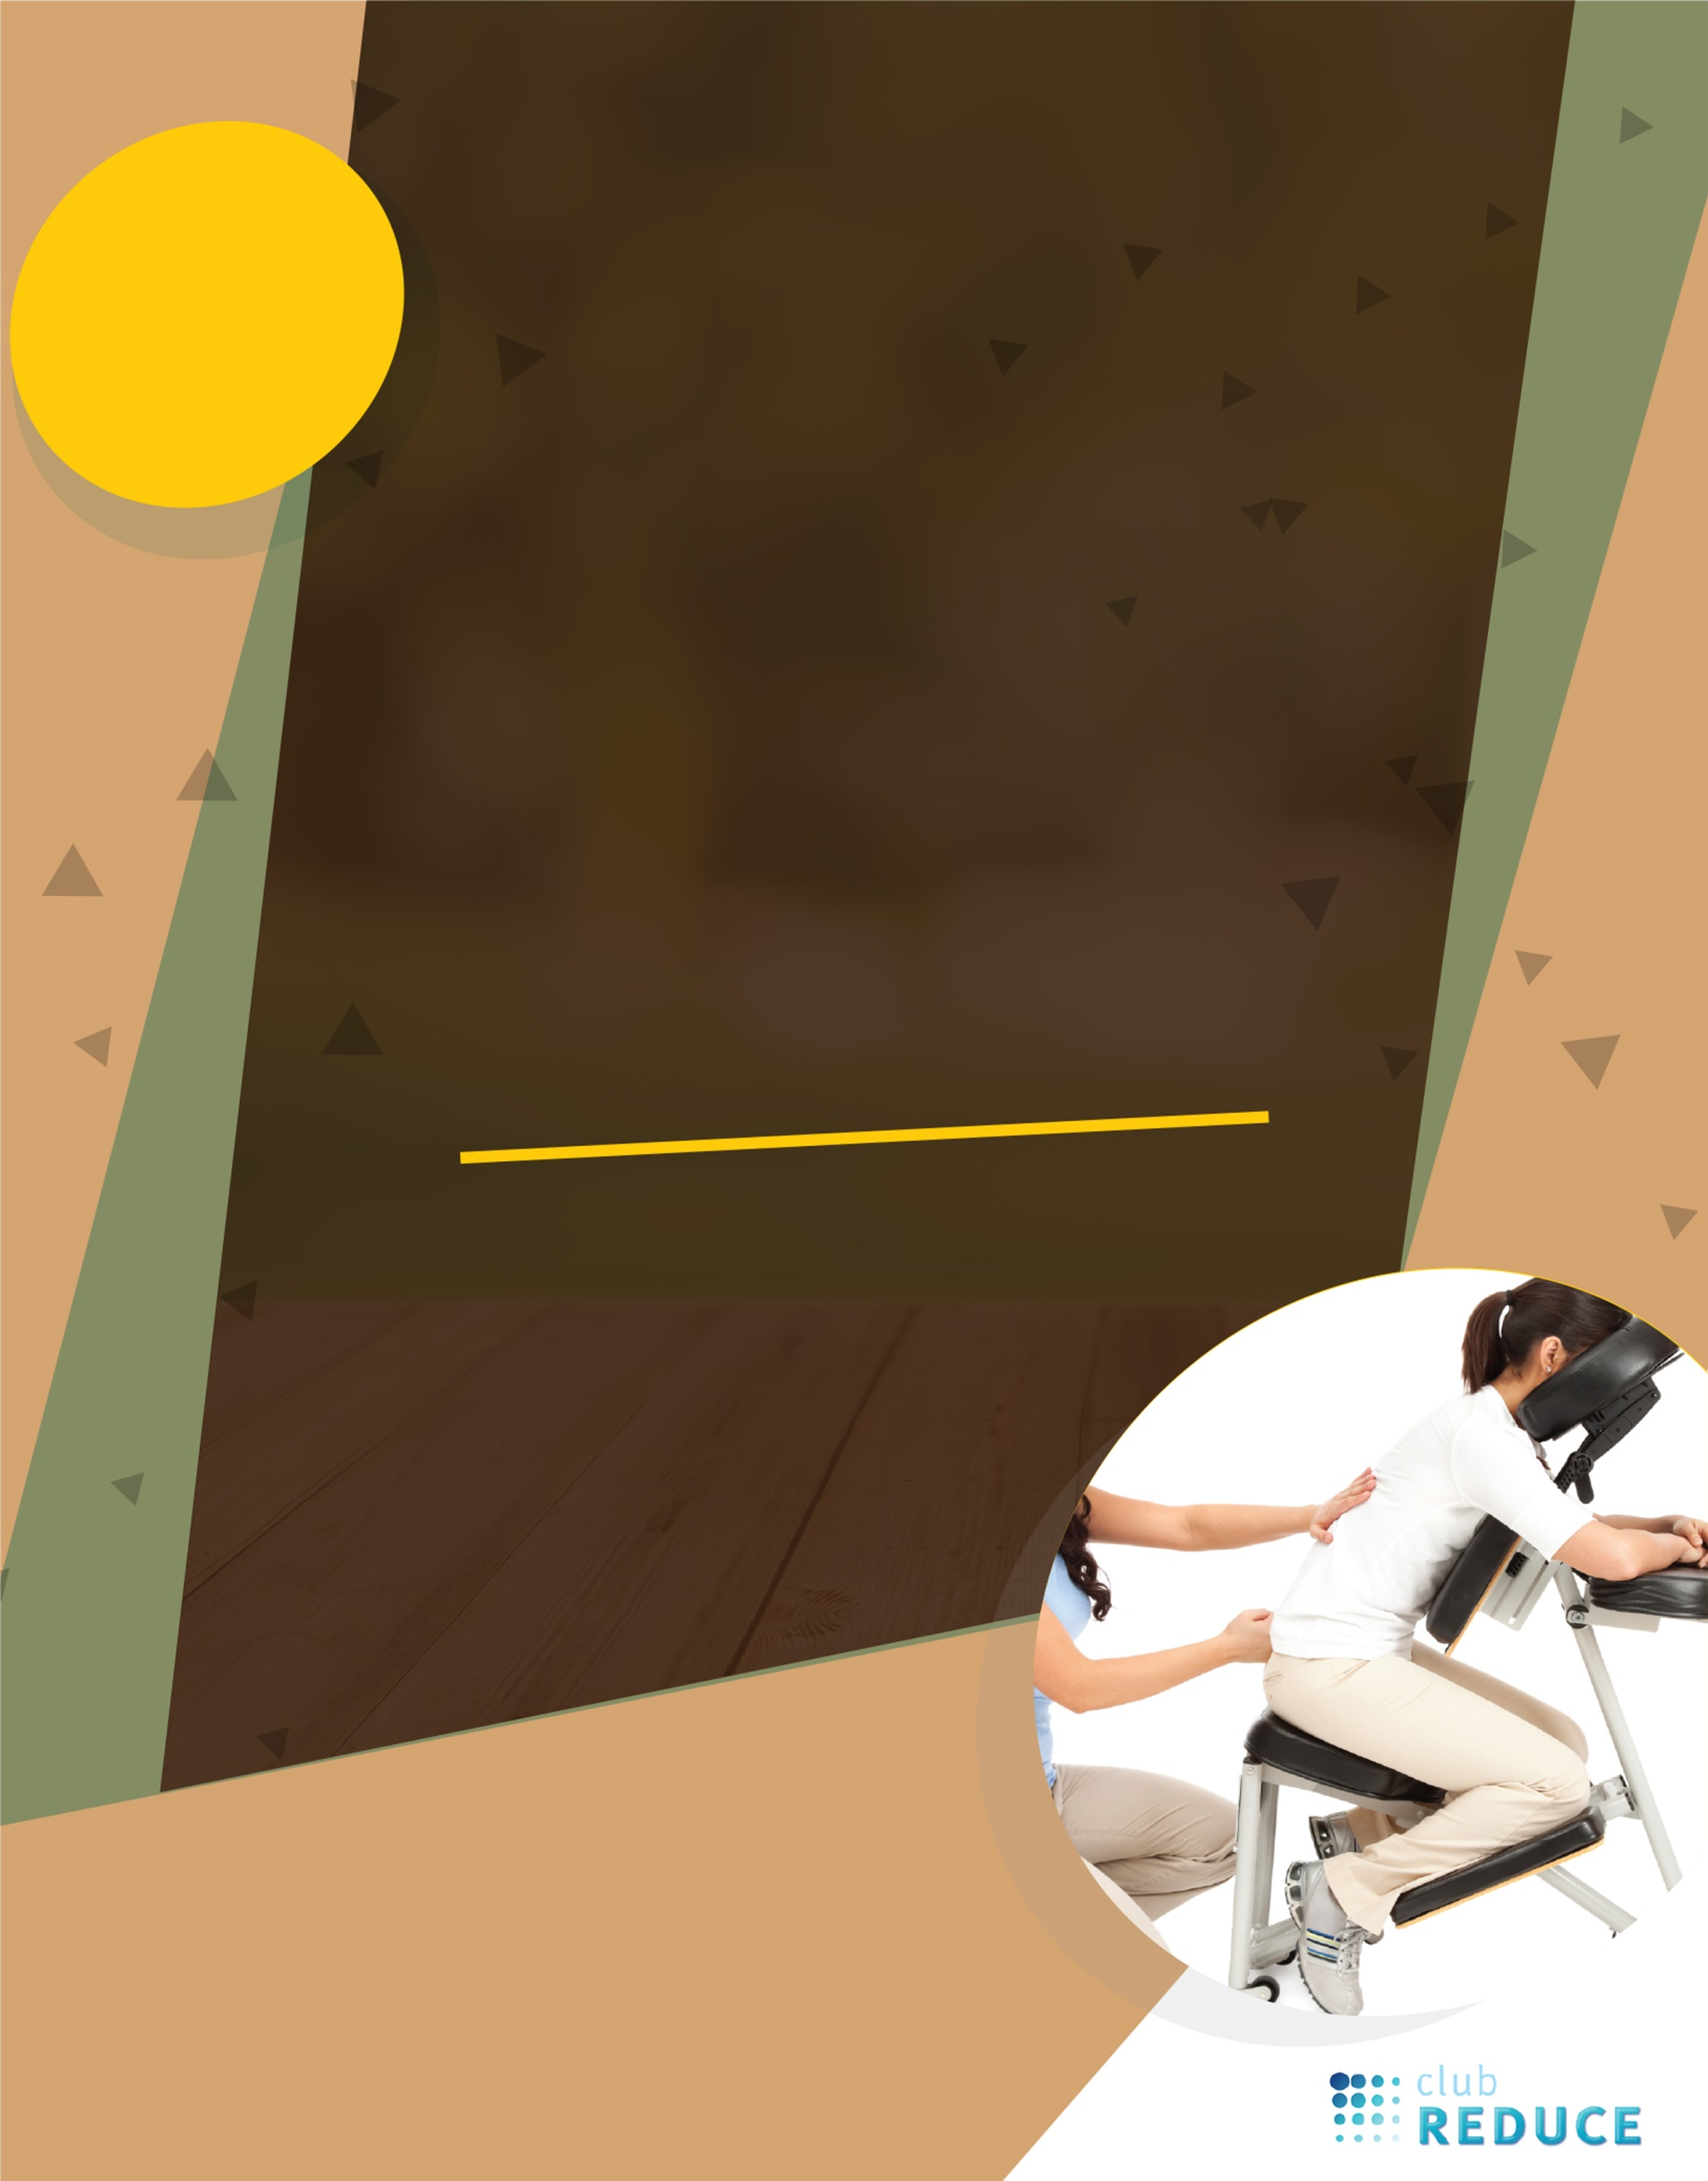
Local Customers ONLY!

Farmers Market Special!
FREE
SEATED CHAIR MASSAGE!
SEE VENDOR
FOR DETAILS!

