
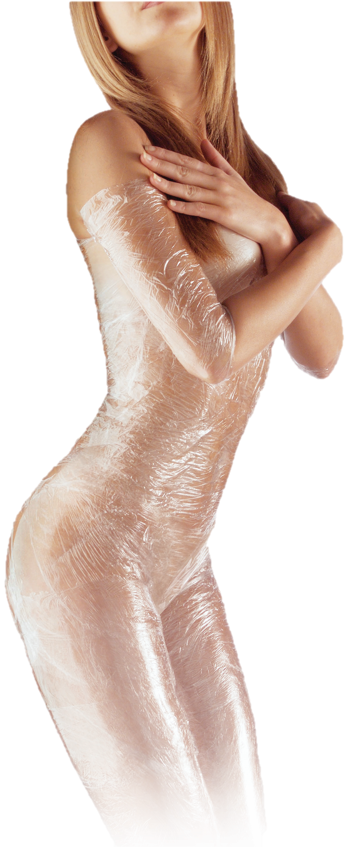
Want to Get 20% Off
Any of Our Products You Purchase?

Attend one of our Seminars and
you can get 20% of your next
purchase of products!

Our amazing seminar reveals some
breakthrough discoveries in weight
loss. We’ll be teaching you how you
can trigger your fat burning
hormones. New technology will also
be introduced that helps people
overcome food addictions. The seminar
is very enlightening and has some great
new information. The presentation is about
90 minutes and is well worth the time spent.

You can register for the seminar by going
to www.DietUtah.com or calling our
clinic at: 801-265-3400. Seating
is limited, so call now!
Something to remember
after your body wrap...

You may notice a flushing in your skin and
possibly even a slight rash after the wrap. The contour cream used is niacin-based,
which helps to detoxify the body
and naturally creates flushing
in the skin due to increased
circulation.

Do not be alarmed if this
occurs, as your body is
either experiencing increased
circulation or is actively flushing
out trapped toxins.

You can always call our clinic at
(801) 265-3400 if you
have any questions or concerns.
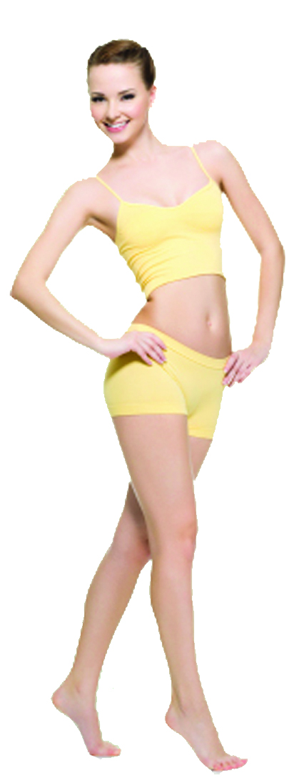
000
Body Wrap Aftercare
We Hope You Enjoyed Your Wrap!
715 E 3900 S, Suite #107
Salt Lake City, UT 84107
Monday - Thursday: 9am to 8pm
(801) 265-3400

We hope you enjoyed the wrap
you just received!

Inch loss is just one of the benefits of these amazing wraps. They also increase overall circulation and help reverse the cellulite formation cycle by assisting your body’s natural lymph elimination functions.

There are a few guidelines we suggest you
follow after you’ve received a Body Wrap:

1) Keep the cream on for at least 12 hours, as it continues to work on the skin, this means you shouldn’t shower for at least 12 hours.

2) Drink at least 2 quarts of water daily, to help flush out the toxins that have been released into the lymphatic system as a result of the contour cream that was used.

3) Exercise! It is important to stimulate your lymphatic
system so your body can flush out toxins.

4) You may also find it helpful to not only decrease
your calorie intake, but to also eat food that is
easily digested. Foods that are heavy and rich
tend to overload the liver and make digestion
difficult.

5) Heat will re-activate the cream and make your
skin sun-sensitive. We advise you not to sun
bathe or tan for at least a day after receiving
the wrap.
Suggested Products for even
BETTER Results!
You are on your way to a beautiful new you!
We’d like to suggest a few of our great products that will only
continue to aid you in getting and maintaining the results you desire. Anti-Cellulite Lotion:
This should be applied immediately after showering to any problem
areas. The lotion helps to increase circulation and flushing in the
areas of connective tissue where cellulite is often trapped. These
areas do not respond to exercise or proper eating, so this lotion
is a great alternative.

Cellulite Cleanse:
This works by stimulating the circulatory system and the
lymphatic system to pick up all stored water retention,
toxins and waste materials (the main contributors to
cellulite), which are trapped in the connective tissues of
the body. It then promotes the elimination function for
these unwanted substances.

Exercise Gel:
Get the most out of your workout with Exercise Gel! When applied before exercising, this innovative gel warms muscles and increases circulation. Typically, fatty tissues have less circulation, making these areas more difficult to target. The gel creates heat, which draws blood to those areas, helping you get maximum results from every workout.

Nutritional Shake (in chocolate, vanilla, strawberry and orange):
This nutritional supplement is the most advanced in the industry. It was formulated with the help of doctors, nutritionist and formulators to provide a completely safe weight loss, or, if used as a dietary supplement, a delicious breakfast or meal replacement drink, containing the vitamins and minerals necessary for the human body each day. The benefits of drinking the shake include: normalized weight, increased energy, enhanced vitality and overall improved nutrition.

