
Infrared Sauna

Keep Your Body in Fat Burning Mode to Keep Your Weight Off for Good!

One of our goals is to help you learn how to trigger your fat-burning hormones; this gives you the most effective leverage over fat-burning hormones. Your fat-burning hormones work through your liver - that’s why it’s so important to do a cleansing program two to four times a year.

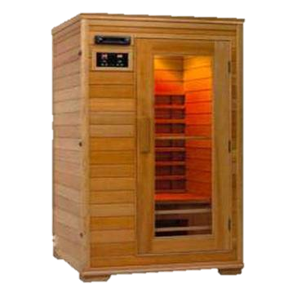
An essential part of cleansing and detoxifying your body is utilizing an Infrared Sauna.

What is Infrared?

Infrared is the band of light you perceive as heat. You can’t see infrared with the naked eye, but you can feel this type of light in the form of heat. The sun produces most of its energy output in the infrared segment of the light spectrum. Infrared rays heat your body without having to heat the air around you.

How Does an Infrared Sauna Aid Weight Loss?

Your body expends energy (calories) to produce sweat - 1 gram of sweat requires approximately 0.586 calories. A moderately-conditioned person can easily sweat off 1000 grams or more in one Infrared Sauna session. That’s the equivalence of running 6-9 Miles! While this weight loss can be regained by rehydration with water, the calories expended in the process will not come back. Sweating also allows the body to release built up toxins naturally, keeping your body cleansed even when not on a cleansing program.
How Safe is an Infrared Sauna?

Because infrared is part of natural sunlight, Infrared Saunas are completely safe! Health professionals have used infrared heat lamps for decades to treat muscle and joint problems. In hospital baby care units, incubators are often equipped with infrared heating systems to keep newborn babies warm.
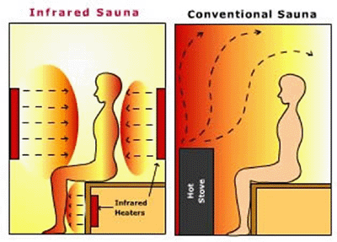
What is the Difference Between an Infrared Sauna and the Conventional Steam Sauna at my Gym?

While conventional saunas make you sweat out water weight, infrared saunas penetrate through the skin, stimulating your lymphatic system, encouraging excess toxins and weight to flush out. This allows an in-depth heat in a more pleasant temperature, thus providing more health benefits and a highly enjoyable and comfortable environment.

