How to Prepare For Your Treatment:

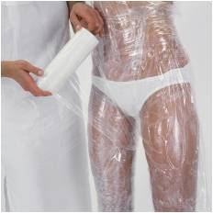
Body Wraps:
- Don't shave the day of the wrap.
- Wear a bikini or bra and underwear.
Thongs are best because you get your glutes wrapped.
- Drink lots of water after the body wrap.
- Don't sweat after the wrap i.e. no hot yoga or sauna's.
- Don't shower for 8 hours after the body wrap.

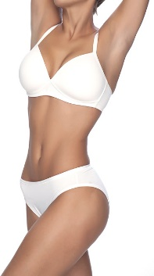
Lipo:
- Don't eat 2 hours before or 2 hours after treatment.
- Drink a lot of water before and after treatment.

